# 

**By**

**Lee Wen Ze**

**TP063743**

**APU3F2308CSDA**

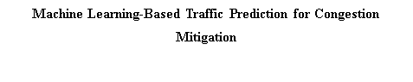

A report submitted in partial fulfilment of the requirements for the degree of

B.Sc. (Hons) Computer Science Specialism in Data Analytics

at Asia Pacific University of Technology and Innovation.

**Supervised by Ms. Hema Krishnan Nair**

**2nd Marker: Assoc. Prof. Dr. Selvakumar Samuel(Mr.)**

**2024**

# 

**DECLARATION OF THESIS CONFIDENTIALITY**

Author’s full name: Lee Wen Ze

IC No./Passport No.: 020202010249

Thesis/Project title: The Title of the Thesis

I declare that this thesis is classified as:

* CONFIDENTIAL
* RESTRICTED
* OPEN ACCESS

I acknowledged that Asia Pacific University of Technology & Innovation (APU) reserves the right as follows:

1. The thesis is the property of Asia Pacific University of Technology & Innovation (APU).

2. The Library of Asia Pacific University of Technology & Innovation (APU) has the right to make copies for the purpose of research only.

3. The Library has the right to make copies of the thesis for academic exchange.

| Author’s Signature: | LeeWenZe |
| --- | --- |
| Date: | 31 March 2024 |
| Supervisor’s Name: | Ms. Hema Krishnan Nair |

Date: 31 March 2024

| Signature: | **HKN** |
| --- | --- |

# Library Form

| First Name: Lee |
| --- |
| Last Name: Wen Ze |
| Title of the Final Year Project / Dissertation / Thesis :  Machine Learning Based Traffic Prediction for Congestion Mitigation |
| Abstract :  Traffic congestion poses significant challenges in urban areas, necessitating effective prediction and management strategies. This project focuses on leveraging machine learning (ML) techniques for traffic prediction to mitigate congestion. By analysing historical traffic data and applying ML algorithms such as Random Forest, LightGBM, Gradient Boosting and Neural Networks, this study aims to develop accurate traffic prediction models. The project includes data preprocessing, feature engineering, model training, evaluation, and deployment in a web-based application. The outcome will provide valuable insights for traffic planners and city administrators to proactively manage and optimise traffic flow, thereby addressing congestion issues. |
| A few keywords associated with the work :  Traffic prediction, Machine learning, Congestion mitigation, Urban transportation, Data analysis |
| General Subject:  Transportation Engineering, Machine Learning, Urban Planning |
| Date of Submission :  24April2024 |

# Acknowledgement

I am deeply grateful to Ms. Hema Krishnan Nair, my project supervisor, for her unwavering guidance throughout the entire process of crafting this research report. In our meetings, her encouragement and invaluable advice played a crucial role, ensuring that my progress stayed on course. The success of this research report stands as a testament to her enduring support.

I also extend my sincere thanks to Dr. Dewi Octaviani, our FYP lecturer, whose clear explanations of tasks and procedures were indispensable. His dedication, evident in patient responses to student inquiries even during late hours, speaks volumes about his commitment as an instructor.

My heartfelt appreciation also goes to my friends who provided unwavering support during challenging moments and late-night work sessions. Their camaraderie made the journey more enjoyable and rewarding.

Lastly, I want to express my deepest gratitude to my parents and family members for their unwavering love, encouragement, and support throughout my academic and extracurricular endeavours. Their belief in me has been a constant source of motivation, propelling me forward in my academic journey.

# Abstract

Traffic is one of the primary challenges faced by almost every urban population. For traffic planners and city administrators, predicting traffic has long been a highly challenging task. With the growth in population and vehicle usage, there's an increasing demand for reliable traffic prediction systems. To enhance the performance of traffic flow prediction, various methods have been proposed, including mathematical modelling, parameter-based approaches, and non-parametric methods. Among these, machine learning-based methods have emerged as prominent solutions due to their ability to capture nonlinear features in traffic data and require less prior knowledge about traffic pattern relationships. Selecting the appropriate ML model is crucial for constructing an effective prediction system, highlighting the importance of understanding different ML methods and their respective strengths and weaknesses.

Keywords: Traffic prediction, Machine learning, Congestion mitigation, Urban transportation, Data analysis

# Table of content

**Library Form 3**

**Acknowledgement 5**

**Abstract 6**

**Table of content 7**

**List of figure 11**

**List of table 15**

**Chapter1: Introduction 16**

1.1 Introduction 16

1.2 Problem Background 17

1.3 Project Aim 18

1.4 Objectives 18

1.5 Scope 18

1.6 Potential Benefit 19

1.6.1 Tangible benefits 19

1.6.2 Intangible benefits 20

1.7 Overview of the FYP 20

1.8 Project Plan 21

**Chapter2: Literature Review 24**

2.1 Domain Research 24

2.1.1 Navigating Traffic Challenges: A Case Study of Kuala Lumpur, Malaysia 24

2.1.2 Machine Learning 25

2.1.3 Overfitting and Underfitting 27

2.1.3 Neural Network 29

2.1.4 Random Forest 30

2.1.5 Gradient Boosting 32

2.1.6 LightGBM 32

2.2 Similar Systems/ Works 33

2.3 Technical Research 35

2.3.1 Identify the hardware / software for the project and justify 35

2.3.1.1 Python 35

2.3.1.2 R Programming 37

2.3.1.3 Python and R Programming comparison 38

2.3.1.4 Reasons for choosing a programming language 39

2.3.2 Interactive Development Environment (IDE) 40

2.3.3 Libraries chosen / Tools chosen 41

2.3.3.1 Numpy and pandas (Data Preprocessing) 41

2.3.3.2 Matplotlib (Data Visualization) 41

2.3.3.3 SkLearn 42

2.3.4 Database Management System chosen 42

2.3.5 Operating System chosen 43

2.4 Summary 44

**Chapter3: Methodology 45**

3.1 Introduction 45

3.2 Methodology 45

3.2.1 Introduction of methodology 45

3.2.1.1 CRISP-DM 45

3.2.1.2 KDD 49

3.2.2 Methodology choice and justification 51

3.2.3 A CRISP-DM Journey towards Efficiency and Sustainability 52

3.2.3.1 Business Understanding 52

3.2.3.2 Data Understanding 53

3.2.3.3 Data Preparation 53

3.2.3.4 Modelling 53

3.2.3.5 Evaluation 53

3.2.3.6 Deployment 54

3.4 Summary 54

**Chapter4: Design And Implementation 55**

4.1 Introduction 55

4.2 Data Collection and Data Understanding 55

4.2.1 Data Collection 55

4.2.2 Data Understanding 55

4.2.2.1 Variables 55

4.2.2.2 Import libraries and dataset 56

4.2.2.3 Exploratory Data Analysis (EDA) 57

4.2.2.3.1 Data type understanding 57

4.2.2.3.2 Missing Values Checking 58

4.2.2.3.3 Duplicate Row Checking 59

4.2.2.3.4 Statistical 60

4.2.2.3.5 Outlier Checking 61

4.2.2.3.6 Traffic Volume Analysis 63

4.2.2.3.7 Weather Description Analysis 64

4.2.2.3.8 Holiday Inconsistency In Record 65

4.2.2.3.9 Data Preprocessing for Improved Visualisation 67

4.2.2.3.10 Traffic Volume in Weekends and Weekdays 69

4.2.2.3.11 Holiday 70

4.2.2.3.12 Weather 73

4.2.2.3.13 Cloud Coverage 74

4.2.2.3.14 Temperature 75

4.3 Data Pre-processing 77

4.3.1 Temporal Feature Enhancement for Improved Model Interpretability 77

4.3.2 Remove Duplicate Rows 78

4.3.3 Handle Outlier 78

4.3.2.1 Temperature Outlier 79

4.3.2.2 Rainfall Outlier 81

4.3.4 Missing Value 82

4.3.5 Label Encoding 83

4.3.4.1 Weather Description 83

4.3.4.2 Snow/ Holiday 85

4.3.4.3 Label Encoding Process 86

4.4 Model Building 87

4.4.1 Short-list Promising Model 87

4.4.2 Models 88

4.4.2.1 Light Gradient-Boosting (LightGBM) 90

4.4.2.2 Random Forest 92

4.4.2.3 Gradient Boosting 94

4.4.2.4 Multilayer Perceptron(MLP) 96

4.5 Summary 98

**Chapter5: Result And Discussion 99**

5.1 Introduction 99

5.2 Model Evaluations and Discussions 99

5.2.1 Light Gradient-Boosting (LightGBM) 100

5.2.2 Random Forest 104

5.2.3 Gradient Boosting 108

5.2.4 Multilayer Perceptron(MLP) 112

5.2.5 Models Comparison 116

5.2.5.1 Evaluation Metrics 117

5.2.5.2 Learning Curve (R2 Score) 118

5.2.5.3 Log Scale Actual Versus Predicted Value 120

5.2.6 Model Selection 121

5.3 Model Deployment 122

5.3.1 Process of the Web Page 122

5.3.1.1 Input Form 123

5.3.1.2 Data Preprocessing 124

5.3.1.3 Model Prediction 124

5.3.1.4 Prediction Result Rendering 125

5.3.2 Testing 126

5.4 Summary 129

**Chapter6: Conclusion 130**

6.1 Critical Evaluation 130

6.2 Limitation 131

6.3 Recommendation 132

**Reference 133**

**Appendix 160**

Appendix A: PPF – Title Registration Proposal 160

Appendix B: Ethics Forms ( Fast Track / Full Track) 171

Appendix C: Log Sheets ( 6 log sheets) 175

Appendix D: Poster 181

Appendix E: Gantt Chart 182

Appendix F: Sources Code 183

# List of figure

| Figure 1: Heavy traffic congestion in Kuala Lumpur | 24 |
| --- | --- |
| Figure 2: Machine learning subtopic | 25 |
| Figure 3: The basic model of machine learning | 26 |
| Figure 4: Underfitting, good fitting and overfitting (simple evaluation) | 27 |
| Figure 5: Underfitting, good fitting and overfitting (advance evaluation) | 28 |
| Figure 6: Neural network concept graph | 29 |
| Figure 7: money and happiness relationship linear graph | 30 |
| Figure 8: Random forest concept graph | 31 |
| Figure 9: Gradient boosted trees for regression | 32 |
| Figure 10: Python (python, 2023) | 35 |
| Figure 11: R programming (Nashine, 2020) | 37 |
| Figure 12: PyCharm (Gasparini, 2021). | 40 |
| Figure 13: Numpy and Pandas (Anello, 2023) | 41 |
| Figure 14: matplotlib (Gupta, 2023) | 41 |
| Figure 15: Scikit learn logo | 42 |
| Figure 16: PostgreSQL | 43 |
| Figure 17: Windows | 44 |
| Figure 18: CRISP-DM process (Hotz, 2023) | 46 |
| Figure 19: Processes search volume result by Google Keyword Planner tools(Hotz, 2023). | 47 |
| Figure 20: KDD process | 49 |
| Figure 21: Imports libraries and reads a CSV file | 56 |
| Figure 22: Displays the first 5 rows of the DataFrame 'df' | 57 |
| Figure 23: data type of each column in data frame | 57 |
| Figure 24: missing values count for each column | 58 |
| Figure 25: duplicate rows in the dataframe | 59 |
| Figure 26: statistical summary for dataframe | 60 |
| Figure 27: Box plot of temperature with outliers | 61 |
| Figure 28: Box plot of rainfall outliers plot | 62 |
| Figure 29: Traffic volume and data time scatter plot | 63 |
| Figure 30: weather description column category frequency code | 64 |
| Figure 31: frequency of weather description by weather main category | 64 |
| Figure 32: display all rows with the same date as the holiday code | 65 |
| Figure 33: display all rows with the same date as the holiday | 66 |
| Figure 34: resample dataframe to hourly intervals code | 67 |
| Figure 35:Weekday and Weekend Extraction from Timestamps code | 68 |
| Figure 36: After resampling examine null sum value | 68 |
| Figure 37: traffic volume trends for weekdays and weekends plot code | 69 |
| Figure 38: Traffic Volume Trends Histogram Plot | 69 |
| Figure 39: The top two plots represent holidays, while the bottom two plots depict normal days. | 71 |
| Figure 40: Average traffic volume by weather main plot | 73 |
| Figure 41: Average traffic volume by cloud coverage bins plot | 75 |
| Figure 42: Average traffic volume by temperature intervals line graph | 76 |
| Figure 43: Temperature outlier specific date time | 79 |
| Figure 44: Handle temperature outlier with specific date time code | 80 |
| Figure 45: Before and after changed in temperature outlier | 81 |
| Figure 46: Before and after change in rainfall outlier | 82 |
| Figure 47: Data Interpolation and Backfilling code | 82 |
| Figure 48: Missing value checked after handled | 83 |
| Figure 49: Weather description category grouping code | 84 |
| Figure 50: Weather description binary group code | 84 |
| Figure 51: Snow and holiday total counts and proportion | 85 |
| Figure 52: Before and after weather binary group | 86 |
| Figure 53: training and testing splitting proportion | 87 |
| Figure 54: R2 Scores of Regression Models | 88 |
| Figure 55: LightGBM Model Evaluation Metrics | 91 |
| Figure 56: LightGBM Top 10 Feature Importance | 92 |
| Figure 57: Random Forest Model Evaluation Metrics | 93 |
| Figure 58: Random Forest top 10 features important | 94 |
| Figure 59: Gradient Boosting model evaluation metrics | 95 |
| Figure 60: Gradient Boosting top 10 features important | 96 |
| Figure 61: MLP evaluation metrics | 97 |
| Figure 62: LightGBM evaluation metrics(Grid Search) | 101 |
| Figure 63: LightGBM Learning Curve | 102 |
| Figure 64: LightGBM actual vs predicted value (log scale) | 103 |
| Figure 65: Random Forest evaluation metrics (Grid Search) | 105 |
| Figure 66: Random Forest Learning Curve | 106 |
| Figure 67: Random Forest actual vs predicted value (log scale) | 107 |
| Figure 68: Gradient Boosting evaluation metrics (Grid Search) | 109 |
| Figure 69: Gradient Boosting Learning Curve | 110 |
| Figure 70: Gradient Boosting actual vs predicted values (log scale) | 111 |
| Figure 71: MLP evaluation metrics (Grid Search) | 113 |
| Figure 72: MLP Learning Curve | 114 |
| Figure 73: MLP actual vs predicted (log scale) | 115 |
| Figure 74: 4 Models evaluation metrics performance plots | 117 |
| Figure 75: 4 Models Learning Curve in R2 Score | 118 |
| Figure 76: 4 Models Actual versus Predicted (log scale) Plot | 120 |
| Figure 77: Traffic Prediction Input Form | 123 |
| Figure 78: Traffic Prediction Result Rendering Page | 125 |
| Figure 79: Testing data show | 127 |
| Figure 80: The traffic volume in the morning is 3720. | 128 |
| Figure 81: The traffic volume in the afternoon is 6082. | 128 |
| Figure 82: The traffic volume in the night is 3286. | 129 |

# List of table

Table 1: Part 1 Project Plan 18

Table 2: Part 2 Project Plan 19

# Chapter1: Introduction

## 1.1 Introduction

Malaysia is undergoing rapid urbanisation, accompanied by a surge in vehicle ownership that has exacerbated traffic problems, leading to frequent accidents and worsening traffic conditions (Chen et al., 2021). To address this, various initiatives are being explored to enhance road network capacity. One such approach involves considering the addition of extra roads or lanes to alleviate traffic congestion. However, studies suggest that simply increasing road capacity may not necessarily alleviate congestion and could even worsen traffic conditions. (Boukerche & Wang, 2020)(Ferreira et al., 2019)

Establishing an efficient and precise traffic management system is crucial in this context. Such a system would not only help optimise traffic resources but also enable proactive measures such as congestion mitigation and improved user experiences. Traffic prediction plays a key role in this endeavour, utilising data from road sensors, traffic cameras, and other sensors to forecast traffic volumes accurately.

Machine Learning (ML) techniques, as part of Artificial Intelligence (AI), are instrumental in developing robust traffic prediction models. ML has emerged as a vital research area in traffic engineering, particularly in the realm of traffic forecasting (S. et al., 2019). Predicting traffic patterns and congestion levels is essential for efficient resource allocation and effective traffic management.

The goal of traffic flow prediction is to provide actionable insights for road users and transportation authorities, enabling informed decision-making to mitigate congestion and improve overall traffic flow. Leveraging advanced data analytics and ML algorithms, traffic prediction models can significantly enhance transportation planning, reduce travel time, and minimise environmental impact.

By integrating cutting-edge technologies and data-driven approaches into traffic management systems, we can work towards creating smarter, more efficient, and sustainable urban environments with improved traffic conditions and enhanced mobility for all.

## 1.2 Problem Background

In Malaysia, urban issues and challenges have become significant constraints to achieving a high quality of life in cities. The increasing population not only demands more job opportunities, housing, and social facilities but also leads to a rise in the number of vehicles on roads and highways (Levkovich et al., 2019). The economic and population growth in Kuala Lumpur has triggered numerous urban transportation problems, such as the increase in private car ownership and traffic congestion.

Private cars have become a predominant mode of transportation in many cities today (Mohammed Naeem Abdulkareem et al., 2020). The number of private cars in Kuala Lumpur is not only higher compared to other cities in Malaysia but also relatively high compared to other developing countries. As mentioned by Shaffi and Musa (2008), continuing to rely heavily on private cars becomes more complex when facing long-term traffic congestion and fatigue.

Kuala Lumpur's public transportation includes buses, light rail transit (LRT), monorail, airport express, and commuter rail. Almselati & Rahmat & Jaafar (2011) note that while public transportation facilities are modernised, they lack service quality. Dissatisfaction with the level and quality of public transportation leads affordable public transport users to shift to private transport modes (*Review of developments in transport in Asia and the pacific, 2021*)

The seemingly simple task of travelling from point A to point B is more complex than most people realise. However, politicians continue to propose building more highways and roads to alleviate congestion, although this is known to be a short-term solution at best. The concept of "induced demand," though not intuitively clear, is no longer exclusive to traffic planning and engineering knowledge. Over time, highways and roads become congested again, leading to a vicious cycle that consumes already saturated urban spaces and gradually encroaches on areas that should have been urban green spaces.

## 1.3 Project Aim

To develop a machine learning-based traffic prediction system using advanced algorithms and data analysis techniques to alleviate traffic congestion issues in urban areas.

## 1.4 Objectives

1. To collect and preprocess relevant traffic data from various sources, including historical traffic patterns, weather conditions, and road infrastructure.
2. To build and train accurate machine learning models, such as Random Forest and LightGBM, to predict traffic volume and congestion levels with high precision.
3. To integrate the developed models into a user-friendly web application that allows real-time input of traffic-related parameters for instant predictions and congestion level assessments.
4. To evaluate the performance of the prediction system through rigorous testing and validation against real-world traffic scenarios, ensuring reliability and effectiveness.

## 1.5 Scope

The project will involve:

* Data collection and preprocessing: Gathering historical traffic data, weather conditions, and road information to create a comprehensive dataset for model training.
* Model development: Building and fine-tuning machine learning models like Random Forest and XGBoost to accurately predict traffic volume and congestion levels.
* Web application development: Creating a user interface where users can input traffic parameters and receive predictions and congestion level assessments.
* Testing and validation: Evaluating the prediction system's performance using test datasets and real-time traffic data to ensure its accuracy and reliability.

Constraints:

* The project scope does not include optimising traffic routes or infrastructure changes; it focuses solely on prediction and assessment.
* Limited to machine learning techniques and data analysis; excludes other non-machine learning approaches to traffic management.
* The project does not involve real-time traffic control or direct interaction with traffic systems; it provides predictive insights for users' awareness and planning purposes.

## 1.6 Potential Benefit

### 1.6.1 Tangible benefits

1. Reduced Fuel Consumption Costs: Predictive traffic volume modelling contributes to a tangible reduction in fuel consumption costs for transportation systems, offering potential financial savings and environmental benefits (Franco González et al., 2021).

2. Improved Traffic Flow: Effective traffic volume prediction and management lead to decreased congestion, resulting in smoother traffic flow and reduced travel times, enhancing overall transportation efficiency (Franco González et al., 2021).

3. Environmental Conservation: Predictive traffic modelling helps optimise vehicle routes, reducing fuel usage and emissions, thereby tangibly contributing to environmental sustainability by lowering greenhouse gas emissions and preserving natural resources (Karimipour et al., 2021).

4. Economic Savings for Transportation Agencies: Transportation agencies benefit from reduced operational costs and improved resource allocation through predictive traffic volume modelling, leading to cost-effective traffic management solutions and financial resilience (Jay Patel et al., 2023).

### 1.6.2 Intangible benefits

1. Public Health Improvement: Mitigating traffic congestion through predictive modelling reduces air pollution and associated health risks, fostering an intangible enhancement in community well-being and creating a safer urban environment (Hantoko et al., 2021).

2. Enhanced Commuter Experience: Efficient traffic volume prediction and management result in smoother travel experiences, reducing stress and frustration among commuters and improving overall satisfaction with transportation services (Rane et al., 2023).

3. Climate Change Mitigation: Optimising traffic volume contributes to climate change mitigation by reducing carbon emissions, aligning with sustainability goals and promoting eco-friendly transportation practices (Damini, 2023).

4. Sustainable Urban Development: Predictive traffic modelling supports sustainable urban development by alleviating congestion, preserving urban spaces, and advocating for transportation systems that prioritise environmental and societal well-being (Damini, 2023).

## 1.7 Overview of the FYP

The final year project (FYP) comprises several essential chapters, each contributing to a comprehensive understanding and execution of the project's objectives. The introduction and problem statement chapter set the groundwork by defining the project's purpose, goals, expected deliverables, and potential benefits. Following this, the literature review and domain research chapter delve into an in-depth exploration of machine learning techniques relevant to the project, along with discussions on similar systems and technical research aligned with the project's direction. The methodology chapter outlines the project management approach within the data science domain, providing a roadmap for implementing the project through structured steps. Subsequently, the design and implementation chapter detail the data collection process, data understanding, preprocessing methods, and actual model building procedures, offering insights into the technical aspects of the project's execution. The results and discussion chapter presents the project's outcomes, including model evaluations using various metrics, analysis of learning curves, discussions on the results, and strategies for model deployment. Finally, the conclusion chapter provides a comprehensive wrap-up, offering critical evaluations of the project's achievements, highlighting limitations, and providing recommendations for future work, thereby concluding the FYP with a thorough examination and synthesis of its outcomes and implications.

## 1.8 Project Plan

Table 1: Part 1 Project Plan

| **Task Name** | **Duration** | **Start Date** | **End Date** | **Status** |
| --- | --- | --- | --- | --- |
| PPF | 10 days | Sept 10, 2023 | Sept 20, 2023 | Done |
| 1.1 Introduction | 1 day | Oct 10, 2023 | Oct 10, 2023 | Done |
| 1.2 Problem Background | 1 day | Oct 11, 2023 | Oct 11, 2023 | Done |
| 1.3 Project Aim and Objectives | 1 day | Oct 12, 2023 | Oct 12, 2023 | Done |
| 1.4 Scope and Potential Benefit | 1 day | Oct 13, 2023 | Oct 13, 2023 | Done |
| 1.7 Overview of the IR | 3 days | Oct 14, 2023 | Oct 16, 2023 | Done |
| 1.8 Project Plan | 2 days | Oct 17, 2023 | Oct 18, 2023 | Done |
| 2.1 Introduction | 2 days | Oct 19, 2023 | Oct 20, 2023 | Done |
| 2.2 Domain Research | 4 days | Oct 21, 2023 | Oct 24, 2023 | Done |
| 2.2 Similar Systems/Works | 3 days | Oct 25, 2023 | Oct 27, 2023 | Done |
| 2.3 Technical Research | 4 days | Oct 28, 2023 | Oct 31, 2023 | Done |
| 2.3.1 Identify hardware/software | 2 days | Nov 1, 2023 | Nov 2, 2023 | Done |
| 2.3.2 IDE Selection and Libraries/Tools | 2 days | Nov 3, 2023 | Nov 4, 2023 | Done |
| 2.3.4 Database Management System | 2 days | Nov 5, 2023 | Nov 6, 2023 | Done |
| 2.3.5 Operating System | 1 day | Nov 7, 2023 | Nov 7, 2023 | Done |
| 2.4 Summary | 2 days | Nov 8, 2023 | Nov 9, 2023 | Done |
| 3.1 Introduction | 1 day | Nov 10, 2023 | Nov 10, 2023 | Done |
| 3.2 Methodology Introduction | 3 days | Nov 11, 2023 | Nov 13, 2023 | Done |
| 3.2.1 Methodology choice | 2 days | Nov 14, 2023 | Nov 15, 2023 | Done |
| 3.2.2 Activities and Process | 3 days | Nov 16, 2023 | Nov 18, 2023 | Done |
| 3.3 Data Collection and Understanding | 2 days | Nov 19, 2023 | Nov 20, 2023 | Done |
| 3.4 Initial Data Pre-processing | 2 days | Nov 21, 2023 | Nov 22, 2023 | Done |
| 3.4 Summary | 1 day | Nov 23, 2023 | Nov 23, 2023 | Done |

Table 2: Part 2 Project Plan

| **Chapter** | **Task** | **Duration** | **Start Date** | **End Date** |
| --- | --- | --- | --- | --- |
| 4 | Design and Implementation |  |  |  |
|  | 4.1 Introduction | 1 day | 11-Mar-24 | 11-Mar-24 |
|  | 4.2 Data Collection | 5 days | 12-Mar-24 | 16-Mar-24 |
|  | 4.3 Data Pre-processing | 6 days | 17-Mar-24 | 22-Mar-24 |
|  | 4.4 Data Understanding | 4 days | 23-Mar-24 | 26-Mar-24 |
|  | 4.5 Model Building | 8 days | 27-Mar-24 | 03-Apr-24 |
|  | 4.6 Summary | 2 days | 04-Apr-24 | 05-Apr-24 |
| 5 | Model Evaluation, Discussion, Deployment |  |  |  |
|  | 5.1 Introduction | 1 day | 06-Apr-24 | 06-Apr-24 |
|  | 5.2 Model Evaluations and Discussions | 6 days | 07-Apr-24 | 12-Apr-24 |
|  | 5.3 Model Deployment | 4 days | 13-Apr-24 | 16-Apr-24 |
|  | 5.4 Summary | 2 days | 17-Apr-24 | 18-Apr-24 |
| 6 | Conclusion |  |  |  |
|  | 6.1 Critical Evaluation | 1 day | 19-Apr-24 | 19-Apr-24 |
|  | 6.2 Limitation | 1 day | 20-Apr-24 | 20-Apr-24 |
|  | 6.3 Recommendation | 1 day | 21-Apr-24 | 21-Apr-24 |

# Chapter2: Literature Review

## 2.1 Domain Research

### 2.1.1 Navigating Traffic Challenges: A Case Study of Kuala Lumpur, Malaysia

Road transportation is a fundamental necessity that brings about numerous benefits for both individuals and nations (Infra Growth 99, 2019). However, the rise in private vehicle usage has led to significant issues with traffic congestion. Traffic jams, characterised by vehicles moving at speeds below optimal levels, result in longer queues and increased travel times (Anupriya et al., 2023). While traffic congestion itself is not inherently dangerous, unlike speeding which is a major cause of accidents resulting in injuries or fatalities, it does slow down vehicle movement, thereby reducing the risk of high-speed collisions for drivers navigating through congested areas.

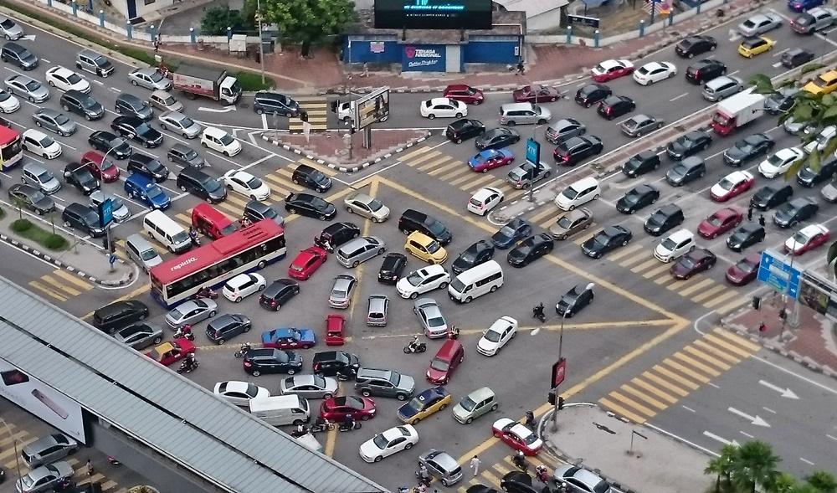

Figure 1*: Heavy traffic congestion in Kuala Lumpur*

In Malaysia, particularly in Kuala Lumpur, the largest urban area in the region, urban development is heavily influenced by factors such as population growth and the increasing demand for land. As a result, Kuala Lumpur ranks 77th globally among the most congested cities and holds the top position for congestion among all states in Malaysia (SD Reporter, 2024).

The impact of traffic congestion extends beyond mere inconvenience, affecting various aspects of daily life and urban functionality. In Kuala Lumpur, a city characterised by rapid urbanisation and economic growth, traffic congestion poses significant challenges to transportation efficiency, environmental sustainability, and overall quality of life.

### 2.1.2 Machine Learning

Machine Learning (ML) is a vital approach in artificial intelligence, enabling automated knowledge acquisition (Mathur, 2023). In contrast to traditional intelligent systems lacking learning capabilities, ML systems promptly correct errors, autonomously acquire needed knowledge, and have inductive reasoning to discover new theorems and rules. Unlike systems limited to deductive reasoning, ML systems enhance their performance through the accumulation of experience, marking a significant advancement in the field of artificial intelligence research (Teng & Gong, 2018).

**

Figure 2*: Machine learning subtopic*

In the view of AI expert Herbert A. Simon, learning involves the strengthening or enhancement of a system's capabilities through repetitive tasks, enabling it to perform similar tasks more effectively in the future. ML stands out as a vital method for computers to acquire knowledge and serves as a key metric in the field of artificial intelligence. ML is a discipline focused on exploring how computers can simulate or execute activities related to human learning (Teng & Gong, 2018)(P. Sethi, 2022).

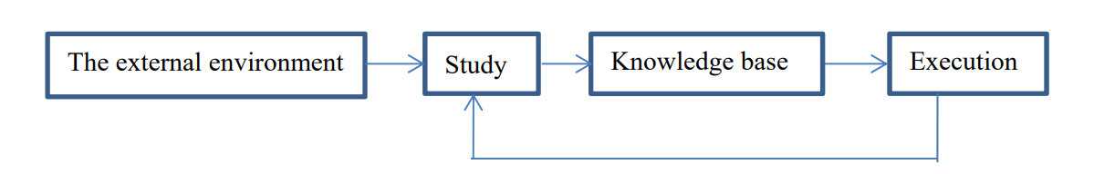

Figure 3*: The basic model of machine learning*

In accordance with H. Simon's definition of learning, can establish the foundational model depicted in Figure. The external environment represents a collection of external information expressed in a certain form, serving as the source of this information. Learning involves the transformation of external information into knowledge. Initially, information is obtained from the environment, processed into knowledge, and then stored in the knowledge base. The knowledge base contains general principles for execution. The execution phase entails using the knowledge stored in the knowledge base to accomplish tasks, with feedback on information gained during the task guiding subsequent learning processes (Teng & Gong, 2018).

Machine Learning offers the advantage of effortlessly identifying trends and patterns by scrutinising large datasets (Team, 2018). For instance, in e-commerce platforms like Amazon, it can analyse user browsing behaviour and purchase history, providing personalised product recommendations, promotions, and reminders. This enables the system to display relevant advertisements to users, showcasing the adaptability of machine learning in recognizing specific trends and patterns that might be overlooked by humans (Team, 2018).

One notable challenge in machine learning continues to be the acquisition of data. Although machine learning relies extensively on extensive and varied datasets for training and precise predictions, obtaining high-quality data can be intricate and resource-intensive. The process of data acquisition involves addressing privacy concerns, performing data cleaning, and ensuring the representativeness of the data, particularly in domains with limited or sensitive data (Pavan Vadapalli, 2023).

### 2.1.3 Overfitting and Underfitting

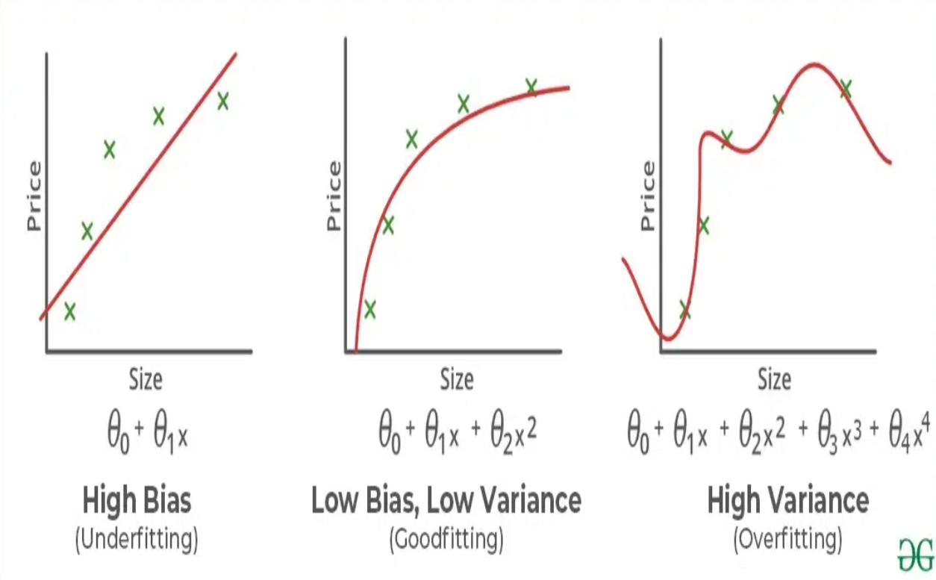

Figure 4*: Underfitting, good fitting and overfitting (simple evaluation)*

Bias: Bias refers to the error in a learning algorithm caused by overly simplistic assumptions. These assumptions make the model easier to understand and learn but may fail to capture the underlying complexity of the data. Bias arises when the model cannot accurately represent the true relationship between inputs and outputs. If a model performs poorly on both training and testing data, it indicates high bias due to underfitting.

Variance: On the other hand, variance is the error caused by the model's sensitivity to fluctuations in the training data. It reflects the variability in predictions of the model for different instances of the training data. High variance occurs when the model learns the noise and random fluctuations in the training data instead of the underlying patterns. Consequently, the model performs well on the training data but poorly on the testing data, indicating overfitting.

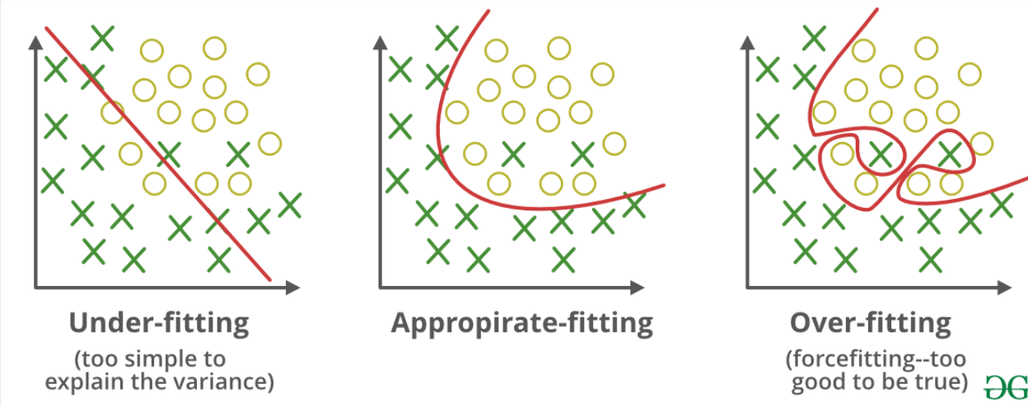

Figure 5*: Underfitting, good fitting and overfitting (advance evaluation)*

Underfitting in Machine Learning occurs when a statistical model or machine learning algorithm is too simplistic to capture the complexity of the data, resulting in poor performance on both training and testing data. This situation arises when the model fails to effectively learn from the training data due to its oversimplified nature, leading to inaccurate predictions, especially on unseen examples. To address underfitting, it's essential to employ more complex models, enhance feature representation, and reduce regularisation to ensure a better fit to the data.

Overfitting in Machine Learning occurs when a model performs exceptionally well on training data but fails to generalise to unseen data, leading to poor performance on testing data. This phenomenon often happens when a model learns from noise and irrelevant details in the training data, causing it to capture the data's idiosyncrasies rather than the underlying patterns. Non-parametric and non-linear methods are particularly prone to overfitting due to their flexibility in modelling complex relationships. To mitigate overfitting, it's crucial to use regularisation techniques, such as setting appropriate hyperparameters or using simpler models if the dataset is small, to prevent the model from fitting noise instead of learning the actual patterns in the data.

### 2.1.3 Neural Network

Artificial Neural Networks (ANNs) are artificial adaptive systems inspired by the functional processes of the human brain (Cybiant, 2021). They are systems capable of modifying their internal structure based on functional objectives. ANNs are particularly suitable for addressing nonlinear problems, as they can reconstruct the optimal solutions to these problems through fuzzy rules.

The basic elements of an ANN are nodes (also known as processing elements or PEs) and connections. Each node has its own input, receiving communication from other nodes and/or the environment, and its own output, communicating with other nodes or the environment. Finally, each node has a function F through which it transforms its global input into output. The characteristic of each connection lies in the strength of the node being excited or inhibited. Positive values represent excitatory connections, while negative values represent inhibitory connections (Vito Paolo Pastore et al., 2018).

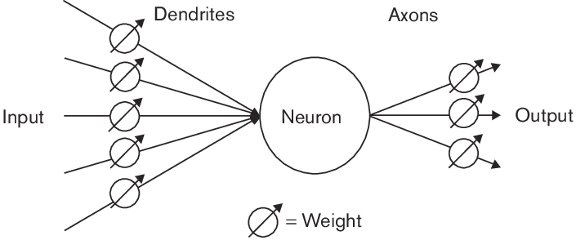

Figure 6*6: Neural network concept graph*

Artificial Neural Networks possess a high capability for pattern recognition, which is necessary for pattern recognition and decision-making, making them powerful classifiers capable of generalising and making decisions based on a large amount of sometimes fuzzy input data. They excel particularly in modelling mechanisms for solving nonlinear problems.

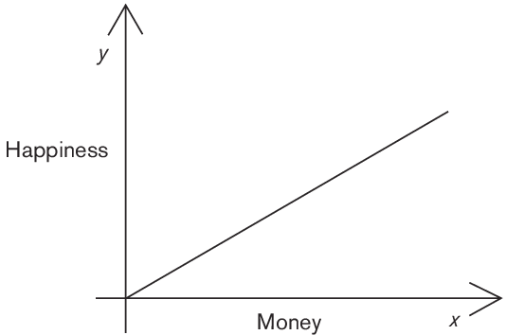

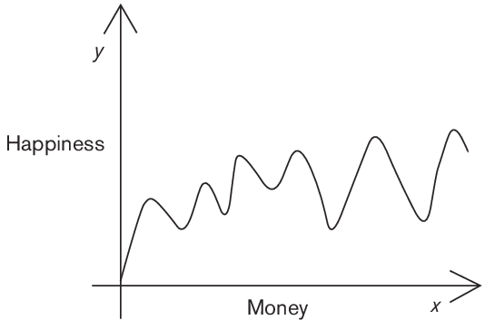

Figure 7*: money and happiness relationship linear graph*

In a real-world context, the relationship between income and happiness is often more complex than initially perceived, as shown in Figure 7. An increase in income can sometimes lead to fear of financial loss or uncertainty about investment decisions, ultimately reducing overall happiness. The complex relationship depicted in Figure 4 underscores the limitations of understanding the money-happiness relationship solely through experimental data. In such cases, using Artificial Neural Networks to precisely define the relationship between income and happiness becomes meaningful.

### 2.1.4 Random Forest

The Random Forest algorithm stands out as a potent tree-based learning method in machine learning. Its core concept involves generating numerous decision trees during the training phase. Each tree is crafted using a random subset of the dataset to evaluate a randomised subset of features within each segment. This inherent randomness injects diversity among individual trees, mitigating the risk of overfitting and enhancing overall predictive capability (R, 2021). During prediction, the algorithm aggregates outcomes from all trees via voting (for classification tasks) or averaging (for regression tasks). This collaborative decision-making process, backed by multiple trees and their insights, yields consistent and precise predictions. Random Forests are widely esteemed for their proficiency in handling complex data, curbing overfitting, and delivering reliable forecasts across diverse scenarios.

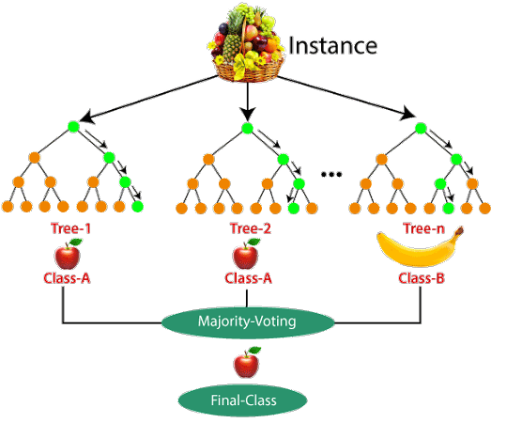

Figure 8*: Random forest concept graph*

Ensemble learning models operate akin to a diverse group of experts pooling their strengths to make informed decisions—imagine them as a team of friends with varied expertise working together to tackle a challenge. Picture them as a team of friends with distinct skills collaborating on a project. Each friend excels in a specific area, and by synergizing their strengths, they formulate a more robust solution than any individual could devise independently.

Bagging represents an ensemble learning approach where multiple models are trained on distinct subsets of the training data. Each subset undergoes sampling with replacement, and predictions are then averaged for regression tasks or determined by majority vote for classification tasks.

### 2.1.5 Gradient Boosting

Gradient boosting stands out as a popular and robust algorithm in machine learning, catering to both classification and regression tasks. It operates within the framework of boosting, an ensemble learning technique where models are trained sequentially to rectify the errors of their predecessors. Through this iterative process, gradient boosting amalgamates numerous weak learners into a formidable one.

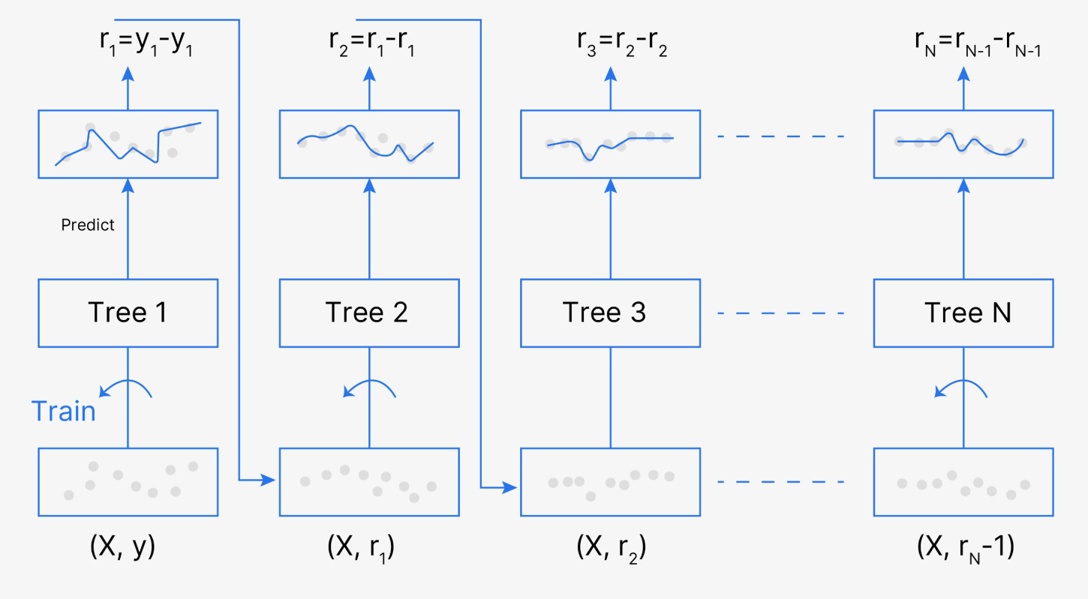

Figure 9*: Gradient boosted trees for regression*

This algorithm's strength lies in its approach to training each new model by minimising the loss function inherited from previous models, employing techniques like gradient descent with metrics such as mean squared error or cross-entropy. At each step, it computes the gradient of the loss function concerning the current ensemble's predictions, training a new weak model to diminish this gradient. Subsequently, the new model's predictions are integrated into the ensemble, iterating until a predefined stopping criterion is met.

### 2.1.6 LightGBM

LightGBM stands out as an open-source, distributed, and high-performance gradient boosting framework crafted by Microsoft. Its design focuses on elevating efficiency, scalability, and accuracy in machine learning endeavours. Rooted in decision trees, LightGBM prioritises optimising model efficiency while minimising memory consumption. It integrates cutting-edge techniques such as Gradient-based One-Side Sampling (GOSS), strategically retaining instances with significant gradients during training to streamline memory usage and training duration. Moreover, LightGBM implements histogram-based algorithms to streamline tree construction, alongside optimizations like leaf-wise tree growth and efficient data storage formats (GfG, 2020). These innovations collectively elevate LightGBM's efficiency, positioning it competitively among other gradient boosting frameworks.

## 2.2 Similar Systems/ Works

This section provides an overview of relevant research articles on traffic prediction, discussing their different perspectives and methods briefly. Frangopol et al. (2004) conducted a comprehensive survey on traditional short-term traffic forecasting methods and their applications. A decade later, the same authors discussed the ten major challenges of newly developed short-term traffic flow prediction methods (Frangopol et al., 2014). Later, Barros et al. (2015) explored data-driven and model-driven short-term traffic flow prediction methods to highlight their capabilities. Li and Shahabi (2018) reviewed several short-term traffic forecasting techniques and proposed some potential future research directions.

Additionally, Naghi and Simeon (2018) summarised data resources and outlined existing machine learning (ML) traffic prediction methods. In the same year, El Maghnouji and Leung (2018) conducted a comprehensive survey and reviewed long-term traffic prediction literature to identify key spatial components and their roles in traffic prediction. They also proposed possible future research directions to improve long-term traffic prediction. Furthermore, Angelita-Sapata et al. (2019) proposed a new classification based on ML modelling and traffic specifications for classifying traffic prediction regression problems, focusing on core features that may change the modelling complexity of traffic prediction regression problems.

Moreover, Bushke and Wang (2020a) and Lana et al. (2018) reviewed models using classical methods and some early deep learning methods. Other related surveys attempted to elucidate how different deep learning models can be utilised in various traffic applications, including Wang et al. (2019) and Zu et al. (2019). Recently, Ahtharal and Moreedpur (2021) compared several popular machine learning techniques for predicting traffic congestion. They also reviewed recurrent neural networks, convolutional neural networks, and feedforward neural network models for traffic prediction (Tijo et al., 2020). In contrast, Ye et al. (2020) focused on outlining graph-based deep learning architectures from the literature, emphasising applications in the general traffic domain.

In recent years, with the continuous advancement of intelligent transportation systems and autonomous driving technologies, efforts have been made to explore and design traffic prediction methods focusing on autonomous driving environments. Ruan et al. (2018) not only reviewed recent deep learning research in traffic data processing, such as traffic network representation, traffic flow prediction, traffic signal control, automatic vehicle detection, traffic event handling, and travel demand prediction but also emphasised the effectiveness and impact of deep learning.

Challenges in traffic prediction due to autonomous driving and driver behaviour are addressed. In Kumar and Sahai (2020), the authors reviewed some recent traffic prediction research in the context of autonomous driving applications. They also provided a comprehensive survey of deep learning applications in autonomous vehicle traffic prediction and practical methods. Meglani and Kumar (2019) highlighted major challenges that remain unsolved in this area to guide future research.

While there are many relevant surveys on traffic prediction, they often focus on specific technical domains or subsets of methods due to the density of methods in the literature. Additionally, not all surveys connect the latest advancements with practical applications and future research directions. Moreover, these surveys are also divided into different disciplinary journals and publication venues, making it challenging for readers to assess the status quo of traffic prediction methods comprehensively. As the literature continues to diversify and span across disciplines, there is a need for a comprehensive review of the literature. Therefore, the primary contribution of this survey is a holistic and extensive review of existing traffic prediction literature, emphasising the latest advancements and emerging research opportunities in AI-based traffic prediction methods.

## 2.3 Technical Research

### 2.3.1 Identify the hardware / software for the project and justify

#### 2.3.1.1 Python

Python programming language originated in the late 1980s through the efforts of Dutch programmer Guido van Rossum. It earned its name, Python, inspired by the British comedy ensemble Monty Python. Python stands out as an interpreted, object-oriented high-level programming language, renowned for its elegance and simplicity, making it one of the most popular programming languages in use today (Ivey, 2023).



Figure 10*: Python (python, 2023)*

Python serves as a versatile programming language, finding applications across a broad spectrum, commonly employed in web development, data analysis, scientific computing, and machine learning. In fact, many of the world's most popular websites, such as Instagram and Reddit, are constructed using Python (Malaysia GA, 2023).

The following provides an in-depth exploration of the attributes and features of the Python programming language:

* Easy to learn - Python stands out as a language that is effortlessly graspable. Positioned as a high-level language, it caters to easy readability and understanding for both humans and computers. With a syntax resembling English and minimal syntactic rules, Python offers an exceptionally smooth learning curve and user-friendly experience (Dhameja, 2023).
* Python standard library - Python is the top choice for developers due to its ease of learning, powerful third-party tools, and an extensive standard library. With valuable packages for various needs, Python makes project development quick and seamless (Dhameja, 2023).
* GUI programming - Python GUI programming is a highly potent development tool that empowers developers to create interactive user interfaces. It combines interactivity and aesthetics, making it an excellent choice for swiftly developing intricate UIs in rapid projects and prototypes (Dhameja, 2023).
* Database - Database in Python is robust and flexible, offering diverse options for development. Whether serving as the backbone for a complete database or streamlining operations in large databases, Python's database capabilities are extensive. Its scalability ensures efficient handling of large datasets without compromising performance (Dhameja, 2023).

Despite the numerous advantages of Python, the programming language does have some drawbacks. These are outlined below:

* Performance and Speed - Python's interpreted nature, executed at runtime by a virtual machine or interpreter, makes it slower and less efficient than compiled languages like C or C++. Not ideal for high-performance applications such as video games (Tabish, 2023).
* Memory Management - Python uses a garbage collector for automated memory management, simplifying code maintenance. However, improper use can lead to inefficiency and slower speeds (Tabish, 2023).
* Dynamic Typing - Python's dynamic typing allows flexibility in assigning values to variables without specifying a fixed type. Although convenient, it can make error detection during compilation more challenging (Tabish, 2023).

#### 2.3.1.2 R Programming

R, born in 1991 at the University of Auckland through the collaborative efforts of Ross Ihaka and Robert Gentleman, draws its name from the initial characters of its creators (kumar, 2020).

**

Figure 11*: R programming (Nashine, 2020)*

R stands out as a powerful programming language extensively utilised in the field of data science. Initially designed for statistical computation and graphics, R has evolved to offer robust frameworks, enabling the swift and efficient implementation of machine learning and deep learning algorithms (kumar, 2020).

The following provides an in-depth exploration of the attributes and features of the R programming language:

* Machine learning - R excels in performing diverse machine learning tasks like classification and regression. With a range of packages and functions, it's a top choice for creating artificial neural networks, making it a staple for the world's leading data scientists *(Nashine, 2020)*.
* Statistics - R is widely acclaimed for its statistical prowess, making it a standout choice for statistical tool development over other programming languages *(Nashine, 2020).*
* Data gathering - R is a powerful tool for data professionals facing the recurring challenge of gathering data from multiple sources. With robust packages, R can import data from various sources, including relational databases, NoSQL databases, websites, social media, and more (kumar, 2020).

Despite the numerous advantages of R programming, the programming language does have some drawbacks. These are outlined below:

* Challenges language - R can be challenging for beginners due to its steep learning curve, especially for those without prior programming experience (Team, 2021).
* Algorithm Implementation Challenges - Algorithm implementation in R can be challenging for programmers who are not familiar with the distribution of algorithms across different packages (Team, 2021).
* Data Processing Limitations - Handling large datasets in R can be challenging due to its requirement to store all data in a single location within the physical memory. This limitation can be a drawback when dealing with extensive data (Team, 2021).

#### 2.3.1.3 Python and R Programming comparison

1. Beginner's Perspective on Programming Ease: Python's straightforward syntax, resembling English, makes it an ideal language for beginners, ensuring a smooth learning curve. In contrast, R, designed for quick basic data analysis, becomes more challenging with complex tasks, demanding additional time for mastery. In essence, Python is considered user-friendly for novices, while R's complexity hinders swift expertise development (Luna, 2022).

2. Tailoring Programming Choices to User Profiles - Python is the preferred programming language for software developers entering the field of data science due to its versatility and user-friendly nature. It caters to a broad audience, making it accessible for both beginners and seasoned developers with its intuitive syntax. Python's emphasis on productivity positions it as an ideal tool for building complex applications. On the other hand, R is widely used in academia and specific industries like finance and pharmaceuticals, serving as an excellent language for statisticians and researchers with limited programming skills (Luna, 2022).

3. Speed and Performance - Python excels in speed and performance due to its simple syntax, making it the preferred choice for building critical and fast applications. Its concise code leads to shorter execution times. In contrast, R, being a low-level programming language, demands longer code, resulting in slower execution speeds even for basic processes. Therefore, Python's simplicity contributes to faster and more efficient code execution compared to R.

#### 2.3.1.4 Reasons for choosing a programming language

Choosing Python as the programming language for your smart waste route optimization system in a website setting is a strategic decision based on various factors. Python's simplicity, versatility, and extensive libraries align well with the project's requirements. I appreciate Python's intuitive syntax and readability, which not only accelerates development but also facilitates collaboration among team members. The language's high-level nature and popularity contribute to a robust ecosystem, ensuring ample resources for our needs.

The speed and performance benefits of Python are particularly appealing for real-time optimization tasks in the waste route system. Python's efficiency in code execution is crucial for delivering a responsive and dynamic web-based application, enhancing the overall user experience. Additionally, Python's compatibility with web development technologies positions it as an excellent choice for seamless integration into a website.

Furthermore, Python's prevalence in the web development community provides a solid foundation for our project. Leveraging Python's strengths, such as its compatibility with web frameworks, will streamline the development process and contribute to the creation of an intuitive and user-friendly interface. This decision reflects a forward-looking approach, addressing potential limitations associated with other languages like R, and ensuring the success and efficiency of our smart waste route optimization system on a website platform.

### 2.3.2 Interactive Development Environment (IDE)

An Integrated Development Environment (IDE) is a tool that combines editors and compilers for writing and compiling programs. It simplifies the development process by offering essential features such as text editors, project organisation, and efficient error detection. The colour-coded distinctions help differentiate classes and methods, and IDEs provide automatic completion for predicting intended keywords in case of errors (Intellipaat, 2023).



Figure 12*: PyCharm (Gasparini, 2021).*

PyCharm, crafted by JetBrains, serves as an integrated development environment (IDE) tailored for Python development and is embraced by tech giants like Twitter and Facebook. Boasting a smart code editor with colour-coded keywords, classes, and functions, enhances code quality, readability, and error identification. Offering features like automatic code completion and easy code navigation, PyCharm streamlines the coding process, ensuring efficient editing and debugging (Intellipaat, 2023).

In this project I selected PyCharm. The reason is PyCharm seamlessly supports various web technologies, aiding developers in crafting web applications using Python, including popular web technologies like HTML, CSS, and JavaScript. It facilitates real-time editing, previews of web pages, and integrates smoothly with Python web frameworks such as Django, providing auto-completion for Django parameters and robust debugging support. Moreover, for Python scientific libraries like Matplotlib, NumPy, and Anaconda, PyCharm proves invaluable in building data science and machine learning projects, featuring interactive charts and seamless integration with tools like IPython, Django, and Pytest, fostering innovative solutions (Intellipaat, 2023).

### 2.3.3 Libraries chosen / Tools chosen

In the development of the Smart Waste Route Optimization website, several key libraries will play pivotal roles in enhancing functionality and efficiency:

#### 2.3.3.1 Numpy and pandas (Data Preprocessing)

**

Figure 13*: Numpy and Pandas (Anello, 2023)*

NumPy, or Numerical Python, is the backbone for efficient array and matrix computations in machine learning, offering a versatile array object with extensive mathematical functions. Pandas, built on NumPy, excels in data manipulation, featuring Series and DataFrame structures. Series represents a sequence of values, and DataFrame is a table with rows and columns, with Pandas supporting diverse file formats like CSV, Excel, JSON, and Parquet for seamless data handling (Anello, 2023).

#### 2.3.3.2 Matplotlib (Data Visualization)

**

Figure 14*: matplotlib (Gupta, 2023)*

Matplotlib is an open-source plotting library widely used for creating various types of plots with minimal code. It allows the generation of plots, histograms, bar charts, and other visualisations using just a few lines of code. Matplotlib finds applications in web application servers, shells, and Python scripts, making it a versatile tool for data visualisation (Gupta, 2023).

#### 2.3.3.3 SkLearn



Figure 15: Scikit learn logo

Scikit-learn, known as sklearn, is a Python library used for machine learning tasks. It's designed to be user-friendly and efficient, offering a range of algorithms for tasks like regression, classification, clustering, and more. Sklearn simplifies working with machine learning models, making it easier to build, train, and evaluate them without needing to write complex code from scratch.

### 2.3.4 Database Management System chosen

A Database Management System (DBMS) is a software system designed to organise and manage data in a structured manner. It empowers users to create, modify, and query databases while overseeing security and access control. Databases are collections of interrelated data, facilitating efficient retrieval, insertion, and deletion of data in various forms such as tables, views, schemas, and reports (GeeksOfGeeks, 2023). In the context of a smart waste route optimization website, a DBMS would enable the seamless organisation and retrieval of data related to waste collection routes, optimising the efficiency of the system.

In selecting PostgreSQL as the Database Management System (DBMS) for this project, I prioritise its open-source nature, known reliability, and flexibility.

**

Figure 16*: PostgreSQL*

PostgreSQL is renowned for its capability to handle both relational and non-relational data types, providing a robust foundation for storing and managing complex datasets. The support for open technology standards ensures compatibility and ease of integration with various tools and frameworks (IBM, n.d.).

Moreover, PostgreSQL's extensibility and feature-rich ecosystem make it well-suited for the dynamic requirements of this project. Its scalability allows for efficient handling of increasing data volumes, and the array of extensions available enables advanced functionalities, such as geospatial analysis and time-series data management (IBM, n.d.). The decision to use PostgreSQL is rooted in its proven track record and adaptability, ensuring a solid and future-proof foundation for the development of the smart waste route optimization system.

### 2.3.5 Operating System chosen

The choice of using Windows as the operating system for this project stems from the familiarity and user-friendly nature of the platform.

**

Figure 17*: Windows*

The following provides an in-depth exploration of the attributes and features of the Windows:

* Easy to Use - Windows stands out for its user-friendly graphical interface, making it accessible even for those with basic computer knowledge. Its consistent features across versions ensure a smooth experience, and the visual changes don't disrupt the overall functionality. This simplicity is a key reason why Windows users tend to stick with this operating system and are less inclined to explore alternatives (Roomi, 2022).
* Software Compatibility - Windows stands out for its widespread compatibility with a variety of applications available on the internet. From video players and browsers to photo and video editing tools, there's a rich selection that seamlessly integrates with the Windows operating system. Notably, the Microsoft Office suite is exclusively designed for Windows, offering users a comprehensive set of tools tailored to this platform (Roomi, 2022).

## 2.4 Summary

In this section, I've undertaken a detailed comparison between two programming languages, aiming to make well-informed decisions for my project concerning development methods, tools, and, notably, the database system. Following the comparison, my choice for the most suitable language for the project is Python. Additionally, I've curated a selection of tools and libraries in this chapter to optimise and enhance the development process.

# Chapter3: Methodology

## 3.1 Introduction

Effective project management is paramount when embarking on a significant data science project. A well-defined project lifecycle serves as the backbone, preventing potential disasters that may arise from vague or poorly planned strategies. Companies seek robust workflow plans to ensure the efficient execution of projects, and a clear understanding of the overall process facilitates seamless collaboration among team members, allowing for effective division of tasks (Kumar, 2022).

However, the primary challenge in achieving success with a data science project lies not in the technical aspects but in the execution of the project's processes. Many data science projects are noted for not leveraging well-defined methodologies, leading to a lack of coordination and collaboration (Lahiri & Saltz, 2023). This, in turn, becomes a significant challenge, often resulting in the failure of data science initiatives.

## 3.2 Methodology

### 3.2.1 Introduction of methodology

#### 3.2.1.1 CRISP-DM

To ensure the success of a data science project, having a reliable and reproducible process is crucial, particularly one that is accessible to those with limited data science expertise (Luna, 2022). Enter CRISP-DM—a versatile methodology that serves as a template to systematically address various aspects specific to a project. Debuting in 1999, CRISP-DM aims to standardise the data mining process across industries, evolving into one of the most widely embraced methodologies for data mining, analysis, and data science projects (Hotz, 2023). By integrating a loosely implemented CRISP-DM with agile project management tailored for teamwork, data science teams can optimise their outcomes (Hotz, 2023).

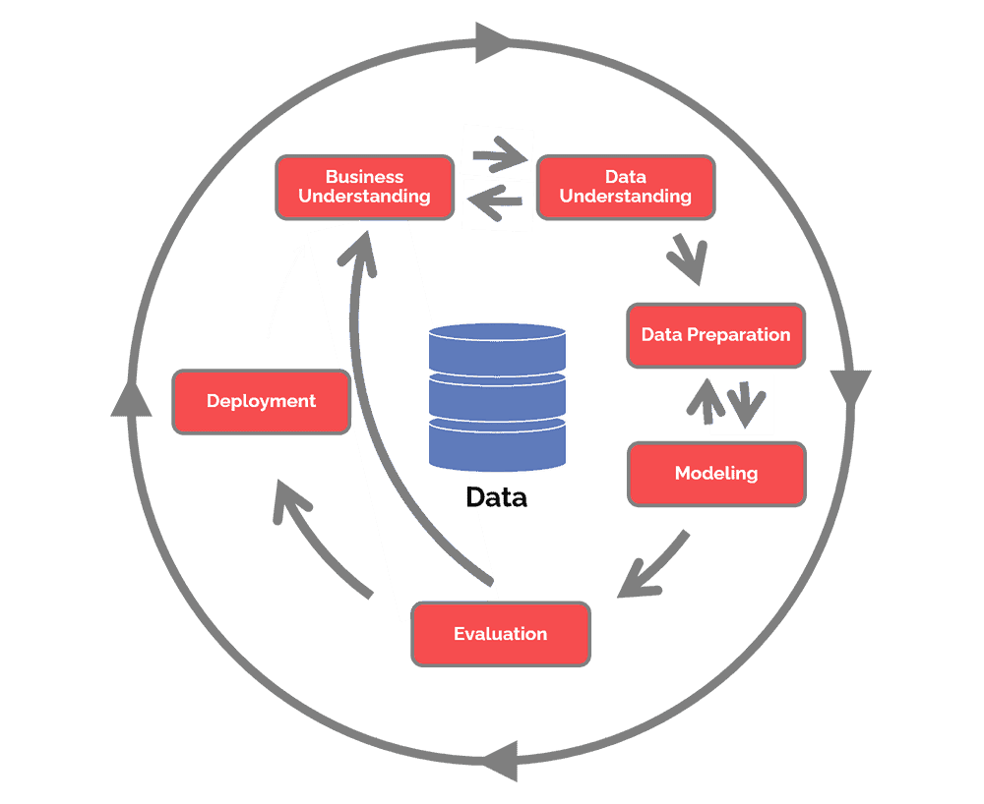

Figure 18*: CRISP-DM process (Hotz, 2023)*

Here are the steps typically undertaken in the CRISP-DM method:

1. Business Understanding: The focus is on grasping the tasks from a business standpoint. It is vital to balance competing goals and constraints within your organisation. The objective is to identify key factors that could influence project outcomes, as neglecting this step may lead to solving the wrong problems (SV-Europe, 2020).
2. Data Understanding: The focus is on acquiring the data listed in the project resources. This involves initial collection and potentially loading data into specific tools for analysis. Integration strategies need consideration when dealing with multiple data sources. A report should be generated, detailing obtained data sources, locations, acquisition methods, and any encountered issues. This documentation assists in replicating the project in the future and executing similar projects (SV-Europe, 2020).
3. Data Preparation: The focus is on deciding which data to use for analysis. This decision is based on factors like the data's relevance to mining goals, its quality, and technical constraints such as volume or type limitations. It involves choosing both specific attributes (columns) and records (rows). Clearly state the reasons for including or excluding particular data and outline the considerations guiding these decisions (SV-Europe, 2020).
4. Modelling: The initial step is to choose the appropriate techniques and apply modelling tools to the prepared dataset, creating one or more models. The subsequent evaluation involves assessing factors such as model accuracy and generalizability (SV-Europe, 2020).
5. Evaluation: In the Evaluation phase, gauge how well the model aligns with your business goals and investigate potential business-related factors contributing to any model shortcomings (SV-Europe, 2020).
6. Deployment: Gather evaluation results and formulate a deployment strategy. Considering deployment methods and means during the Business Understanding phase is crucial, as successful deployment is essential for the project's overall success. This is where predictive analytics plays a vital role in enhancing business operations (SV-Europe, 2020).

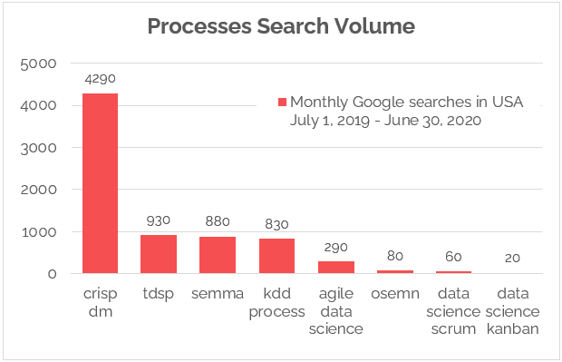

Figure 19*: Processes search volume result by Google Keyword Planner tools(Hotz, 2023).*

The figure above indicates that the search volume for "Processes" on Google Keyword Planner tools is statistically higher for CRISP-DM compared to other methodologies on average each month *(Hotz, 2023).*

Advantages of the CRISP-DM Methodology:

* Cross-Industry Standard: CRISP-DM is recognized as a cross-industry standard, providing a versatile methodology that can be implemented in various data science projects, ensuring its applicability across different domains and industries (Think Insights, 2023) .
* Business-Focused Approach: The framework encourages data miners to focus on business goals, ensuring that the project outputs align with and contribute to tangible benefits for the organisation (James Taylor., 2017) .
* Iterative and Flexible: CRISP-DM allows for a flexible and iterative approach, enabling users to cycle through its stages to gain deeper insights into data and issues, fostering adaptability to changing project requirements (Zavgorodniy, A., 2018) .
* Clear Project Phases: The methodology breaks down the project into well-defined phases, providing a structured and organised approach to data science projects, which facilitates better project management (Mukesh Kumar, 2022).

Disadvantages of the CRISP-DM Methodology:

* Limited Project Management Activities: CRISP-DM lacks comprehensive project management activities, potentially leading to challenges in managing and coordinating complex data science projects (Chatterjee T.K., 2022).
* Potential Flaws in Quick Iteration: Some critics argue that CRISP-DM shares flaws with the Waterfall process, hindering quick iteration and responsiveness to changing project needs (Mukesh Kumar, 2022).
* Insufficient Consideration of Quick Wins: The model may not emphasise enough the importance of delivering quick wins in the early stages of a project, potentially affecting stakeholder engagement and project momentum (Zavgorodniy, A., 2018) .

#### 3.2.1.2 KDD

KDD, short for Knowledge Discovery in Databases, is a method to extract meaningful data and patterns from raw databases. It involves steps like searching, transforming, and refining information for diverse applications. Think of it like exploring a riverbed filled with stones and artefacts. In this analogy, being a craft enthusiast or adventurer, you collect items like stones and shells. However, to prepare these findings for use, there's a need to clean and categorise them (Sharma, 2020). This process may iterate based on your needs, leading to a refined and specific set of knowledge.

In the data science realm, this is akin to collecting and transforming data. It's about recognizing patterns and refining information for efficient problem-solving. Imagine finding the most valuable stones or artefacts by learning where they are located and how they can be best utilised for your specific goals(Sharma, 2020). This iterative and purpose-driven approach in knowledge discovery contributes to effective data analysis and decision-making.

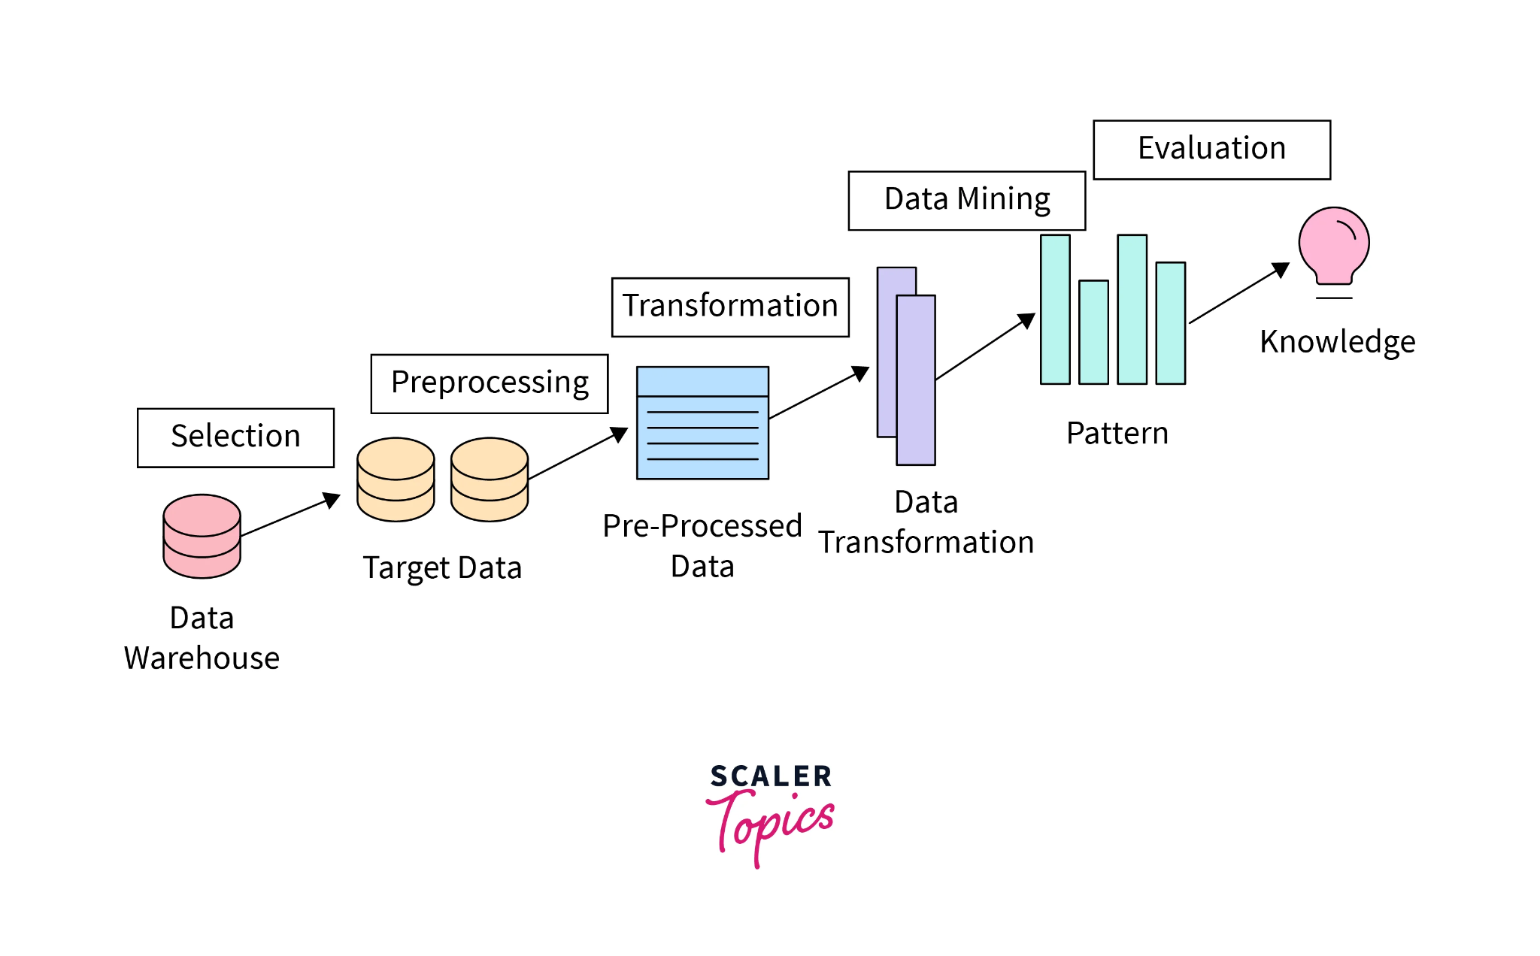

Figure 20*: KDD process*

Here are the steps typically undertaken in the KDD method:

1. Goal-Setting and Application Understanding: The KDD process starts by defining goals and understanding the application. This initial step involves setting clear objectives for what knowledge is sought and how it will be applied in a specific context *(Jodha, 2023)*.
2. Data Selection and Integration: Once goals are set, relevant data is selected and integrated. This step ensures that the chosen data sources align with the objectives of the knowledge discovery process *(Jodha, 2023)*.
3. Data Cleaning: To enhance the quality of data, a crucial step involves cleaning pout inconsistencies and errors. This ensures that the subsequent analysis is based on reliable and accurate information *(Jodha, 2023)*.
4. Pattern Discovery: In this phase, the focus is on uncovering patterns within the data. Various techniques are employed to identify relationships, trends, and valuable insights that contribute to knowledge discovery (GeeksOfGeeks, 2023).
5. Knowledge Representation: The discovered patterns are then represented in a form that is understandable and useful. This step involves transforming the identified knowledge into a format suitable for interpretation and application (GeeksOfGeeks, 2023).
6. Interpretation and Evaluation: Finally, the knowledge is interpreted and evaluated in the context of the initial goals. This ensures that the discovered insights align with the intended applications and provide meaningful value *(Jodha, 2023)*.

Advantages of the KDD Methodology:

* Iterative Process: The KDD process is cyclical, allowing knowledge gained to continuously refine the data at each stage. This iterative loop ensures that experiences and lessons learned in any phase can contribute to improving the process, even after the final results are implemented. Every part of the KDD process contributes to knowledge gathering, creating a feedback loop that enhances efficiency (Hotz, 2023).
* Consumer Trends Prediction: KDD assists in recognizing and predicting evolving consumer trends, offering businesses a competitive edge. It also extends its focus to forecasting preferences for other product types (Jodha, 2023).
* Fraud Detection: In fraud detection, KDD efficiently identifies and flags fraudulent activities by analysing data patterns and detecting anomalies (Jodha, 2023).

Disadvantages of the KDD Methodology:

* Costly: Storing a large and growing amount of data involves significant upfront expenses. Before analysing and refining data, there's a need for storage, which can be expensive, especially considering different data types. Even before starting any analysis, managing data space and maintenance can be costly (Hotz, 2023).
* Waterfall Approach: The step-by-step waterfall process, while iterative, can lead to inflexibility and slow progress. For better results, it's recommended to combine the KDD process with more modern and agile approaches to better respond to changing project requirements (Hotz, 2023).
* Iterative Time-Consuming Process: The KDD process, while effective, is time-consuming as it requires iterative loops back to the initial stages for continuous refinement towards established goals (Jodha, 2023).

### 3.2.2 Methodology choice and justification

In selecting CRISP-DM over KDD for the development of the Smart Waste Route Optimise Website, several project-specific considerations influenced this decision. Firstly, the versatility of CRISP-DM across industries aligns seamlessly with the multifaceted nature of smart waste management. Unlike KDD, which tends to be more data-centric, CRISP-DM's cross-industry standardisation ensures adaptability to the unique challenges posed by optimising waste collection routes.

Moreover, the business-focused approach embedded in CRISP-DM resonates with the objectives of the smart waste optimization project. By prioritising business goals throughout the methodology, CRISP-DM ensures that the outcomes directly contribute to tangible benefits for the waste management organisation. This aspect is particularly crucial in a project aimed at minimising route distances and times while considering operational efficiency and resource usage.

The iterative and flexible nature of CRISP-DM is another factor that influenced the choice. In a dynamic field like waste management, where factors such as traffic patterns and waste generation rates can evolve, the ability to iteratively refine the optimization algorithms is essential. CRISP-DM's flexibility allows for continuous adaptation to changing project requirements, a feature that complements the real-time data considerations inherent in the smart waste optimization domain.

While KDD is undoubtedly a powerful methodology, its primary focus on data-driven decision-making might not align as seamlessly with the comprehensive and business-centric approach required for smart waste route optimization. CRISP-DM's clear project phases, proven track record, and applicability to a diverse range of industries further solidify its suitability for guiding the development of the Smart Waste Route Optimise Website.

### 3.2.3 A CRISP-DM Journey towards Efficiency and Sustainability

#### 3.2.3.1 Business Understanding

Understanding the traffic landscape in Malaysia involves analysing various factors such as population density, urbanisation trends, road infrastructure, public transportation systems, and peak traffic hours. By identifying key traffic bottlenecks and congestion-prone areas, the project aims to improve traffic management strategies. The objective is to develop accurate predictive models that can anticipate traffic patterns, reduce congestion, and enhance overall transportation efficiency.

#### 3.2.3.2 Data Understanding

The dataset collected includes historical traffic data, weather conditions, road network information, vehicle counts, and possibly data from smart city sensors. Exploratory Data Analysis techniques are applied to understand correlations between different variables and their impact on traffic congestion. Understanding how factors like weather, time of day, road conditions, and events influence traffic flow is essential for model development.

#### 3.2.3.3 Data Preparation

The collected data undergoes rigorous cleaning and preprocessing to ensure its quality and suitability for machine learning algorithms. Steps include handling missing values, encoding categorical variables, scaling numerical features, and performing feature engineering to extract meaningful insights. Data balancing techniques may also be applied to address class imbalances in the dataset.

#### 3.2.3.4 Modelling

Multiple machine learning models are trained and evaluated using the prepared dataset. Neural networks, random forest, SVM, LightGBM, and XGBoost are chosen for their ability to capture complex traffic patterns and nonlinear relationships. Each model is fine-tuned using hyperparameter optimization techniques to improve its predictive performance. Ensemble methods may be employed to combine the strengths of different models for more robust predictions.

#### 3.2.3.5 Evaluation

The performance of the trained models is evaluated using various metrics such as Mean Absolute Error (MAE), Mean Absolute Scaled Error (MASE), R-squared (R2), R-squared Adjusted (R2 Adjusted), and learning curves depicting Mean Squared Error (MSE) over training epochs. These metrics provide insights into the models' accuracy, generalisation ability, and potential for real-world deployment. Cross-validation techniques are used to validate the models' performance on unseen data.

#### 3.2.3.6 Deployment

The best-performing models are selected for deployment in a practical traffic management system in Malaysia. User-friendly dashboards and interfaces are developed to visualise real-time traffic predictions, identify congestion hotspots, and suggest optimised routes. Continuous monitoring and model updates ensure that the deployed system remains effective in mitigating congestion and improving traffic flow across different regions in Malaysia.

## 3.4 Summary

In the context of machine learning-based traffic prediction to address traffic congestion in Malaysia, Chapter 3 focuses on presenting the research methodology and initial data analysis. A comparison between SEMMA and CRISP-DM data mining methods was conducted, with CRISP-DM selected as the preferred method for this dataset after thorough consideration. The next section of this chapter will provide detailed insights into using CRISP-DM to handle the dataset, and preliminary data examination will be discussed in the following section (4.3).

# Chapter4: Design And Implementation

## 4.1 Introduction

In Chapter 4, the primary emphasis was on comprehensively understanding the data, performing meticulous data cleaning, conducting thorough data preprocessing, and engaging in exploratory data analysis (EDA). Following the completion of these crucial steps, the focus shifted towards model building. This involved leveraging the cleaned dataset and the insights gained from understanding the relationships between variables to construct various predictive models.

## 4.2 Data Collection and Data Understanding

### 4.2.1 Data Collection

This study utilised the Metro Interstate Traffic Volume dataset available on Kaggle. The information is stored in a widely-used Comma-Separated Values (CSV) format, known for its simplicity. This comprehensive dataset captures detailed measurements of traffic volume on the westbound lanes of Interstate 94 at Minnesota Department of Transportation (DoT) ATR station 301. This station is situated roughly midway between Minneapolis and St. Paul in Minnesota. Additionally, the dataset includes hourly weather and holiday attributes, enabling an evaluation of their influence on traffic volume.

Link: <https://www.kaggle.com/datasets/mikedev/metro-traffic-volume?resource=download>

### 4.2.2 Data Understanding

#### 4.2.2.1 Variables

| **Attribute** | **Description** |
| --- | --- |
| holiday | Indicates whether the date is a holiday and specifies the holiday if applicable; otherwise, None. |
| temp | Temperature in Kelvin. |
| rain_1h | Rainfall amounts in millimetres within the last hour. |
| snow_1h | Snowfall amounts in millimetres within the last hour. |
| clouds_all | Percentage of cloud cover. |
| weather_main | Short textual description of the current weather conditions. |
| weather_description | Detailed textual description of the current weather conditions. |
| date_time | Hour of data collection in local CST (Central Standard Time) timezone. |
| traffic_volume | Hourly traffic volume on the westbound lanes reported by I-94 ATR 301. |

Table 1: Metro Interstate dataset variables description

The table 1 includes a total of nine attributes that provide detailed information about the dataset.

#### 4.2.2.2 Import libraries and dataset

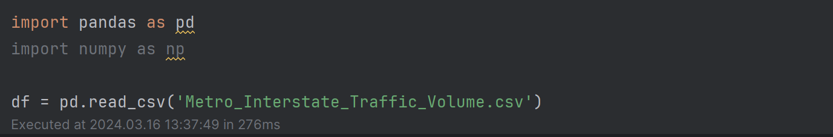

Figure 21*: Imports libraries and reads a CSV file*

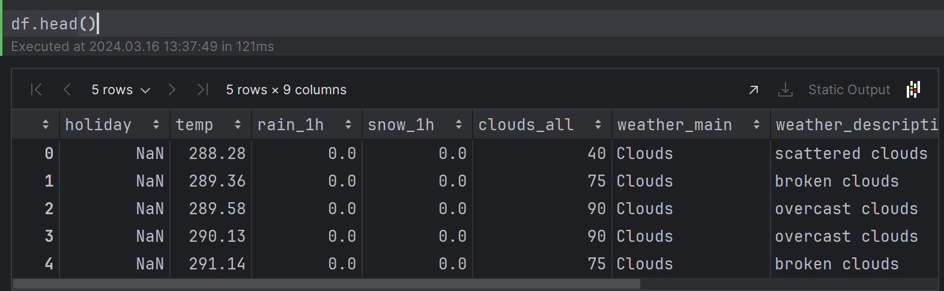

Figure 22*: Displays the first 5 rows of the DataFrame 'df'*

Figure shows that imports libraries, reads a CSV file named 'Metro_Interstate_Traffic_Volume.csv' into a pandas DataFrame called 'df', and then displays the first five rows, it helps to quickly inspect the structure and contents of the dataset.

#### 4.2.2.3 Exploratory Data Analysis (EDA)

##### 4.2.2.3.1 Data type understanding

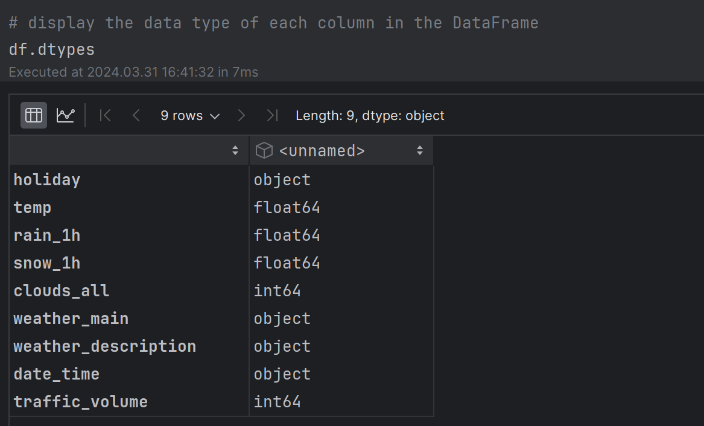

Figure 23*: data type of each column in data frame*

When preparing data for machine learning training models, understanding data types is crucial for effective model development. Categorical variables such as 'holiday,' 'weather_main,' 'weather_description,' and 'date_time' are typically represented as objects in pandas DataFrames, signifying categorical variables. These variables require preprocessing techniques such as encoding, specifically one-hot encoding or label encoding, to convert them into numerical formats suitable for machine learning algorithms. For instance, 'holiday' may require encoding to represent holidays numerically or as binary indicators, while 'date_time' might need conversion to datetime format for time-series analysis.

In contrast, numerical variables like 'temp,' 'rain_1h,' 'snow_1h,' 'clouds_all,' and 'traffic_volume' are already in numeric formats (float64 or int64) and can be directly used in machine learning models without further transformation. Understanding and appropriately handling these data types ensure that the data is compatible with machine learning algorithms and contributes to the overall effectiveness of the model development process.

##### 4.2.2.3.2 Missing Values Checking

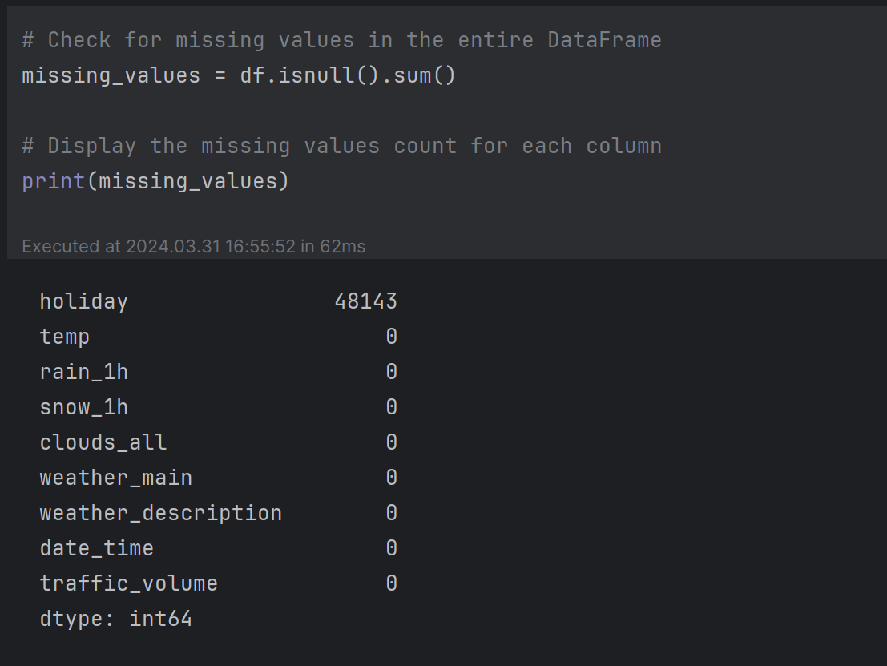

Figure 24*: missing values count for each column*

It's important to note the significant number of missing values in the 'holiday' column, which may require further investigation and handling during data preprocessing to ensure the quality and reliability of the machine learning models.

##### 4.2.2.3.3 Duplicate Row Checking

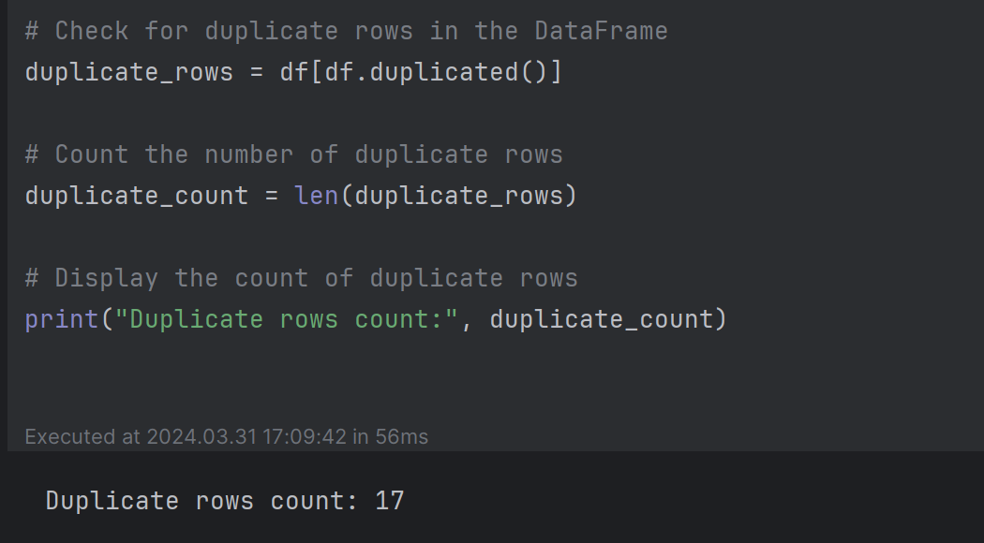

Figure 25*: duplicate rows in the dataframe*

The DataFrame contains 17 duplicate rows, which means there are 17 rows that have identical values across all columns. Duplicate rows can affect the accuracy and reliability of machine learning models by introducing bias or skewing the results.

##### 4.2.2.3.4 Statistical

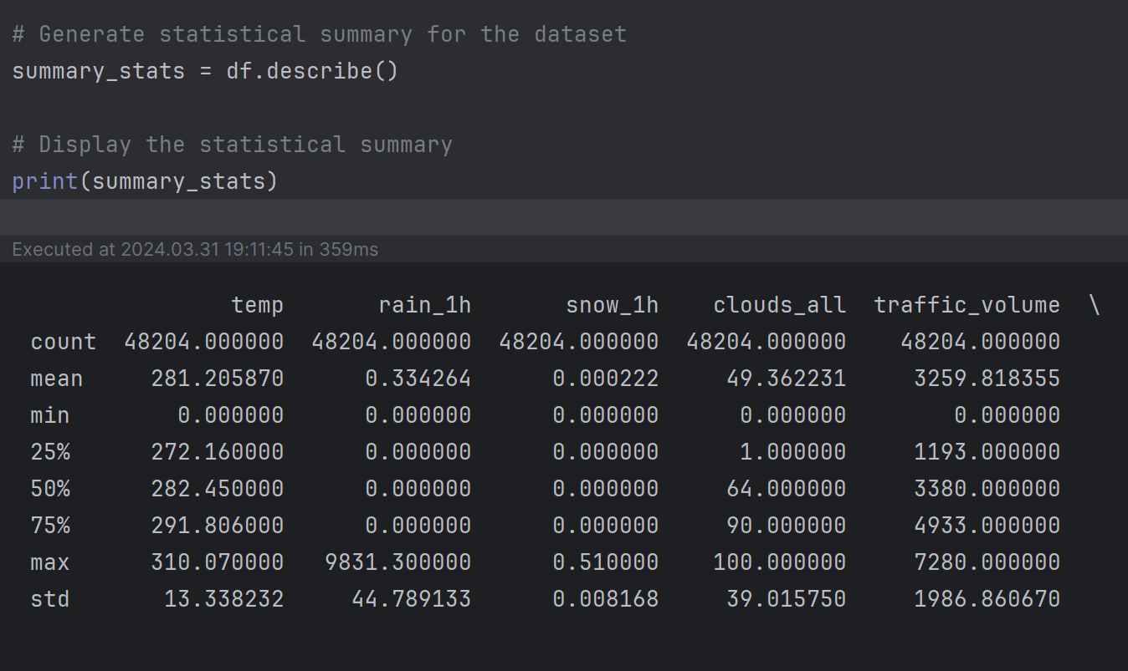

Figure 26*: statistical summary for dataframe*

Statistical summaries help understand data quickly, spotting trends, outliers, and deciding how to prepare data for machine learning models; it reveals key insights about the dataset's numerical variables. The temperature (temp) data shows an average of about 281 Kelvin, ranging from 0 to 310 Kelvin. Rainfall (rain_1h) on average is around 0.33 millimetres per hour, but there's an outlier with very high rainfall recorded at 9831.3 millimetres per hour. Snowfall (snow_1h) is minimal, averaging at 0.000222 millimetres per hour. Cloud cover (clouds_all) varies from 0% to 100%, with an average of about 49%. Traffic volume (traffic_volume) has an average of approximately 3259 vehicles per hour, ranging from 0 to 7280 vehicles per hour.

##### 4.2.2.3.5 Outlier Checking

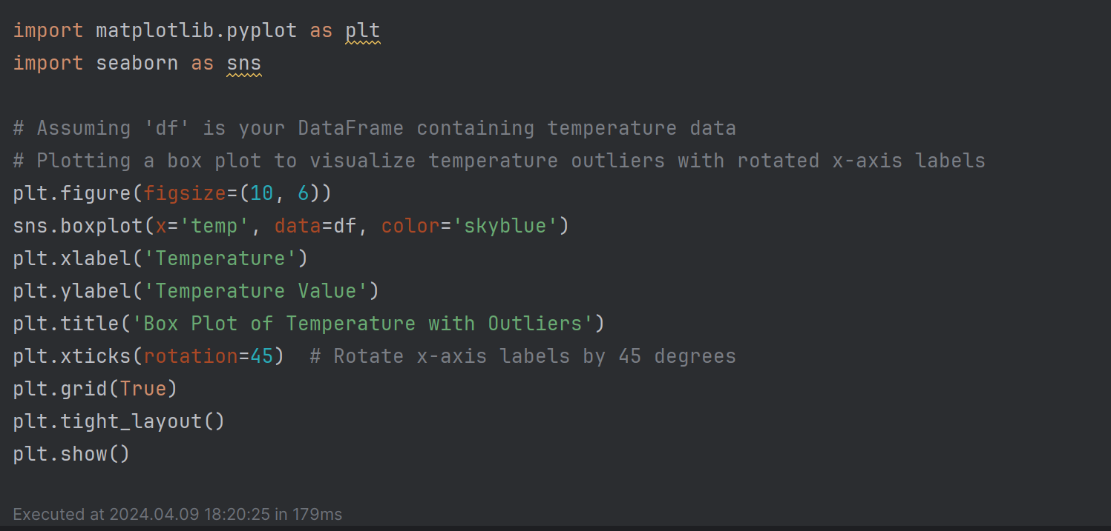

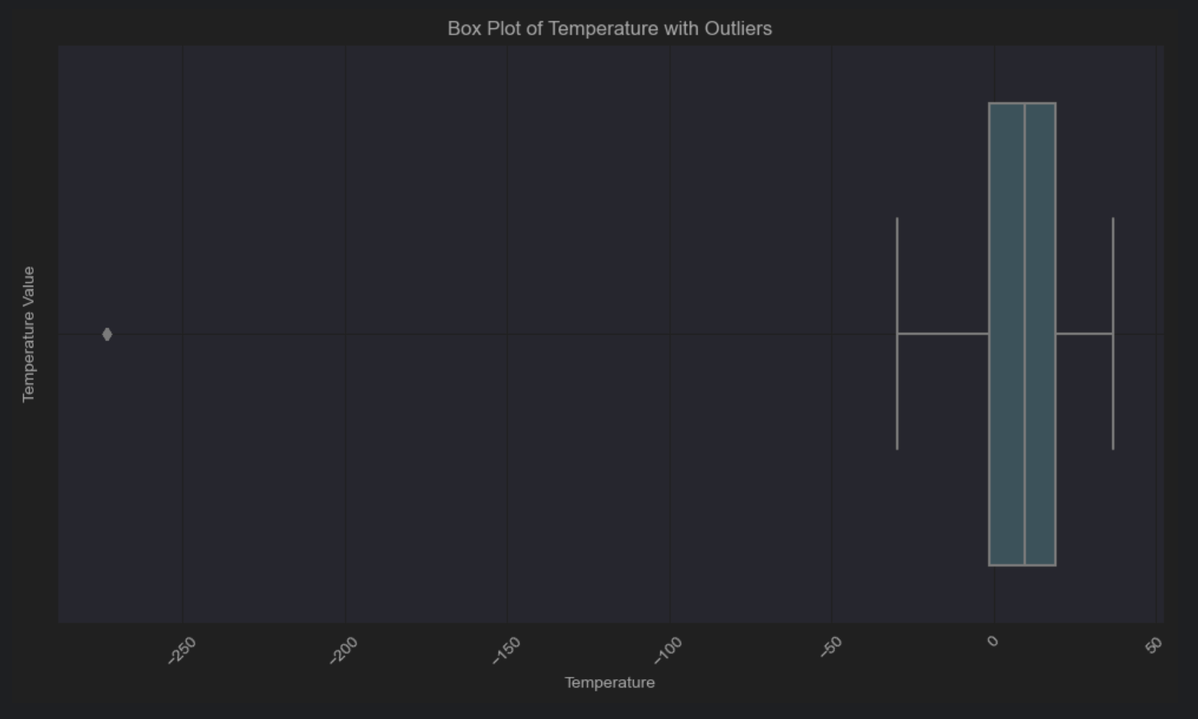

Figure 27: Box plot of temperature with outliers

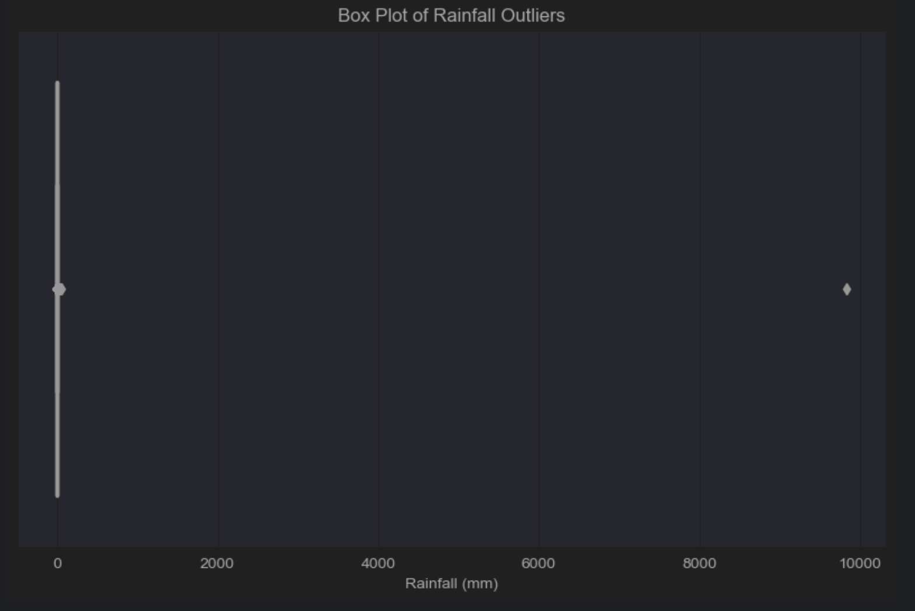

Figure 28*: Box plot of rainfall outliers plot*

In Chapter 4.3, the project will address outlier detection based on variables such as rainfall and temperature, as depicted in the box plot. This step is crucial for ensuring the integrity and accuracy of the data analysis.

##### 4.2.2.3.6 Traffic Volume Analysis

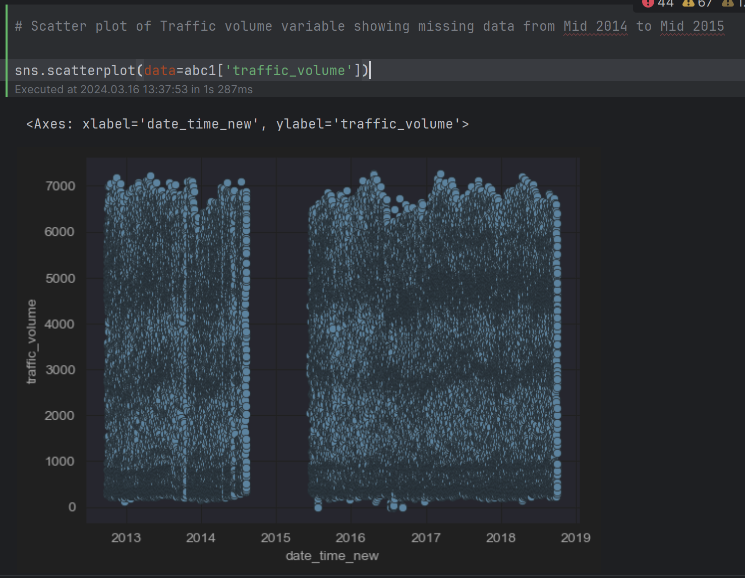

Figure 29*: Traffic volume and data time scatter plot*

The scatter plot of the Traffic Volume variable will show how traffic volume changes over time. The missing data from mid-2014 to mid-2015 will appear as gaps or empty spaces in the plot, indicating periods without recorded traffic volume information. These gaps highlight potential data collection issues or incomplete data during that time frame.

##### 4.2.2.3.7 Weather Description Analysis

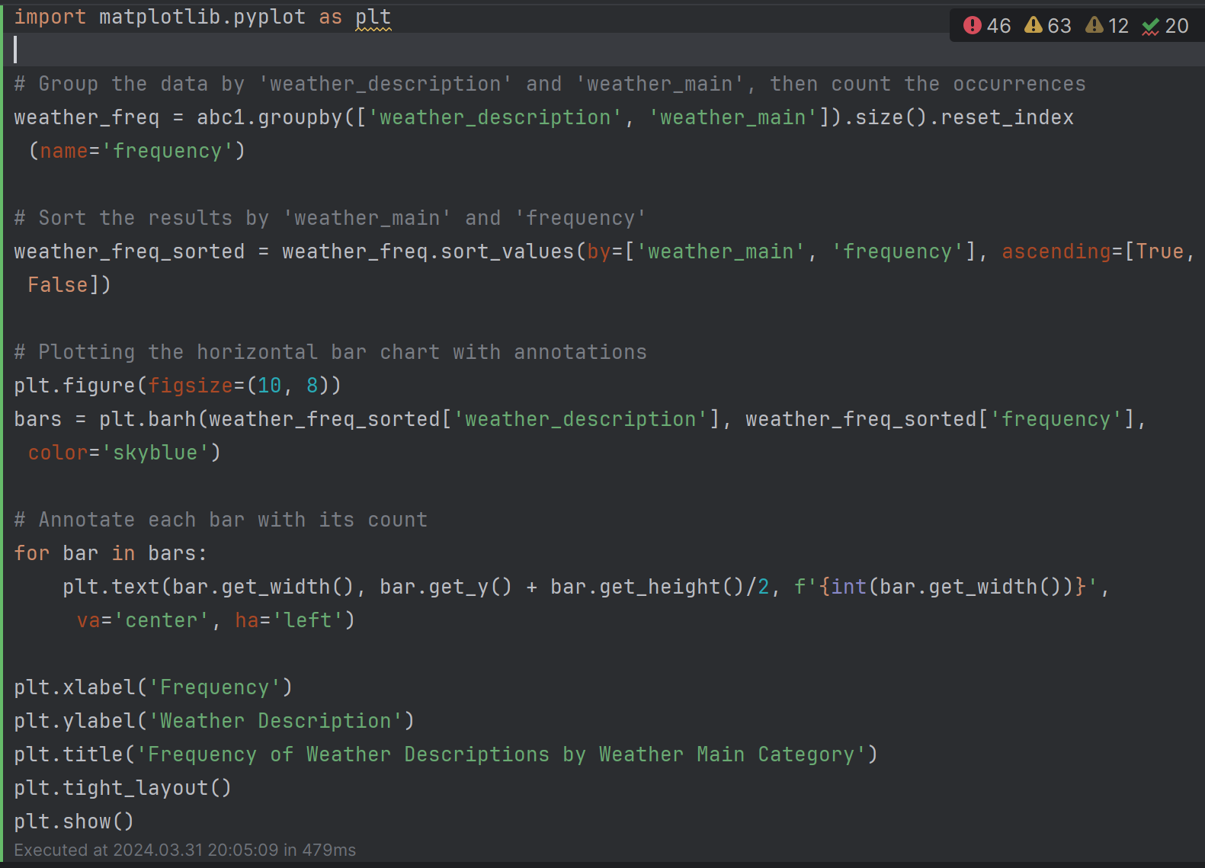

Figure 30*: weather description column category frequency code*

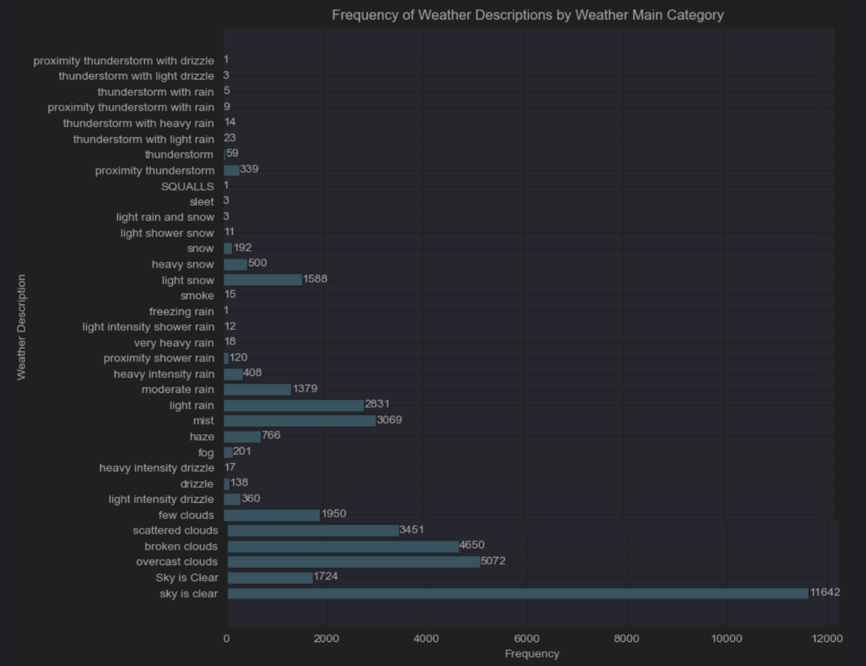

Figure 31*: frequency of weather description by weather main category*

The issue found in the provided data is related to inconsistency and redundancy in the 'weather_description' column. Specifically, there are multiple entries that represent similar weather conditions but are labelled differently, such as "sky is clear" and "Sky is Clear" for the 'Clear' weather main category, or "overcast clouds," "broken clouds," "scattered clouds," and "few clouds" for the 'Clouds' weather main category. Additionally, there are variations in labelling for similar weather phenomena, such as "light intensity drizzle," "drizzle," and "light intensity shower rain" for the 'Drizzle' weather main category, or "light rain," "moderate rain," "heavy intensity rain," "proximity shower rain," "very heavy rain," "light intensity shower rain," and "thunderstorm with light rain" for the 'Rain' weather main category.

This inconsistency and redundancy in labelling can lead to ambiguity and confusion in data analysis and modelling tasks. It can affect the accuracy and reliability of machine learning models trained on this data, as the model may struggle to generalise patterns effectively due to the overlapping and inconsistent labels. It's important to standardise and consolidate similar weather descriptions under the appropriate weather main categories to improve data quality and model performance.

##### 4.2.2.3.8 Holiday Inconsistency In Record

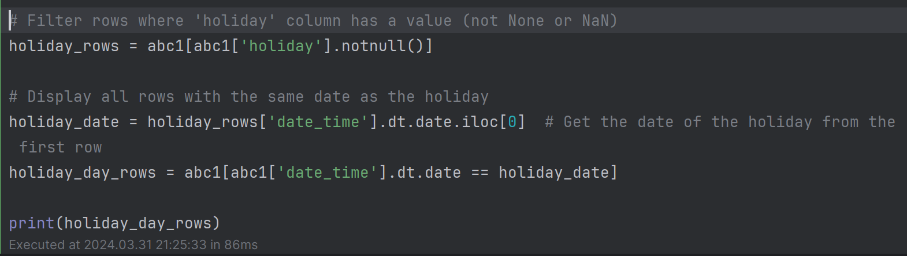

Figure 32*: display all rows with the same date as the holiday code*

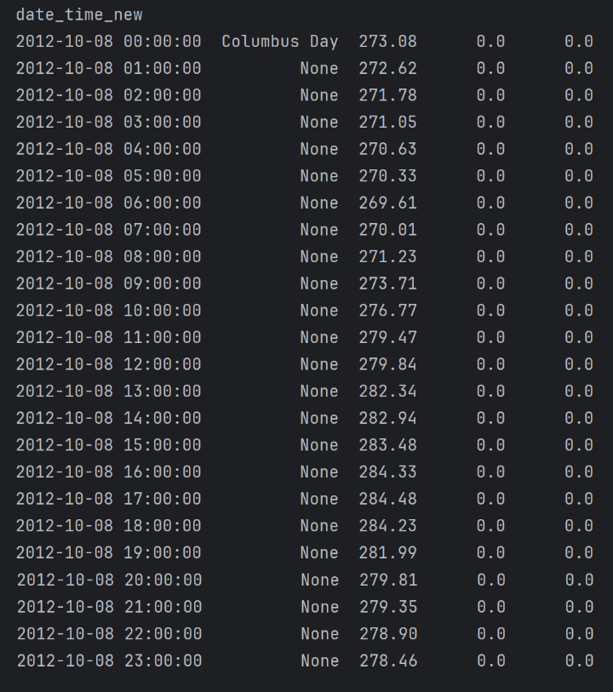

Figure 33*: display all rows with the same date as the holiday*

The dataset's holiday column exhibits a significant anomaly where holidays are marked only for the first hour of a designated holiday day. This means that while the dataset correctly identifies the initial hour of a holiday, it lacks consistency in labelling the subsequent 23 hours of the same day as holiday periods. Instead, these hours are categorised as non-holiday periods. This inconsistency can lead to misinterpretation of the data, especially in scenarios where the entire day should be considered a holiday for analytical or modelling purposes.

##### 

##### 4.2.2.3.9 Data Preprocessing for Improved Visualisation

To optimise the plot's clarity, I will conduct essential preprocessing tasks such as ensuring that all data entries are hourly, covering a full 24-hour cycle. Additionally, I'll convert certain data types to their appropriate formats to facilitate smoother exploration and analysis.

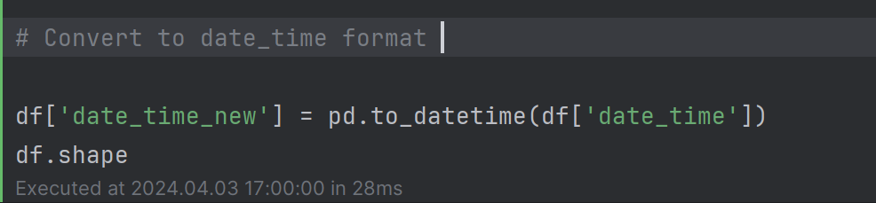

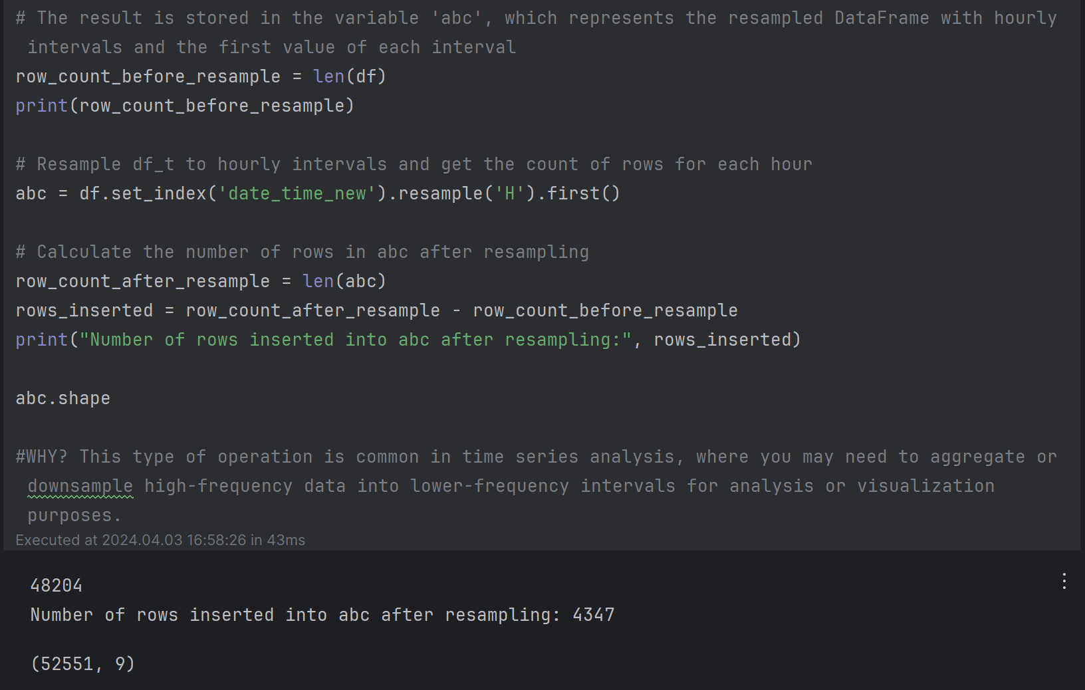

Figure 34*: resample dataframe to hourly intervals code*

The purpose of the provided code is to preprocess the DataFrame by converting the 'date_time' column to datetime format and then resampling the data to hourly intervals using the 'date_time_new' column as the index. This action helps ensure that the data is organised in a consistent hourly format, which is beneficial for various analyses and visualisations. It allows for easier tracking and comparison of data points across hourly intervals, providing a more granular view of trends and patterns in the data.



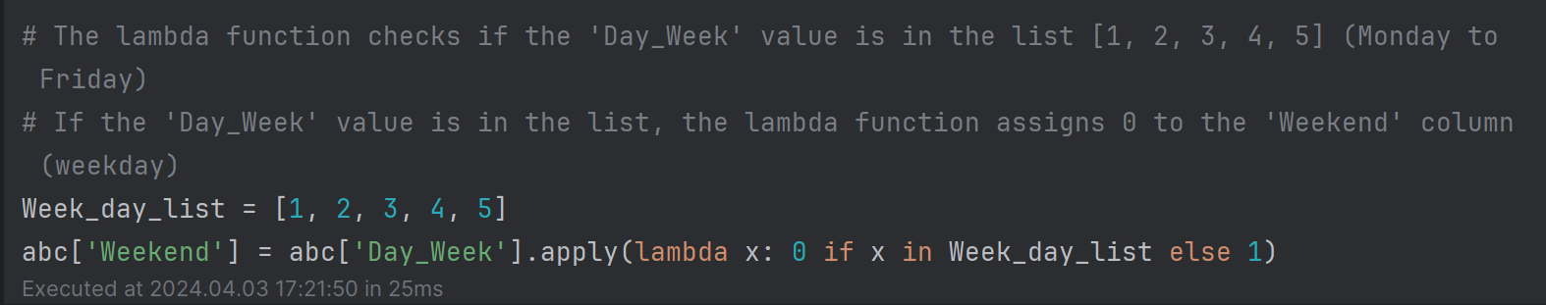

Figure 35*:Weekday and Weekend Extraction from Timestamps code*

The code adds a 'weekday' column to 'abc' with values representing the day of the week (0 for Monday, 1 for Tuesday, etc.) and a 'Weekend' column indicating weekdays (0) and weekends (1) based on the 'Day_Week' column. This categorization aids in analysing and understanding trends and behaviours across different days of the week.

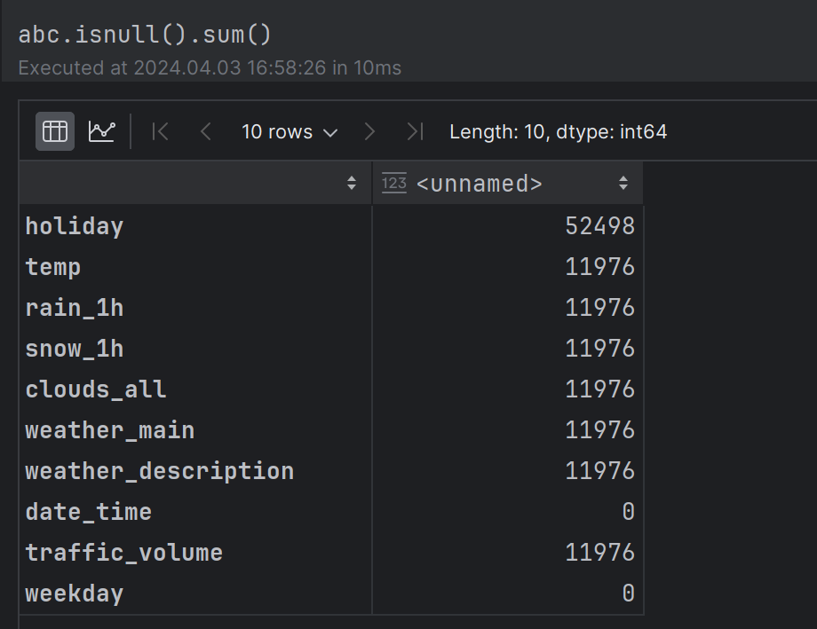

Figure 36*: After resampling examine null sum value*

##### 4.2.2.3.10 Traffic Volume in Weekends and Weekdays

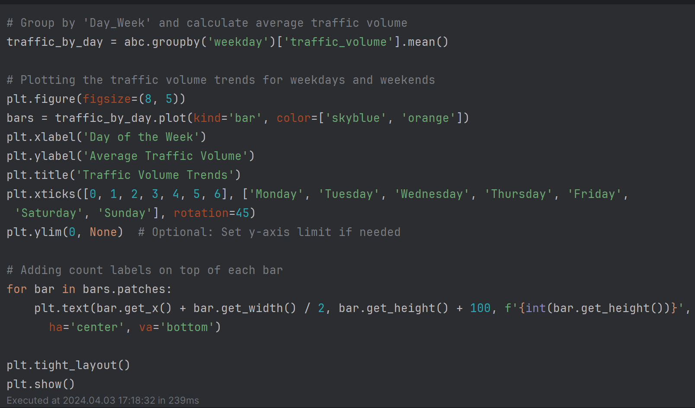

Figure 37*: traffic volume trends for weekdays and weekends plot code*

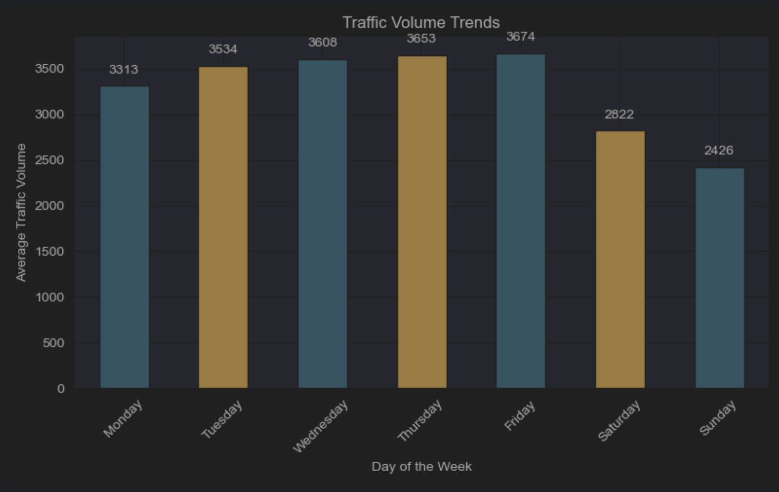

Figure 38*: Traffic Volume Trends Histogram Plot*

The analysis of average traffic volume throughout the week reveals interesting trends. Weekdays, starting from Monday through Friday, show a gradual increase in traffic volume. In contrast, weekends display a significant decrease in traffic volume. Saturdays observe a considerable drop compared to weekdays, averaging 2822 vehicles, reflecting a shift in commuter patterns and reduced work-related travel. Sundays record the lowest average traffic volume of 2426 vehicles, indicating a day of minimal commuting and more leisure or home-based activities.

##### 4.2.2.3.11 Holiday

In Chapter 4.2.2.3.8, we address holiday inconsistency within records. The following code snippet illustrates how we handle this issue in the dataset.

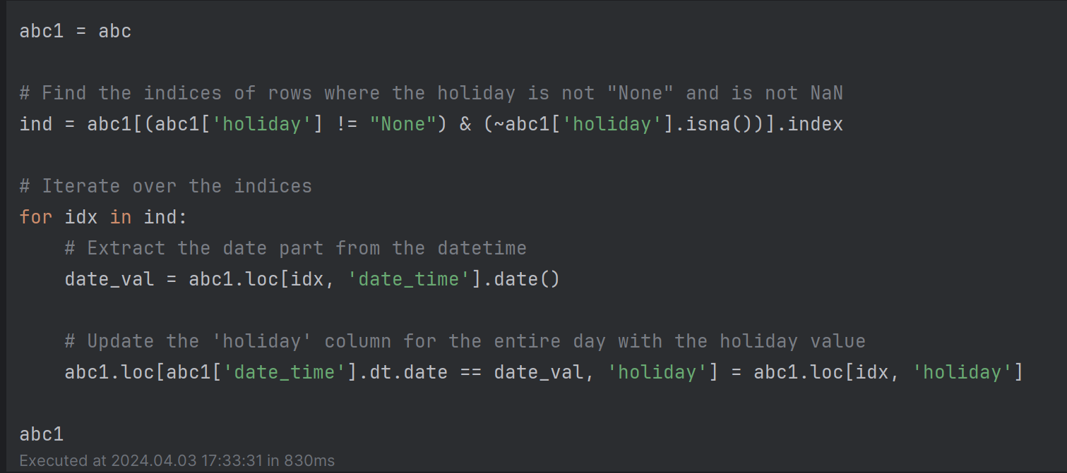

This approach ensures consistency in holiday labelling across the dataset, resolving any inconsistencies that may exist in holiday records.

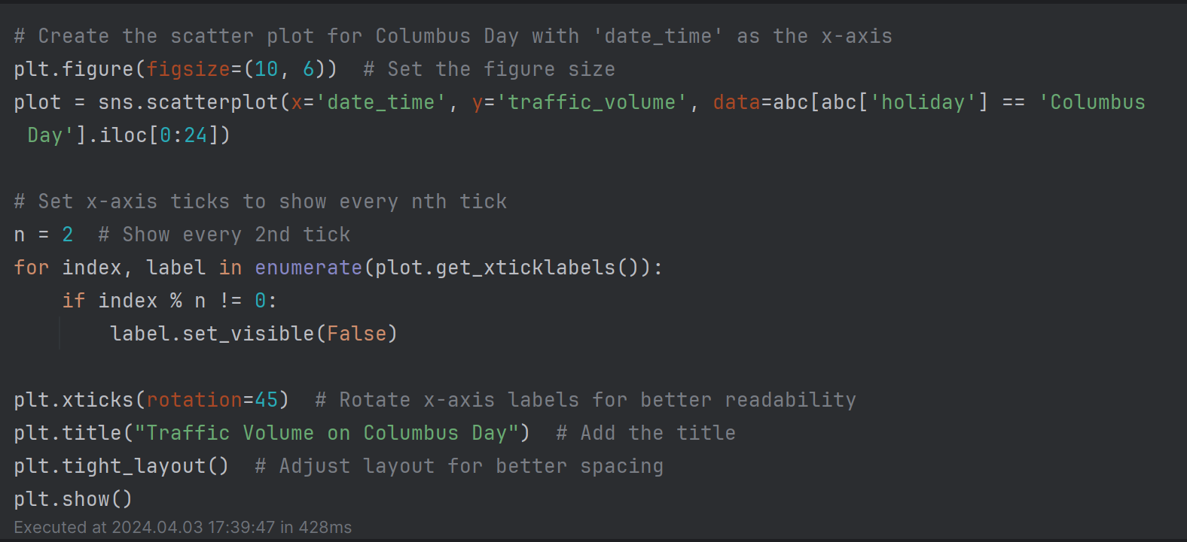

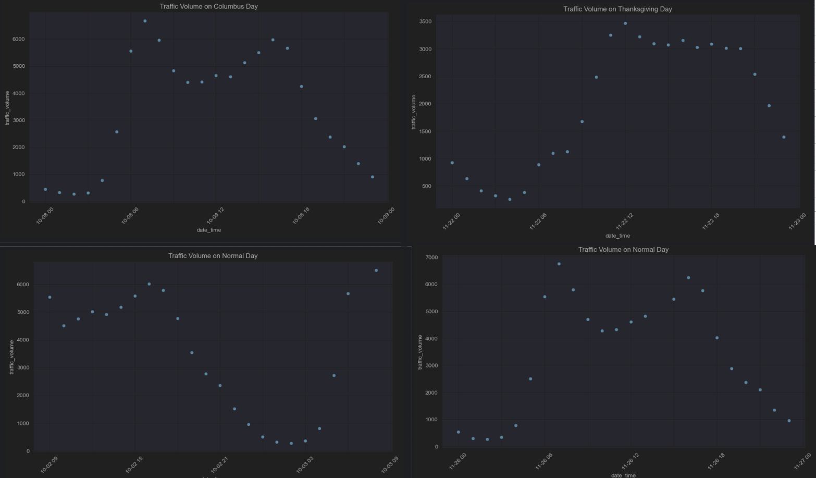

Figure 39*: The top two plots represent holidays, while the bottom two plots depict normal days.*

The traffic volume patterns on weekdays and holidays are distinctly different, as observed from the four plots. Weekdays typically experience heavy traffic during the early morning hours, attributed to the rush of people commuting to work, and again in the evening as they return home. This dual peak in traffic is a characteristic feature of weekdays.

Conversely, holidays exhibit a contrasting traffic pattern. During holidays, the traffic volume peaks later in the morning to afternoon period. This shift is due to people engaging in leisure activities such as parties, spending quality time with family, or embarking on vacations, resulting in increased traffic during these hours compared to the early morning rush seen on weekdays.

##### 4.2.2.3.12 Weather

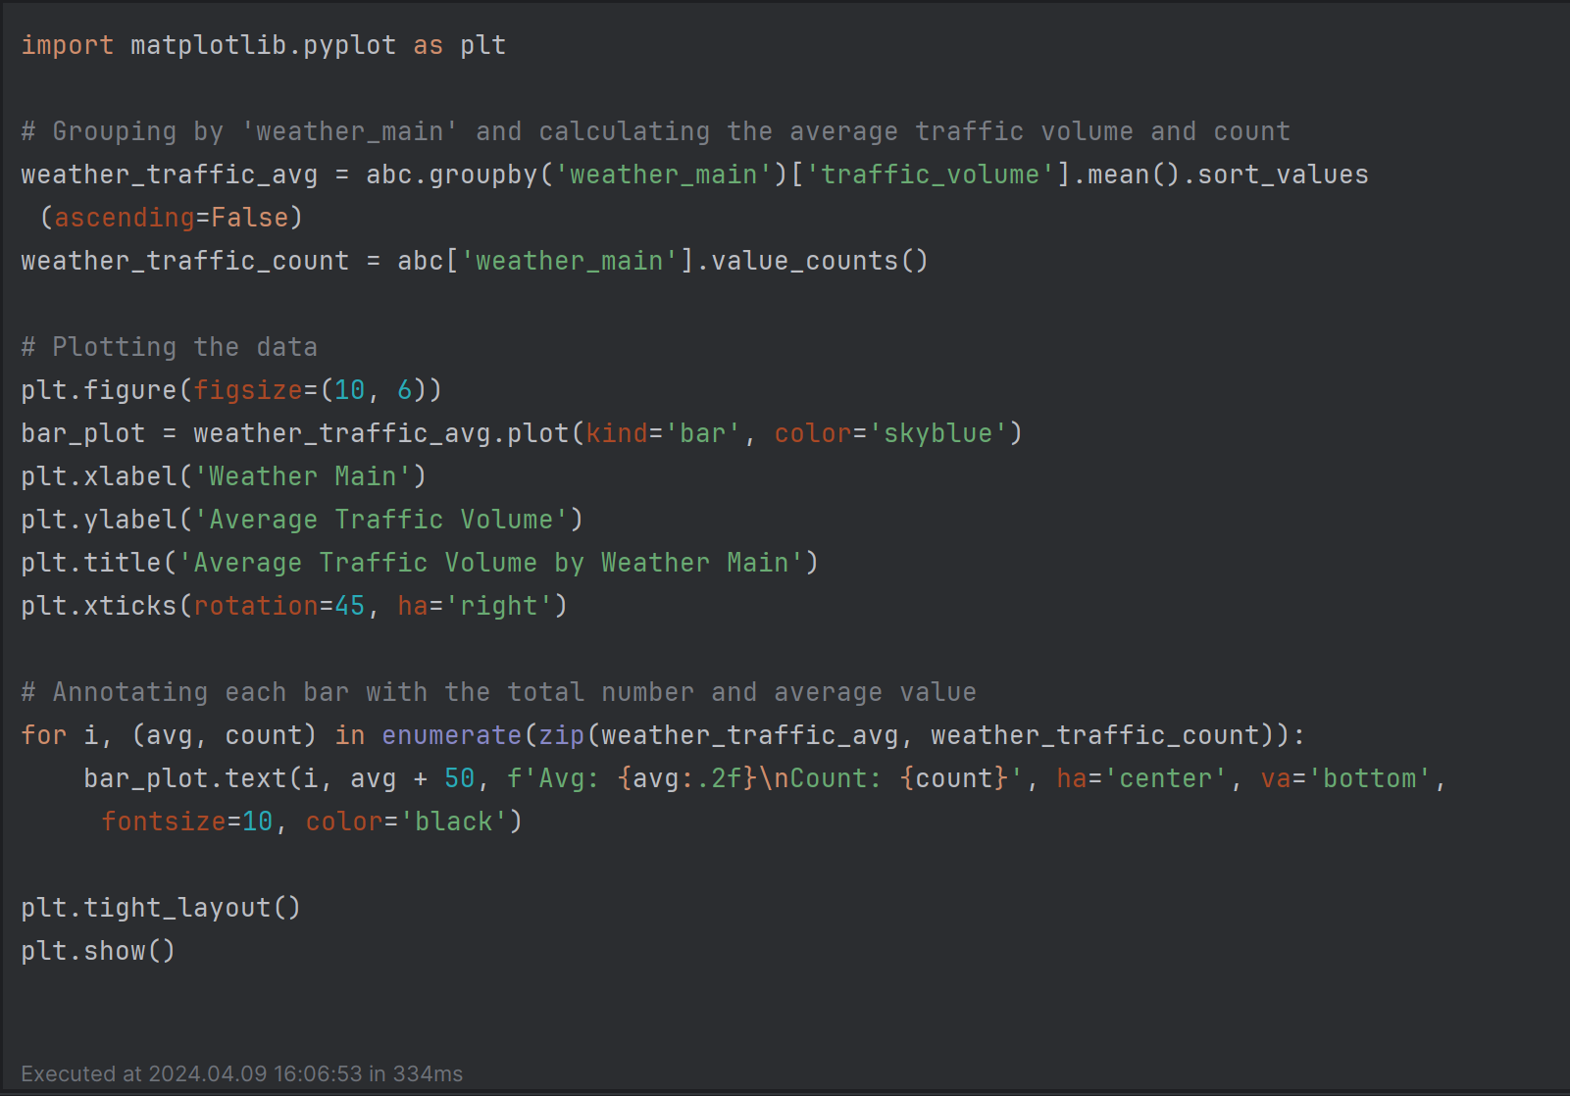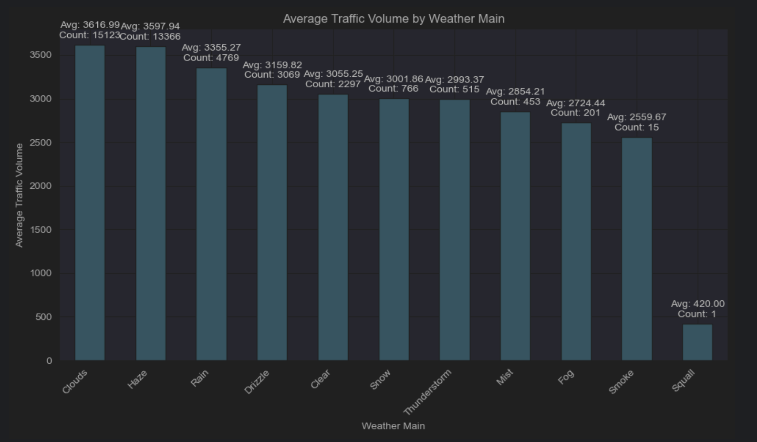

Figure 40*: Average traffic volume by weather main plot*

Cloudy and hazy weather conditions show the highest average traffic volume, with over 15,000 data points each. Rainy and drizzly weather have slightly lower volumes but still impact traffic flow. Surprisingly, clear weather results in lower traffic volume compared to some other conditions. Snowy weather and thunderstorms significantly reduce traffic volume. Misty, foggy, smoky, and squally conditions also lower traffic volume but occur less frequently. Overall, adverse weather like rain, snow, and fog noticeably affect traffic volume, while clear and hazy conditions have a lesser impact.

##### 4.2.2.3.13 Cloud Coverage

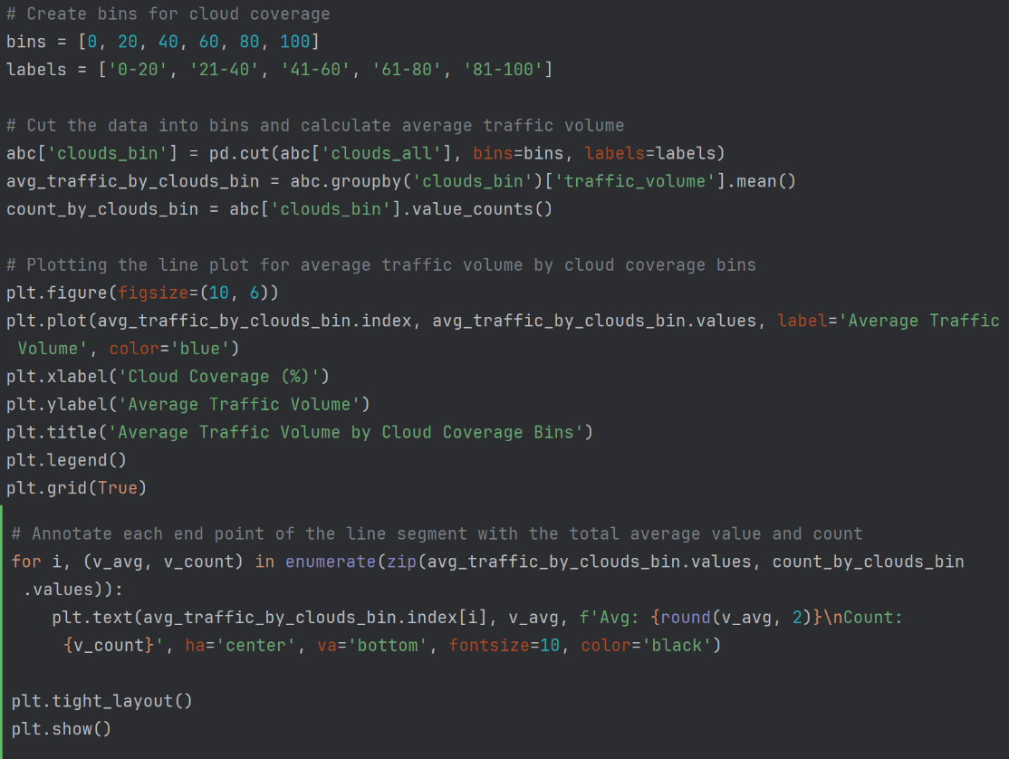

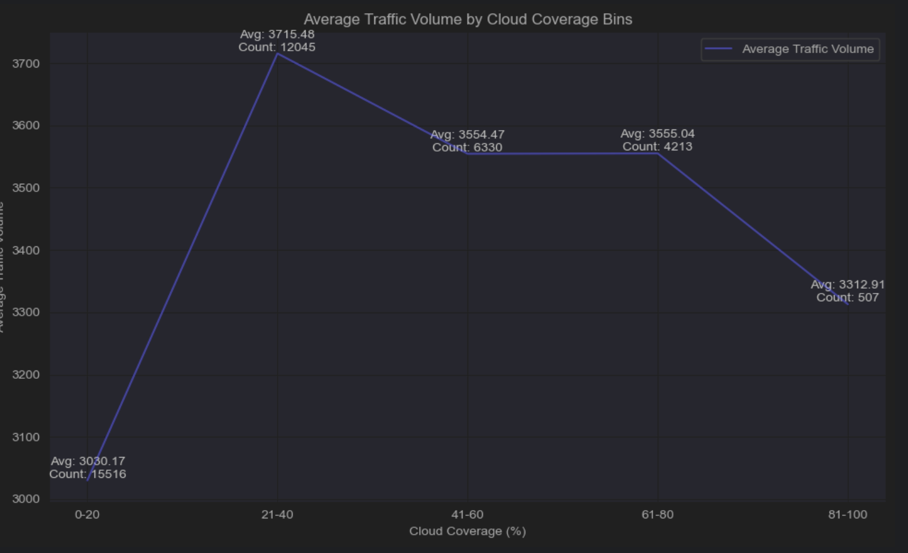

Figure 41*: Average traffic volume by cloud coverage bins plot*

The analysis of average traffic volume by cloud coverage bins indicates that moderate cloud coverage (21-40%) has the most significant impact on traffic volume, with an average of 3715.48 vehicles despite a lower count of 12045 data points. This suggests that moderate cloudiness affects traffic flow more noticeable than other cloud coverage ranges.

##### 4.2.2.3.14 Temperature

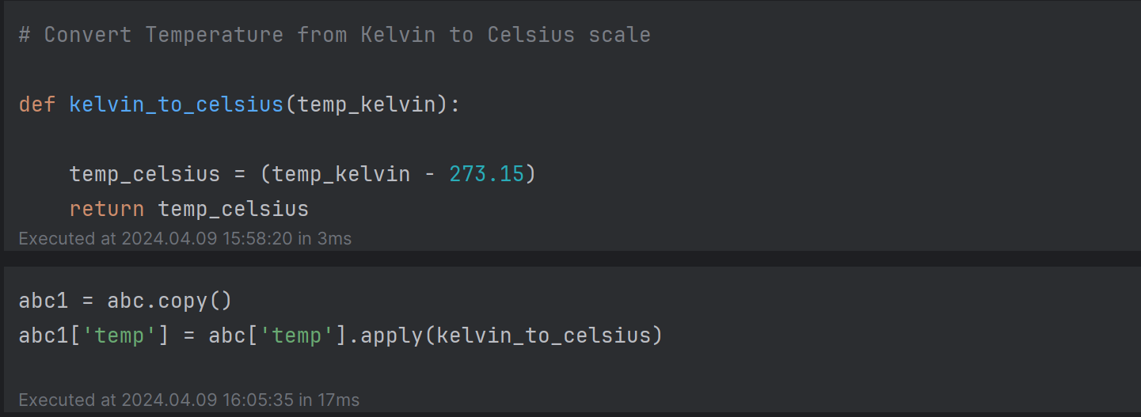

Converting temperatures from Kelvin to Celsius is necessary because Celsius is the scale commonly used and understood in everyday life. It's based on the freezing and boiling points of water, making it more relatable for weather forecasts, cooking, and daily temperature discussions. This conversion makes temperature data more accessible and relevant to people's daily experiences and understanding.

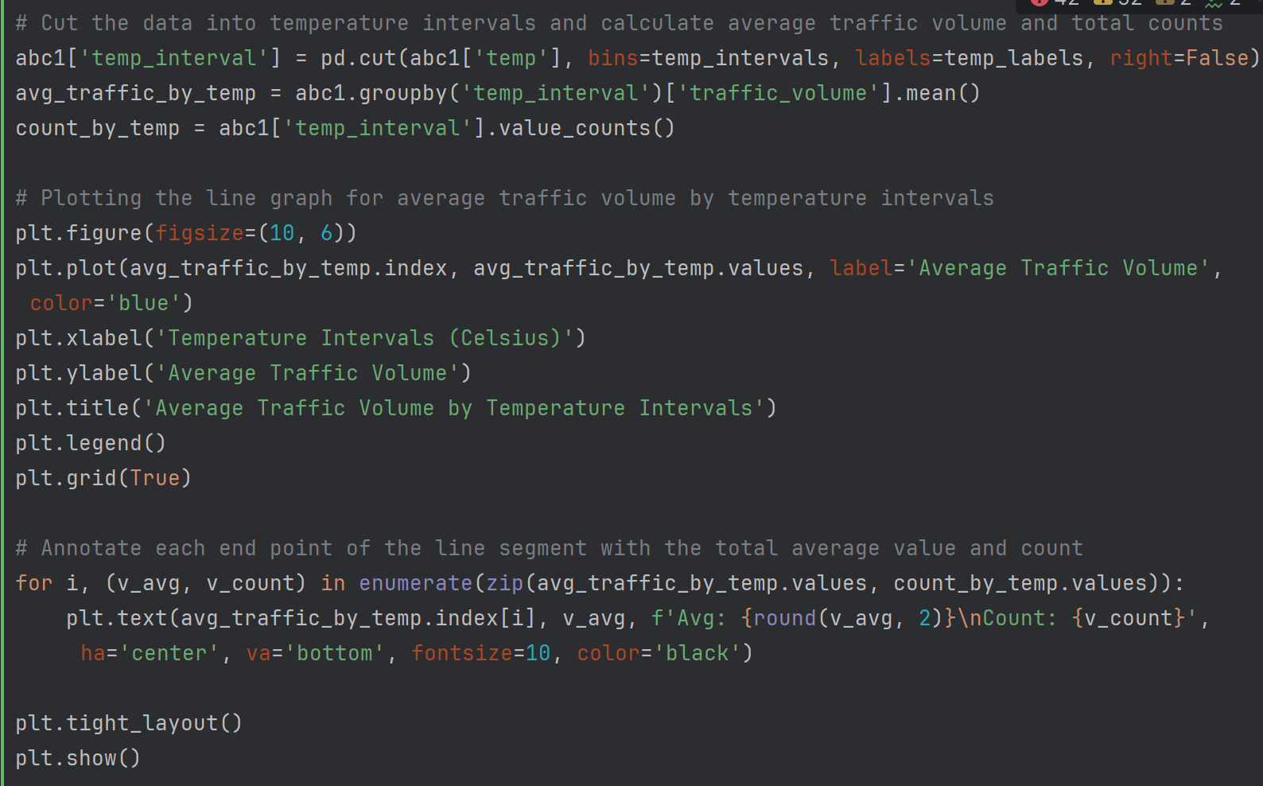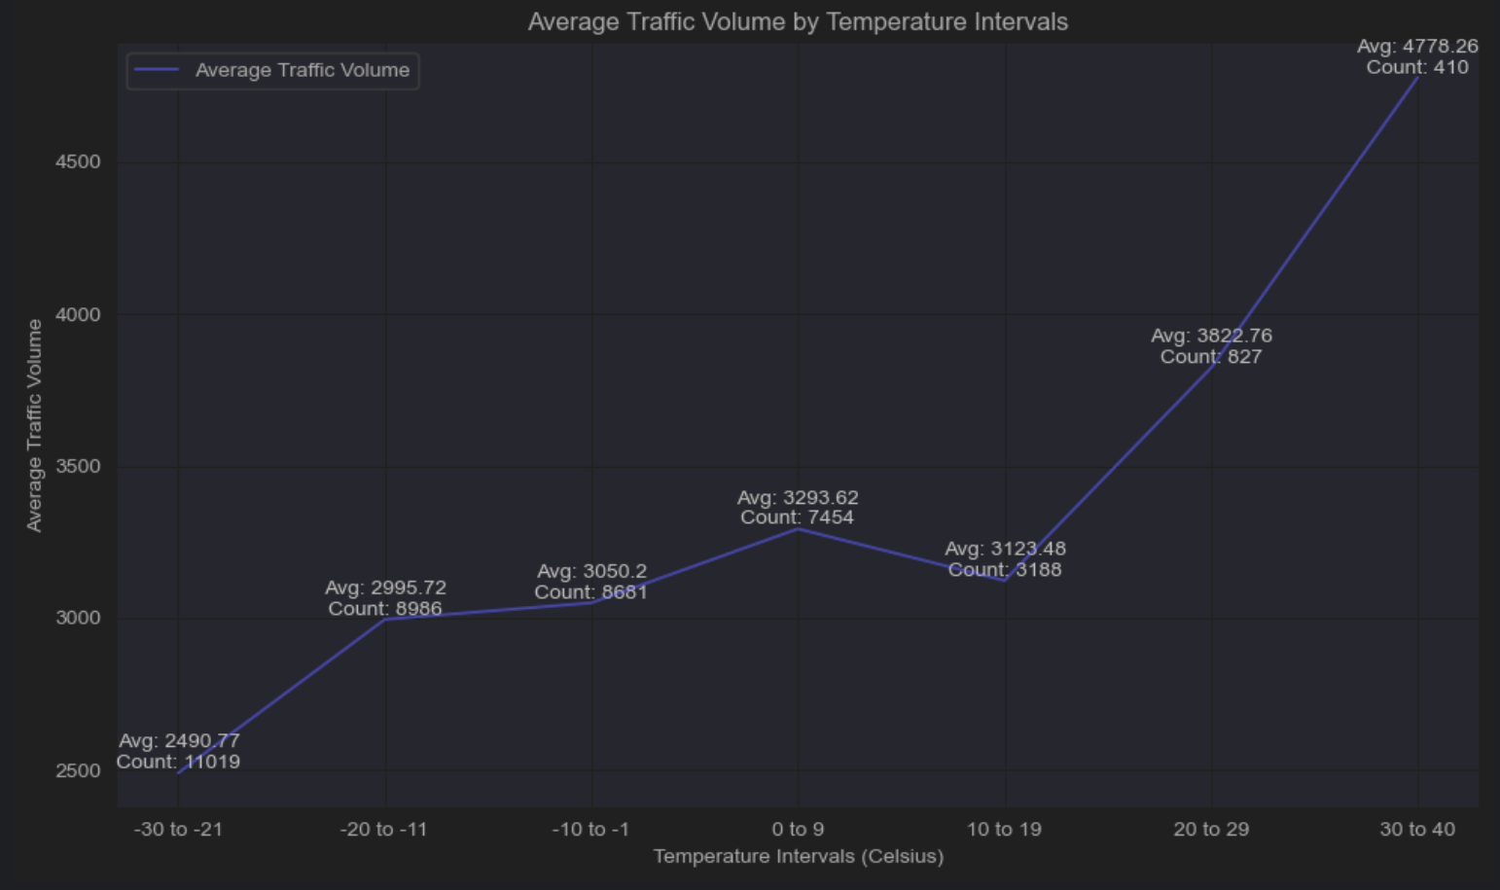

Figure 42*: Average traffic volume by temperature intervals line graph*

The analysis of average traffic volume by temperature intervals reveals that warmer temperatures generally correspond to higher traffic volumes. Specifically, temperature intervals from 30 to 40 degrees Celsius exhibit the highest average traffic volume, indicating increased outdoor activities or travel during warm weather conditions. Moderate temperatures between -10 to 9 degrees Celsius also influence traffic flow significantly. In contrast, extremely cold temperatures below -10 degrees Celsius result in lower traffic volumes, likely due to adverse weather conditions affecting road conditions and travel patterns.

## 4.3 Data Pre-processing

### 4.3.1 Temporal Feature Enhancement for Improved Model Interpretability

# Convert 'date_time' column to datetime format if it's not already

df['date_time'] = pd.to_datetime(df['date_time'])

# Now you can use the .dt accessor to extract year, month, weekday, and hour

new_df = df.copy()

new_df['year'] = new_df['date_time'].dt.year

new_df['month'] = new_df['date_time'].dt.month

new_df['weekday'] = new_df['date_time'].dt.weekday

new_df['hour'] = new_df['date_time'].dt.hour

def categorize_hour(hour):

cat = None

if hour in [1,2,3,4,5]:

cat = 'dawn'

elif hour in [6,7,8,9,10,11,12]:

cat = 'morning'

elif hour in [13,14,15,16,17,18]:

cat = 'afternoon'

elif hour in [19,20,21,22,23,0]:

cat = 'night'

return cat

new_df['day_part'] = new_df['hour'].map(categorize_hour)

The code transforms the 'date_time' column into datetime format using `pd.to_datetime(df['date_time'])`, enabling the extraction of year, month, weekday, and hour components using the .dt accessor. These extracted features are added as new columns in a copy of the DataFrame (`new_df`). Additionally, a function `categorize_hour` categorises hours into four parts of the day, and this categorization is applied to create a new column 'day_part' in `new_df`. These transformations aim to enrich the model with temporal information, enhancing its ability to explain the target variable based on time-related patterns.

### 4.3.2 Remove Duplicate Rows

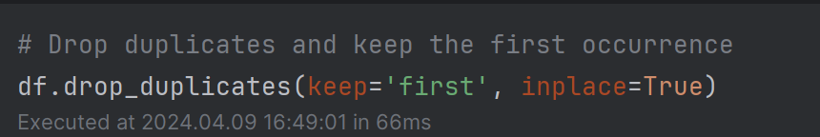

When we apply `drop_duplicates(keep='first')` to a DataFrame, it checks for duplicate rows based on all columns by default or specified columns if provided. The `keep='first'` parameter ensures that only the first occurrence of each duplicated row is retained, while subsequent duplicates are removed. This approach aligns with best practices in data cleaning and integrity, as it eliminates redundancy without losing valuable information.

By incorporating this method into our data preprocessing steps, specifically in the context of section 4.2.2.3.3, we maintain data accuracy and consistency. Removing duplicate rows mitigates the risk of skewed analyses and enhances the reliability of our findings.

### 4.3.3 Handle Outlier

Having identified the outliers using the methods outlined in the 4.2.2.3.5 chapter, our next step is to address them effectively. We will apply appropriate techniques such as data transformation to handle these outliers. This proactive approach ensures that our data analysis remains accurate and reliable, enabling us to derive meaningful insights and make informed decisions based on trustworthy data.

#### 4.3.2.1 Temperature Outlier

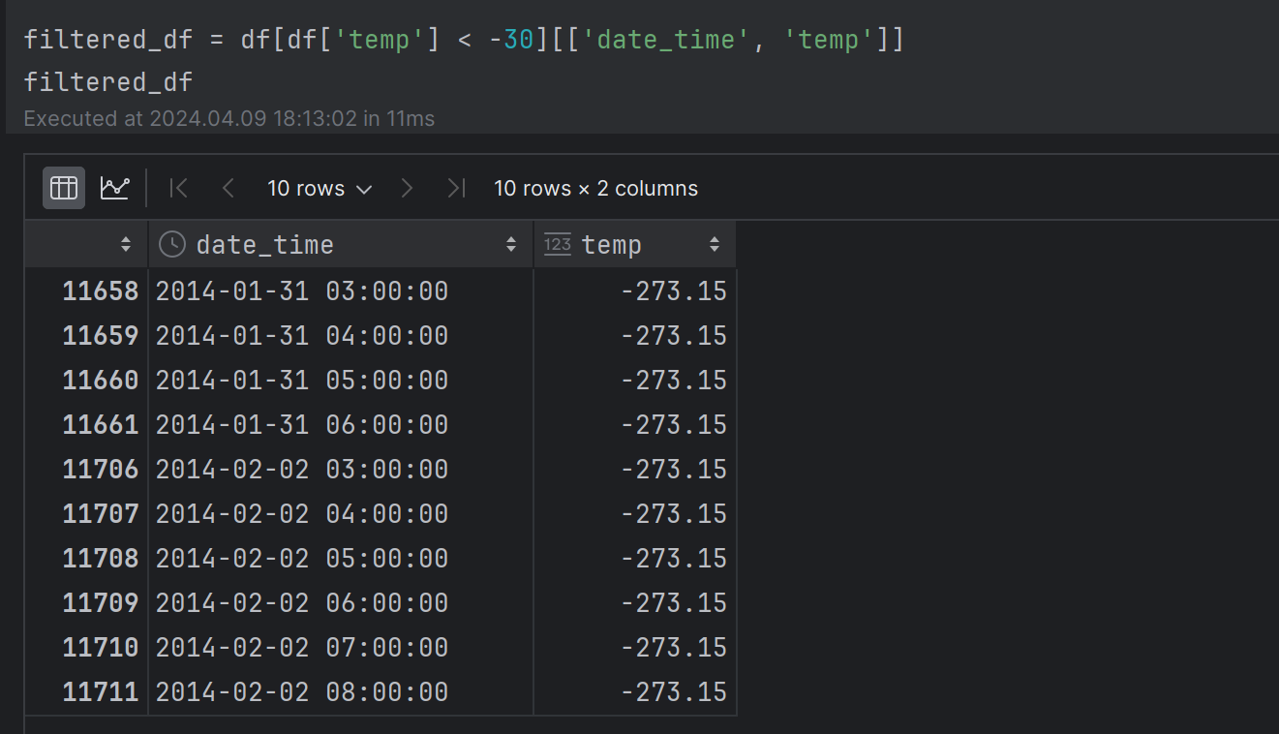

Figure 43*: Temperature outlier specific date time*

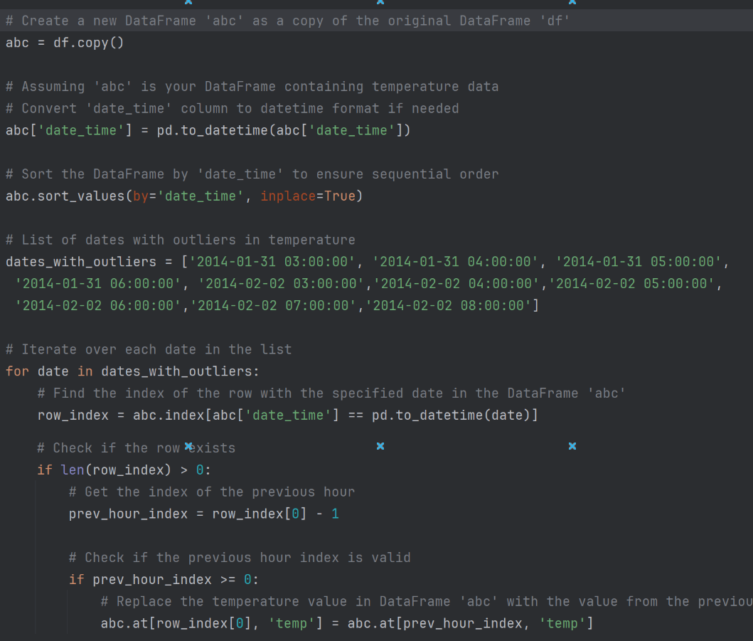

Figure 44*: Handle temperature outlier with specific date time code*

To handle temperature outliers in the 'abc' DataFrame, we first created a copy of the original 'df' DataFrame to ensure data integrity. Next, we identified specific dates with outliers in temperature and iterated over each date in the list. We replaced the outlier temperature value with the value from the previous hour, ensuring a smoother and more consistent temperature profile. This approach helps improve the overall quality and reliability of our temperature data for accurate analysis and decision-making.

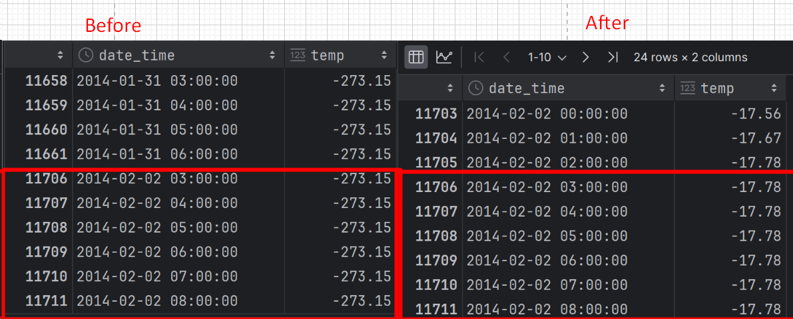

Figure 45*: Before and after changed in temperature outlier*

#### 4.3.2.2 Rainfall Outlier

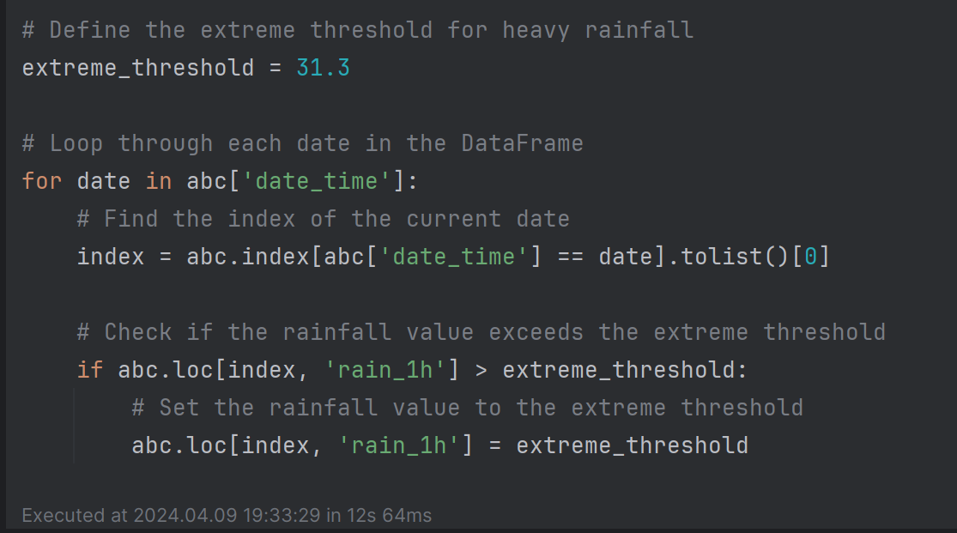

Figure: Handle extreme rainfall code

We're setting a limit on heavy rainfall in the data to ensure our analysis isn't thrown off by extreme values. Extreme rainfall can distort our understanding of normal conditions, so by capping these values, we're making sure our data accurately represents typical rainfall patterns.

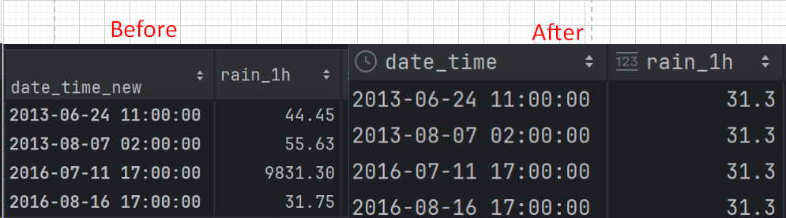

Figure 46: Before and after change in rainfall outlier

### 4.3.4 Missing Value

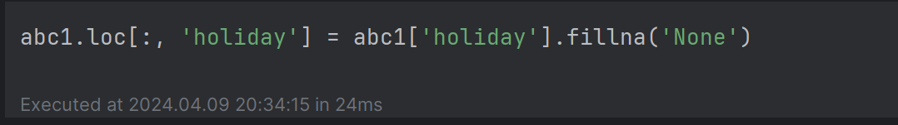

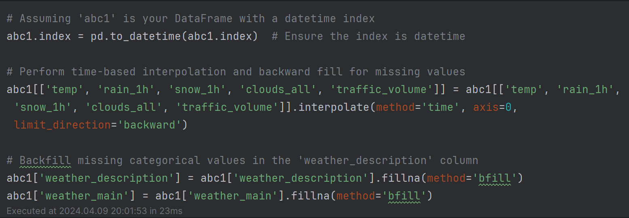

Figure 47*: Data Interpolation and Backfilling code*

Having identified the missing value in the 4.2.2.3.2 and 4.2.2.3.9 chapter. We used time-based interpolation to fill missing numerical values like temperature and rainfall, and backward filling for categorical columns like weather descriptions. Time-based interpolation is useful when dealing with time series data, as it considers the temporal order of the data points. By interpolating based on time, we can estimate missing values more accurately, especially when there's a pattern or trend in the data over time. Backward filling for categorical columns ensures that missing values are replaced with the most recent valid observation, preserving the continuity of information in the dataset.

These techniques are commonly used in data preprocessing to prepare the data for further analysis or modelling, ensuring that the data is complete and suitable for meaningful insights.

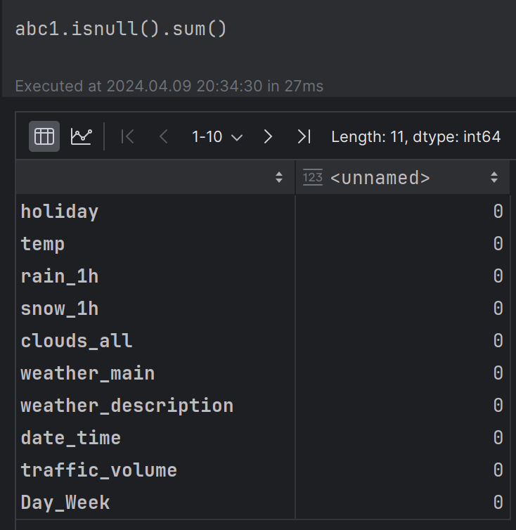

Figure 48: Missing value checked after handled

After handling missing values, all data in the DataFrame `abc1` is now complete and does not contain any missing or NaN values.

### 4.3.5 Label Encoding

This encoding facilitates easier analysis and model training as it transforms the data into a format suitable for computational processes while preserving the essential categorical information.

#### 4.3.4.1 Weather Description

To simplify the weather description, which currently has 34 unique values, I'll categorise them into 9 distinct classes based on the main weather conditions. For instance, in the clouds category, we have various descriptions like scattered clouds, broken clouds, overcast clouds, and clear skies, among others. By grouping these into broader categories such as clear skies, cloudy, and overcast, we can reduce complexity and make it easier to analyse and interpret the weather data.

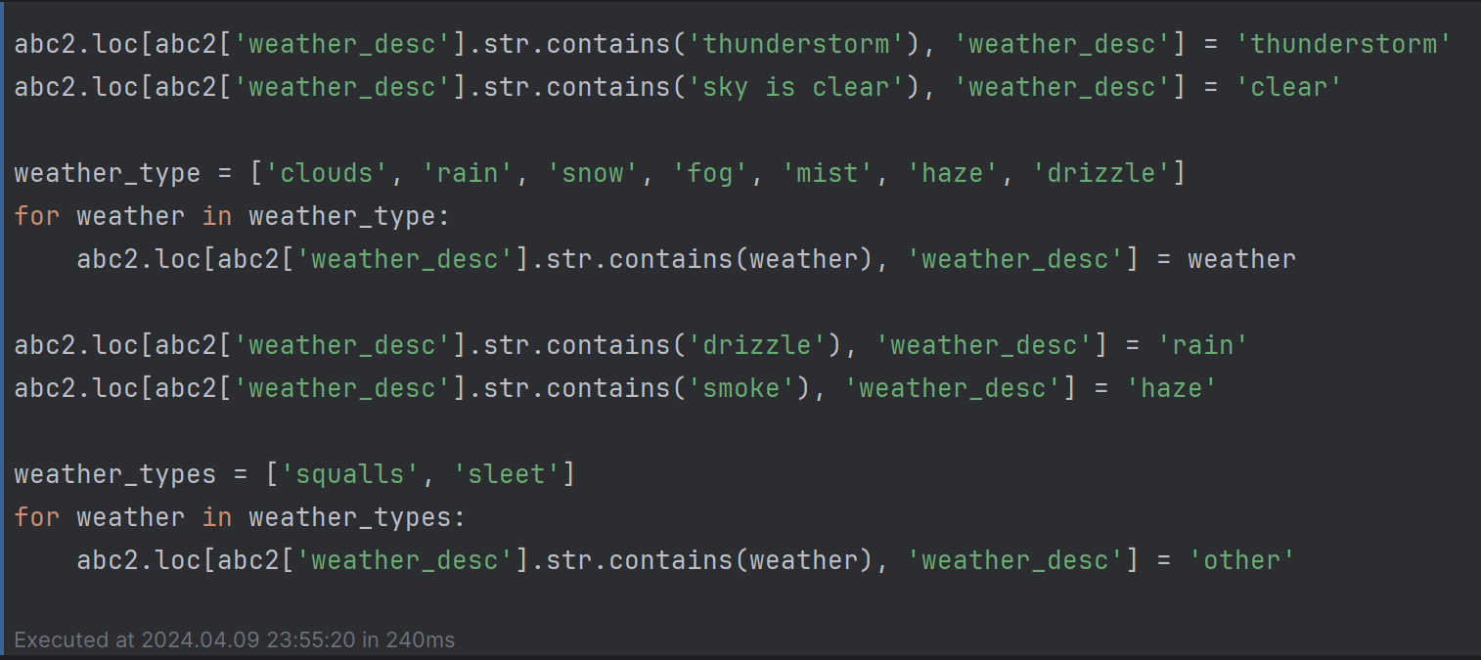

Figure 49: Weather description category grouping code

We're simplifying the 'weather_desc' column in 'abc2' by categorising various weather conditions into broader categories. This includes grouping descriptions like 'thunderstorm' and 'sky is clear' into more general terms like 'thunderstorm' and 'clear,' respectively. Additionally, we're condensing detailed weather types like clouds, rain, snow, fog, mist, haze, and drizzle into their main categories for easier analysis and interpretation.

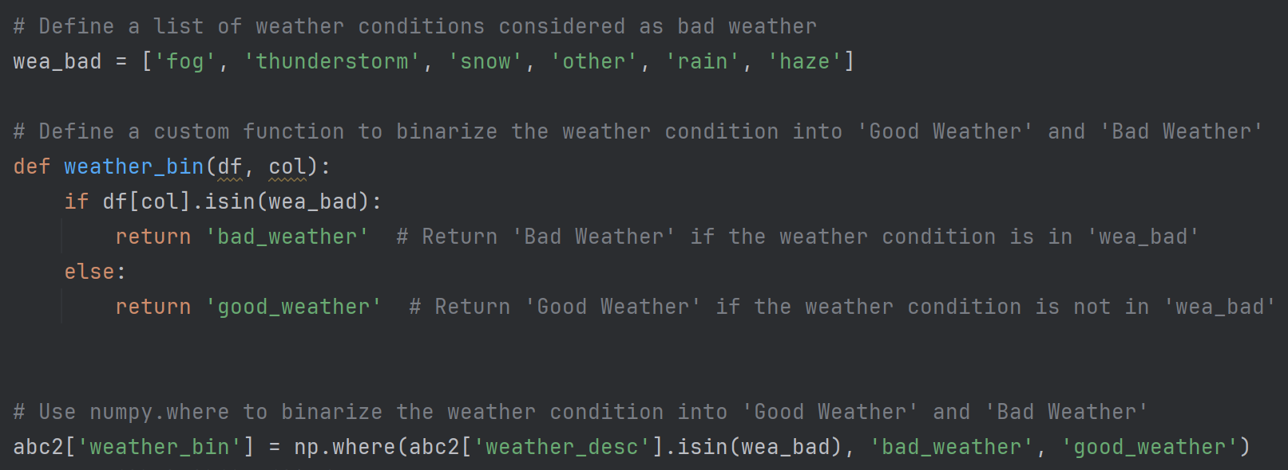

Figure 50: Weather description binary group code

We're identifying bad weather conditions like fog, thunderstorms, snow, etc. Then, we use a custom function to categorise weather as either 'bad_weather' or 'good_weather' based on this list.

#### 4.3.4.2 Snow/ Holiday

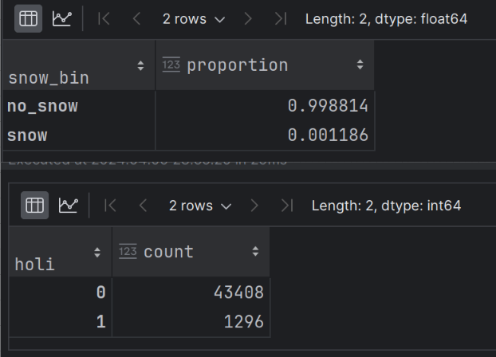

Figure 51*: Snow and holiday total counts and proportion*

I've completed the categorization process by creating a binary classification for snow conditions, where if there's snow, it's labelled as 'snow,' otherwise, it's labelled as 'no_snow.' Similarly, I've applied the same approach to handle holidays, assigning a value of 1 if there's a holiday present, and 0 otherwise. This method simplifies the data into clear categories, making it easier to analyse and interpret patterns or correlations within the dataset.

#### 4.3.4.3 Label Encoding Process

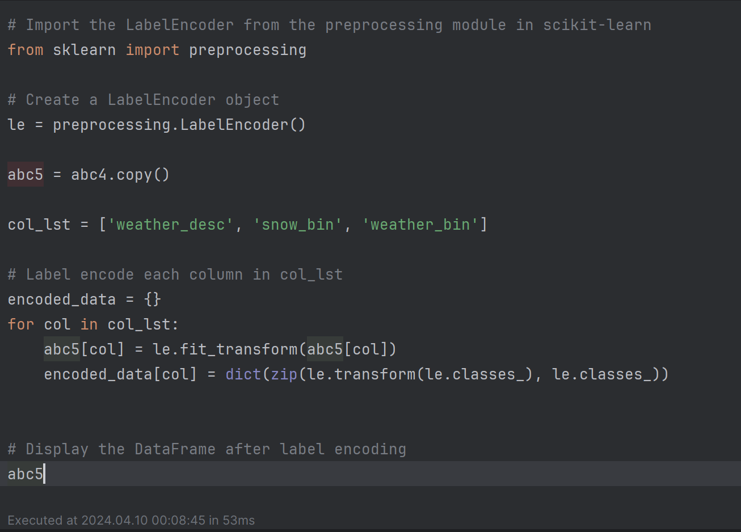

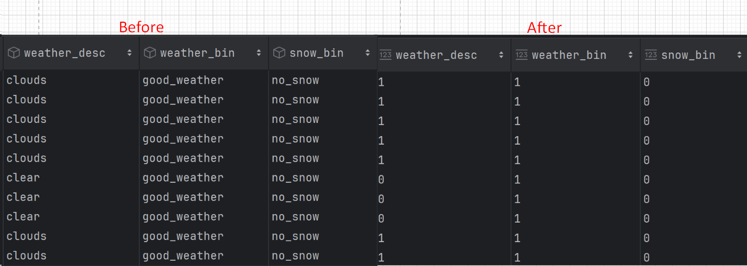

Figure 52*: Before and after weather binary group*

After categorising the 'weather_desc', 'snow_bin', and 'weather_bin' columns into their main classes, the next step involves label encoding the data. This process converts the categorical data into numerical form, which is essential for machine learning algorithms that require numeric inputs. Each column in the specified list, col_lst, undergoes label encoding, where unique categorical values are assigned numerical labels.

## 4.4 Model Building

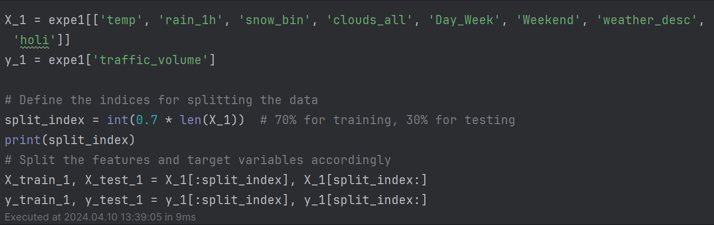

Figure 53: training and testing splitting proportion

I extracted relevant features from the dataset, and the target variable is 'traffic_volume'. Then, I split the data into training and testing sets using a 70-30 split ratio for model training and evaluation.

### 4.4.1 Short-list Promising Model

Before diving into model building, it's prudent to shortlist promising models. This approach allows for identifying the top 5 best models based on their R2 scores, providing a clear direction for subsequent model tuning. By shortlisting models first, it streamlines the process by focusing efforts on refining the most promising candidates, optimising resources, and ensuring a more efficient and effective modelling strategy.

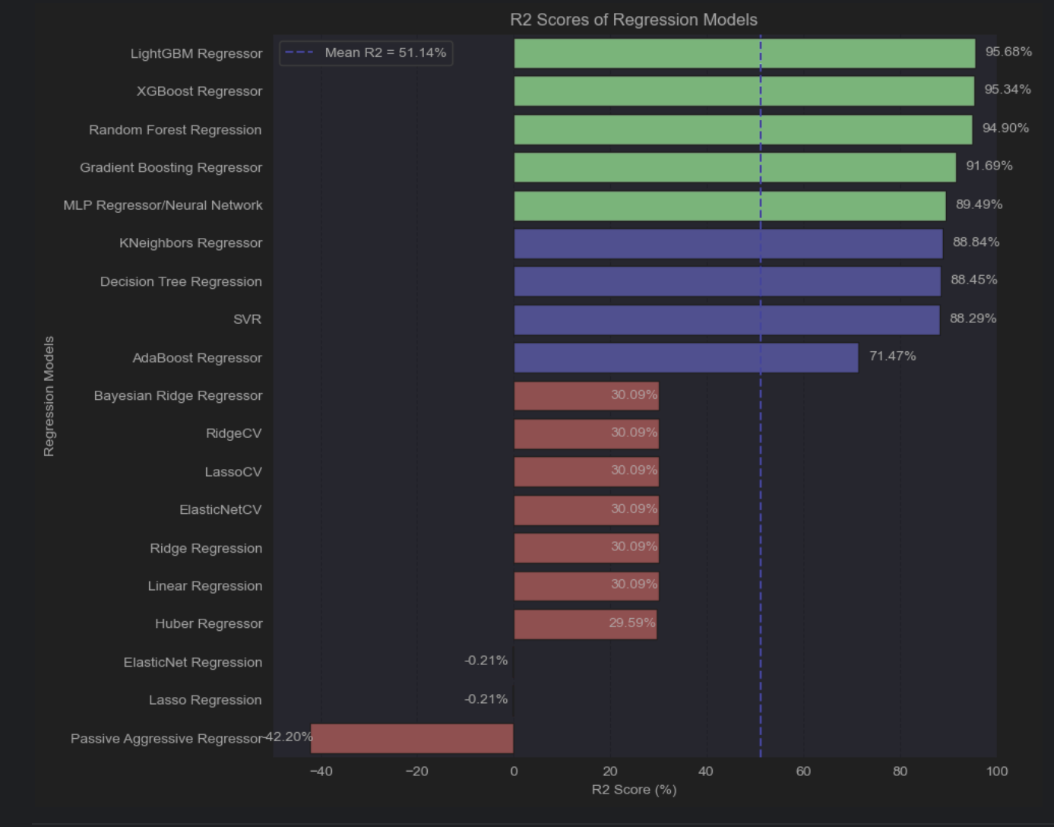

Figure 54*: R2 Scores of Regression Models*

The models with the highest R2 scores, ranging from 90.69% to 95.68%, are XGBoost Regressor, LightGBM Regressor, Random Forest Regression, Gradient Boosting Regressor, and MLP Regressor/Neural Network. These top-performing models exhibit strong predictive capabilities and will undergo more comprehensive evaluation metrics to refine and enhance their accuracy further. The focus will be on optimising these models to achieve greater precision and reliability in predicting the target variable.

### 4.4.2 Models

The top-performing models based on R2 score will undergo further evaluation using cross-validation (CV) techniques to establish a default model. Subsequently, additional evaluation metrics such as Mean Squared Error (MSE), Root Mean Squared Error (RMSE), and Mean Absolute Error (MAE) will be employed to comprehensively assess model performance. In addition to these metrics, an analysis of important features will also be conducted in this chapter to gain insights into the factors contributing significantly to model performance and predictive accuracy.

Let's introduce the code for calculating these evaluation metrics below:

def evaluate_regression_model(model, X, y, cv=5):

# Calculate R-squared

r2_scores = cross_val_score(model, X, y, scoring='r2', cv=cv)

r2_mean = np.mean(r2_scores)

# Calculate MSE and RMSE

mse_scores = -cross_val_score(model, X, y, scoring='neg_mean_squared_error', cv=cv)

rmse_scores = np.sqrt(mse_scores)

mse_mean = np.mean(mse_scores)

rmse_mean = np.mean(rmse_scores)

# Calculate MAE

mae_scores = -cross_val_score(model, X, y, scoring='neg_mean_absolute_error', cv=cv)

mae_mean = np.mean(mae_scores)

# Text-based results

print("R-squared:", r2_mean)

print("MSE:", mse_mean)

print("RMSE:", rmse_mean)

print("MAE:", mae_mean)

# Plotting results

metrics = ['R-squared', 'MSE', 'RMSE', 'MAE']

scores = [r2_mean, mse_mean, rmse_mean, mae_mean]

plt.figure(figsize=(10, 6))

plt.bar(metrics, scores, color=['blue', 'green', 'orange', 'red'])

plt.xlabel('Metrics')

plt.ylabel('Score')

plt.title('Regression Model Evaluation Metrics')

plt.ylim(min(scores) - 0.1 * max(scores), max(scores) + 0.1 * max(scores))

plt.grid(axis='y')

for i in range(len(metrics)):

plt.text(metrics[i], scores[i] + 0.01 * max(scores), f'{scores[i]:.3f}', ha='center')

plt.show()

The `evaluate_regression_model` function is designed to assess the performance of a regression model using key evaluation metrics such as R-squared (R2), mean squared error (MSE), root mean squared error (RMSE), and mean absolute error (MAE). This evaluation process involves leveraging cross-validation on the provided dataset to obtain robust and reliable metric values. After computing these metrics, the function presents the mean scores for each metric in a clear and concise text format.

Furthermore, the function goes beyond textual reporting by creating a visually informative bar plot. This plot serves as a graphical representation of the evaluation metrics, enhancing the understanding of model performance. Each metric is labelled on the x-axis, while the corresponding score is depicted on the y-axis. To aid interpretation, distinct colours are assigned to each metric: blue for R2, green for MSE, orange for RMSE, and red for MAE. Additionally, the scores are explicitly displayed above each bar for easy reference. The plot is appropriately titled "Regression Model Evaluation Metrics" and includes gridlines for improved visual clarity and precision.

#### 4.4.2.1 Light Gradient-Boosting (LightGBM)

# Define the LightGBM regressor model

lgb_model = lgb.LGBMRegressor()

# Fit the model on the training data

lgb_model.fit(X_train_no_split, y_train_no_split)

evaluate_regression_model(lgb_model,X_train_no_split, y_train_no_split)

The code defines a LightGBM regressor model (`lgb_model`) and fits it to the training data (`X_train_no_split`, `y_train_no_split`). The `evaluate_regression_model` function is then used to evaluate the model's performance on the training data. This model is considered the best performer based on the previously shortlisted promising models due to its high R-squared (R2) score. LightGBM is a gradient boosting framework that uses tree-based learning algorithms. It is designed for efficiency and can handle large datasets faster than other boosting algorithms.

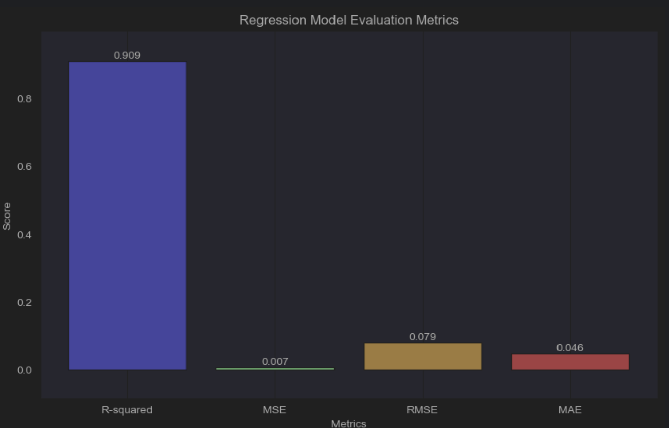

Figure 55*: LightGBM Model Evaluation Metrics*

The results provided are based on the default LightGBM model without any additional tuning or optimization. The model including an R-squared value of around 0.909, MSE of approximately 0.00666, RMSE of about 0.0785, and MAE of 0.0458.

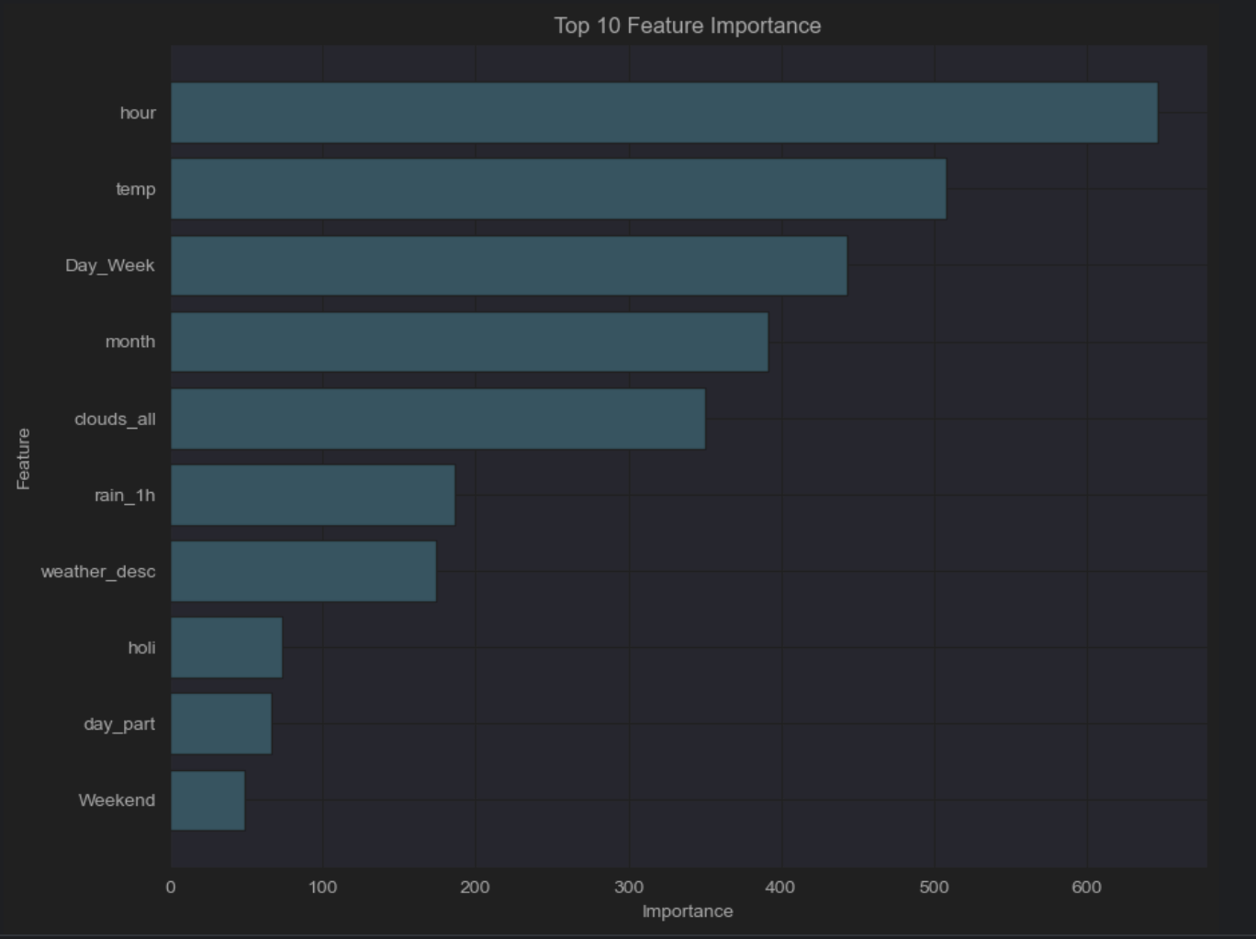

Figure 56: LightGBM Top 10 Feature Importance

The most crucial features in the model for traffic prediction are "Hour," "temp," "Day_Week," and "month." These variables represent time-related aspects, weather conditions, and seasonal variations, which significantly influence traffic patterns. On the other hand, features like "holi," "day_part," and "Weekend" have lower importance scores, indicating their relatively minor impact on traffic prediction compared to the top features.

#### 4.4.2.2 Random Forest

# Create the Random Forest Regressor model

rf_model = RandomForestRegressor()

# Fit the model on the training data

rf_model.fit(X_train_no_split, y_train_no_split)

evaluate_regression_model(rf_model,X_train_no_split, y_train_no_split)

The Random Forest Regressor model is one of the top-performing models based on its R-squared score, ranking as the third best in our shortlisted promising models. This model utilises an ensemble of decision trees to make predictions, offering robust performance in capturing complex relationships within the data. The model was trained using the training data without splitting.

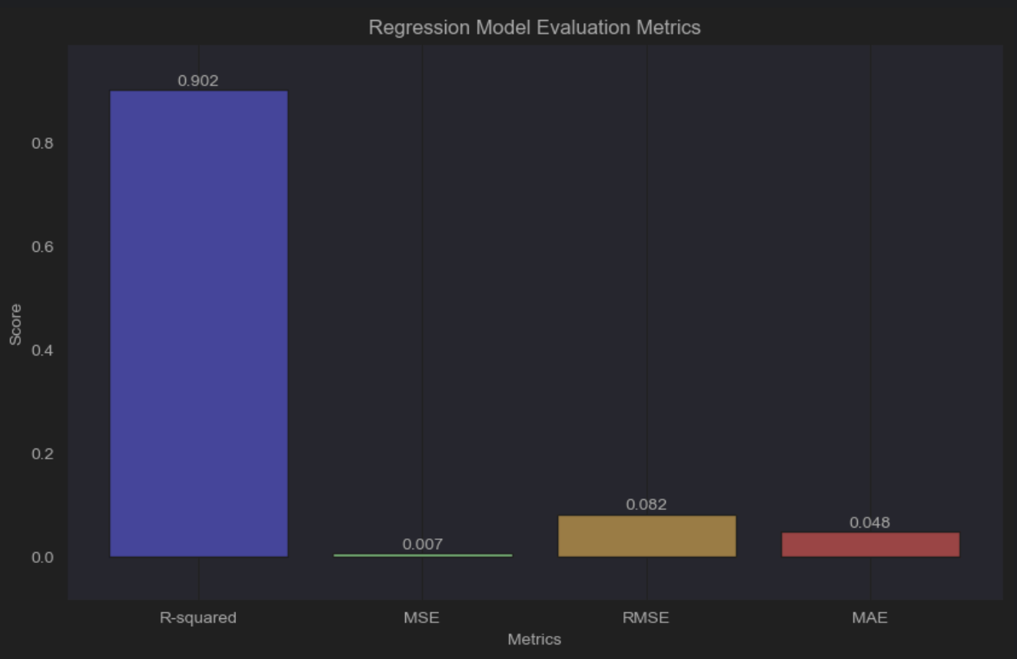

Figure 57: Random Forest Model Evaluation Metrics

The results provided are based on the default Random Forest regression model without any additional tuning or optimization. The model achieved an R-squared (R2) score of 0.9015, MSE of 0.0072, RMSE of 0.0824, and MAE of 0.0482.

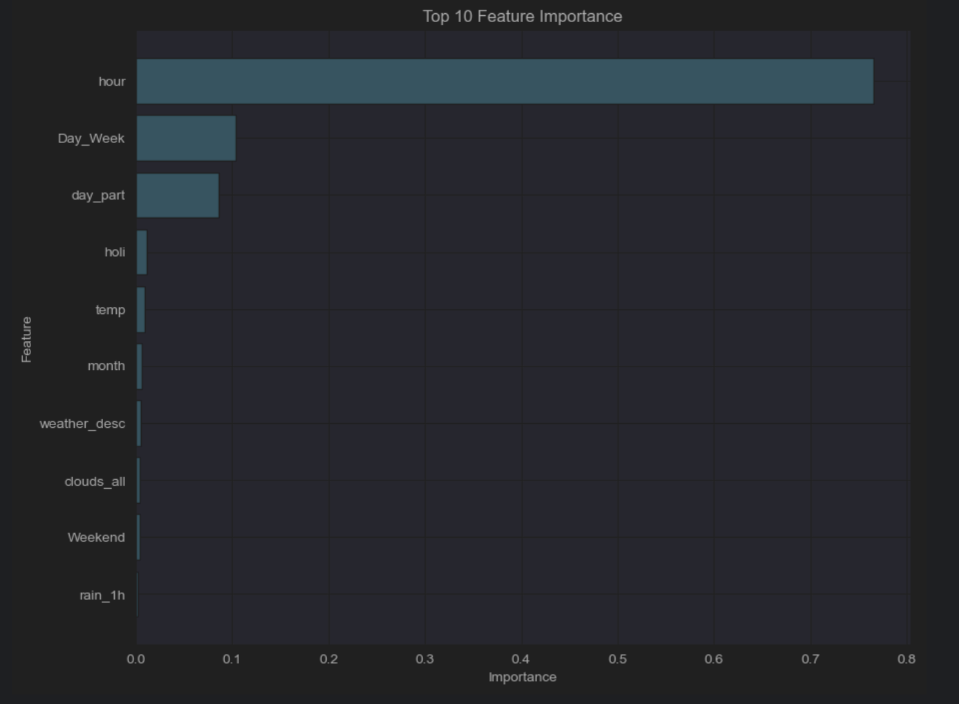

Figure 58: Random Forest top 10 features important

The feature importance analysis for the Random Forest model emphasises the dominance of the "hour" feature, with a significant score of 0.7653, indicating its strong correlation with the target variable. This underscores the pivotal role of time of day in predicting outcomes. Following closely is the "Day_Week" feature at 0.1039, suggesting distinct patterns between weekdays and weekends. Additionally, the "day_part" feature, representing specific time intervals within a day, also shows considerable importance at 0.0866. Conversely, features such as "holi," "temp," "month," "weather_desc," "clouds_all," "Weekend," and "rain_1h" have lower importance scores, with "rain_1h" being the least impactful among the top 10 features.

#### 4.4.2.3 Gradient Boosting

gb_model = GradientBoostingRegressor()

# Fit the model to the training data

gb_model.fit(X_train_no_split, y_train_no_split)

# Evaluate the model using the evaluate_regression_model function

evaluate_regression_model(gb_model, X_train_no_split, y_train_no_split)

The Gradient Boosting Regressor model (`gb_model`) emerges as a top-performing contender, showcasing a remarkable R-squared score and earning its place among our shortlisted promising models. This model harnesses the power of gradient boosting, a sophisticated ensemble technique that sequentially combines weak learners (often decision trees). Each subsequent model corrects the errors of its predecessor, leading to a robust predictive capability that excels at capturing intricate relationships within the dataset.

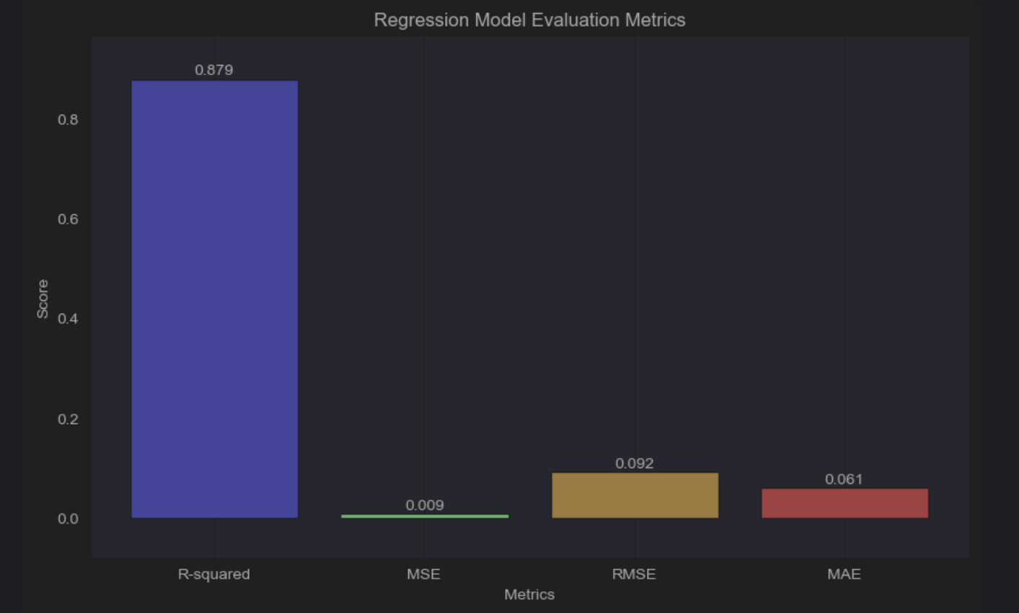

Figure 59: Gradient Boosting model evaluation metrics

The Gradient Boosting Regressor model's performance metrics are as follows: an R-squared (R2) score of 0.8792, MSE of 0.0088, RMSE of 0.0924, and MAE of 0.0611. These results are derived from the default model configuration, without any additional tuning or optimization.

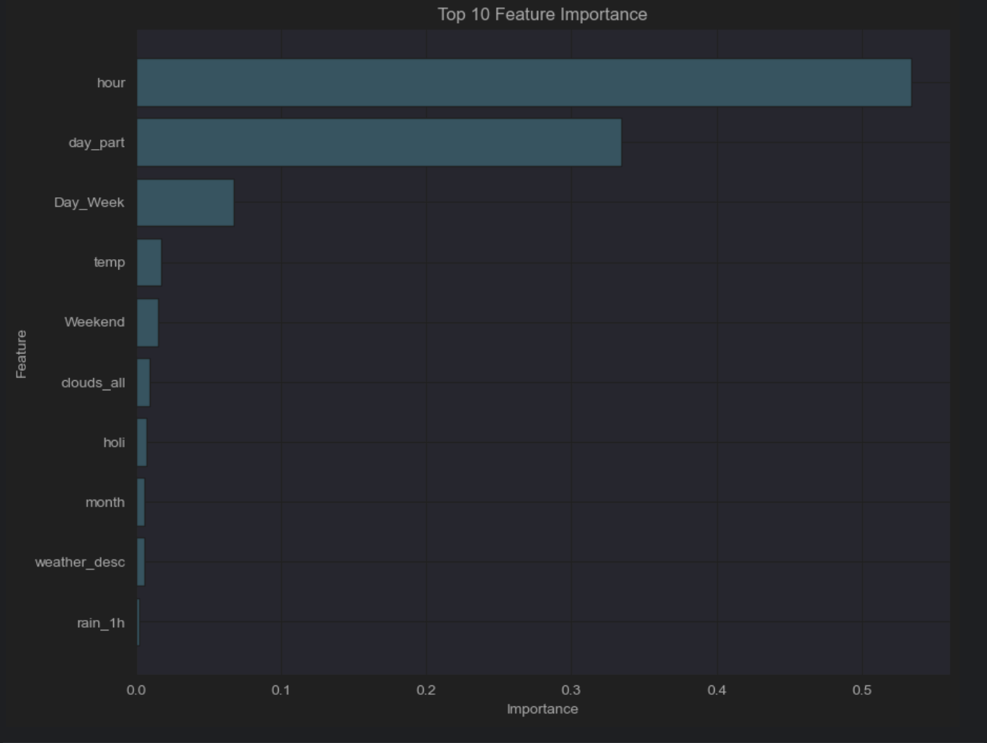

Figure 60: Gradient Boosting top 10 features important

The Gradient Boosting Regressor (GBR) model's feature importance analysis reveals insights into the significance of different predictors. The most influential feature is "hour," with a substantial importance score of 0.5340, indicating a strong correlation between the time of day and the target variable. Following closely is "day_part" at 0.3347, which likely represents specific time intervals within a day that impact the outcome. Other features like "temp," "Weekend," "clouds_all," "holi," "month," "weather_desc," and "rain_1h" exhibit lower importance scores, indicating less impact on the model's predictions compared to the top three features.

#### 4.4.2.4 Multilayer Perceptron(MLP)

mlp_model = MLPRegressor()

# Fit the model on the training data

mlp_model.fit(X_train_no_split, y_train_no_split)

evaluate_regression_model(mlp_model,X_train_no_split, y_train_no_split)

The MLPRegressor, short for Multi-layer Perceptron Regressor, is a type of artificial neural network (ANN) that can be used for regression tasks. It consists of multiple layers of nodes, each connected to nodes in adjacent layers, and uses activation functions to introduce non-linearity into the model. MLPs are known for their ability to capture complex relationships in data.

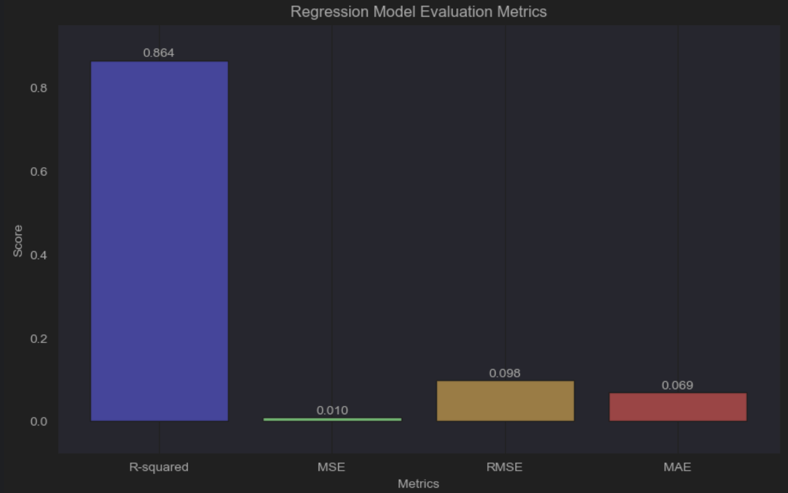

Figure 61: MLP evaluation metrics

The MLPRegressor model's performance metrics are as follows: an R-squared (R2) score of 0.8643, MSE of 0.0099, RMSE of 0.0980, and MAE of 0.0685. These results are derived from the default model configuration, without any additional tuning or optimization.

Since the MLPRegressor model does not have a feature_importances_ attribute, we are unable to perform a feature importance analysis directly on this model.

## 4.5 Summary

In Chapter 4 of the project, significant progress has been made, focusing on essential phases like data understanding, meticulous data cleaning, and thorough data preprocessing. These foundational steps have laid a robust groundwork for the subsequent model building phase. During this phase, a diverse array of models has been carefully crafted to address various aspects of predictive analytics or machine learning tasks. The shortlisted promising models for this project include LightGBM, Random Forest, Gradient Boosting (GB), and Multi-layer Perceptron (MLP). Each of these models brings unique strengths and capabilities to the table, providing a comprehensive and versatile approach to tackling the complexities inherent in the project's data-driven challenges.

# Chapter5: Result And Discussion

## 5.1 Introduction

In this chapter, the focus shifts towards enhancing the top-performing models identified in Chapter 4.4.2, primarily based on their high R2 scores. These models encompass LightGBM, Random Forest, Gradient Boosting (GB), and Multi-layer Perceptron (MLP). Advanced techniques such as grid search will be employed to fine-tune their hyperparameters, aiming for optimal predictive accuracy. The evaluation process will involve learning curves to gauge the models' generalisation capabilities as data volume increases.

The analysis will delve into crucial evaluation metrics like MSE, RMSE, and MAE, providing insights into prediction accuracy and error management. Furthermore, log scale plots will be utilised to visually represent the models' predictive accuracy against actual values. These iterative steps are designed to refine the models, addressing complexities and enhancing their performance across a range of predictive tasks.

## 5.2 Model Evaluations and Discussions

In this chapter, we'll focus on enhancing models that have shown the best performance in terms of R2 score, as identified in the default model evaluation results from section 4.4.2. We'll utilise advanced techniques like grid search to fine-tune hyperparameters and aim to improve the R2 score of these models. Additionally, we'll use learning curves to assess model performance, particularly focusing on enhancing the R2 score.

Let’s introduce the learning curve code:

def plot_learning_curve(model, X, y, cv=5):

train_sizes, train_scores, val_scores = learning_curve(model, X, y, cv=cv, scoring='r2')

train_scores_mean = np.mean(train_scores, axis=1)

train_scores_std = np.std(train_scores, axis=1)

val_scores_mean = np.mean(val_scores, axis=1)

val_scores_std = np.std(val_scores, axis=1)

# Plotting the learning curve

plt.figure(figsize=(12, 8))

plt.fill_between(train_sizes, train_scores_mean - train_scores_std,

train_scores_mean + train_scores_std, alpha=0.1,

color="blue")

plt.fill_between(train_sizes, val_scores_mean - val_scores_std,

val_scores_mean + val_scores_std, alpha=0.1, color="orange")

plt.plot(train_sizes, train_scores_mean, 'o-', color="blue", label="Training score")

plt.plot(train_sizes, val_scores_mean, 'o-', color="orange", label="Validation score")

plt.xlabel("Training examples")

plt.ylabel("Score")

plt.title("Learning Curve")

plt.legend(loc="best")

plt.grid(True)

plt.show()

The `plot_learning_curve` function is designed to visualise the learning progress of regression models using cross-validation (CV) techniques. It focuses on the crucial metric R-squared (R2), which measures the model's predictive performance. By plotting the training and validation scores against different training dataset sizes, it provides insights into how well the model generalises as it learns from more data. The blue curve shows the model's performance on the training data, while the orange curve indicates its performance on validation data. This plot helps assess how well the model generalises and whether there are issues like overfitting or underfitting.

### 5.2.1 Light Gradient-Boosting (LightGBM)

params = {

'num_leaves': [20, 30],

'learning_rate': [0.05, 0.1],

'max_depth': [-1, 5],

'min_child_samples': [10, 20],

'subsample': [0.6, 0.8],

'colsample_bytree': [0.6, 0.8],

'reg_alpha': [0.0, 0.1],

'reg_lambda': [0.0, 0.1],

'n_estimators': [100, 200]

}

# Define the LightGBM regressor model

lgb_model = lgb.LGBMRegressor()

# Create Grid Search with cross-validation

grid_search = GridSearchCV(estimator=lgb_model, param_grid=params, cv=5, scoring='r2', verbose=1, n_jobs=-1)

The code snippet initialises a grid search for optimising hyperparameters in a LightGBM regressor model. Hyperparameters like num_leaves, learning_rate, max_depth, etc., are varied within specified ranges. The GridSearchCV object employs 5-fold cross-validation and targets the R-squared metric (scoring='r2') to evaluate model performance. This setup aims to find the best combination of hyperparameters that maximises the model's R-squared score.

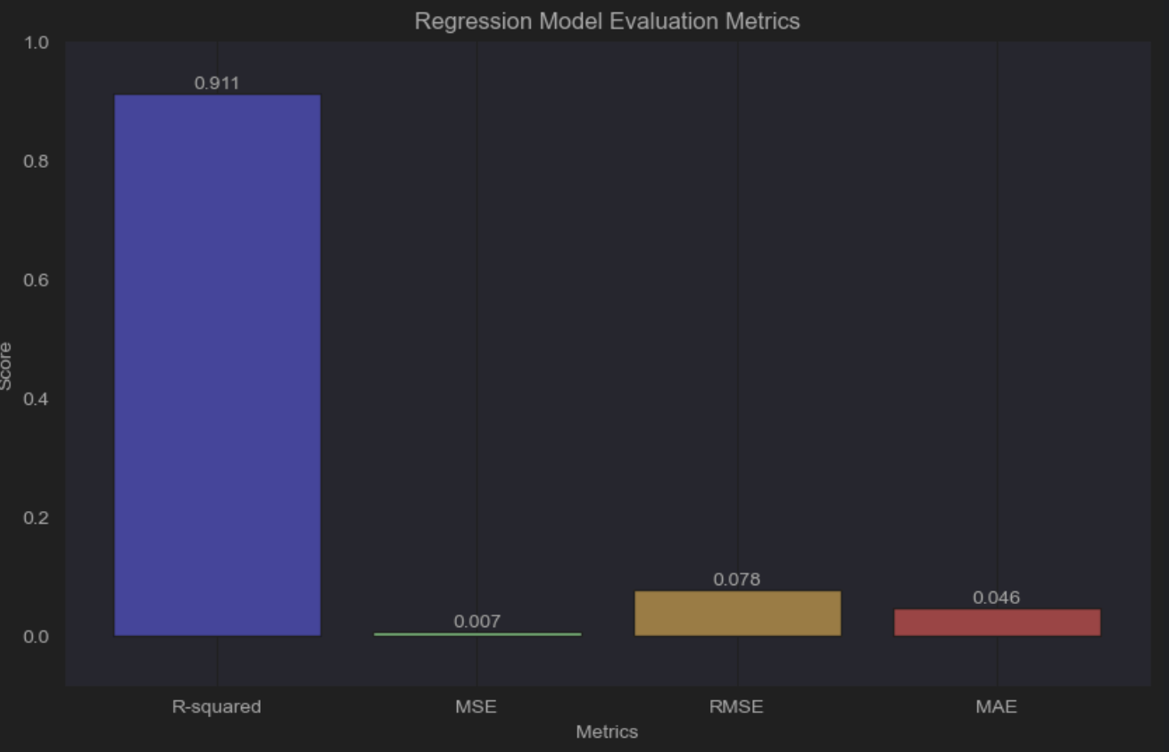

Figure 62: LightGBM evaluation metrics(Grid Search)

Before the grid search, the LightGBM regressor model exhibited promising performance, boasting an R-squared (R2) score of 0.9090, which translates to explaining around 90.90% of traffic variance. The mean squared error (MSE) stood at 0.0067, indicating reasonably accurate predictions but suggesting room for refinement. Additionally, the mean absolute error (MAE) was measured at 0.0458, showcasing the average magnitude of errors in the model's traffic predictions.

Following the grid search optimization, notable enhancements were observed in the model's performance metrics. The R2 score experienced a notable surge, reaching 0.9110, which signifies a tighter fit to the traffic data and an improved ability to capture underlying trends accurately. Simultaneously, the MSE decreased to 0.0065, indicating closer proximity between the model's predicted values and the actual traffic data. The MAE also saw a slight improvement, dropping to 0.0457, reflecting reduced error magnitudes in the model's traffic predictions.

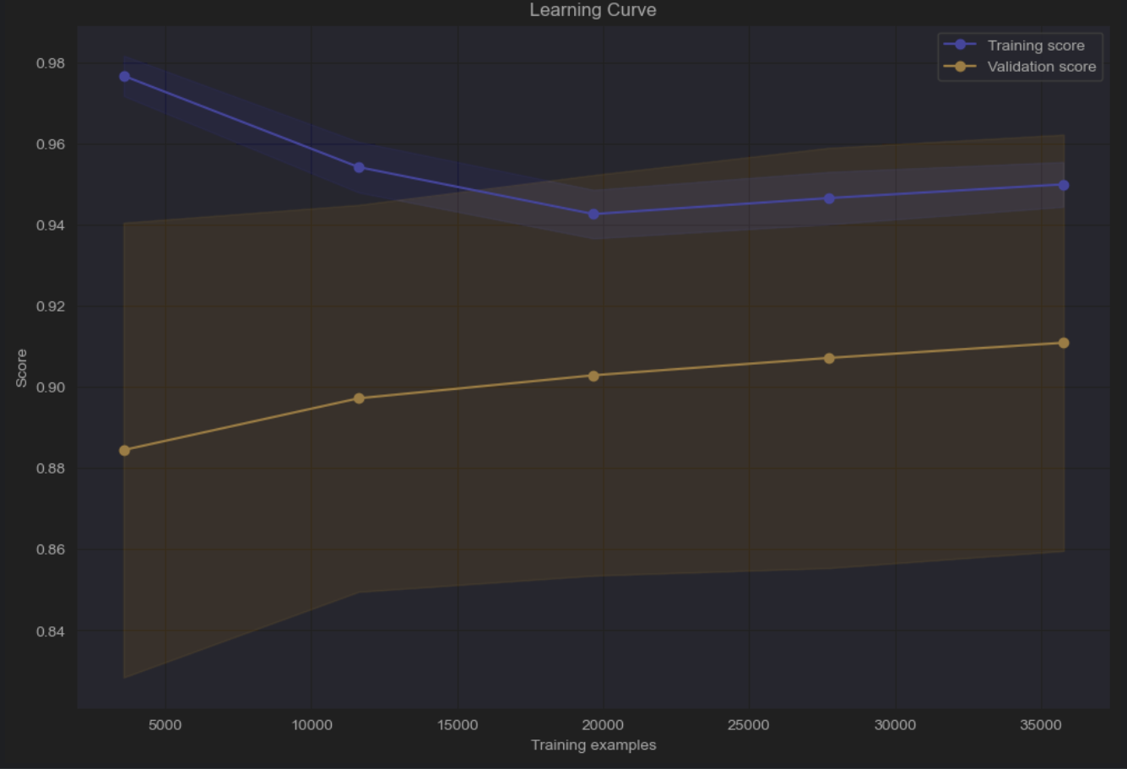

Figure 63: LightGBM Learning Curve

The learning curve for the LightGBM model illustrates its performance as training data size increases. The training sizes range from 3576 to 35763 examples. The mean training scores, representing the R-squared (R2) scores during training, are notably high and progressively decrease slightly as more data is used for training. This decrease is expected as the model encounters more diverse and complex patterns in the larger training sets.

The mean validation scores, reflecting the model's performance on unseen validation data, increase with larger training sizes. This trend indicates that as the model learns from more data, it generalises better to new data, as seen in the increasing validation scores. The convergence of training and validation scores suggests that the model is not overfitting or underfitting significantly and is finding a balance between learning from the training data and generalising to unseen data.

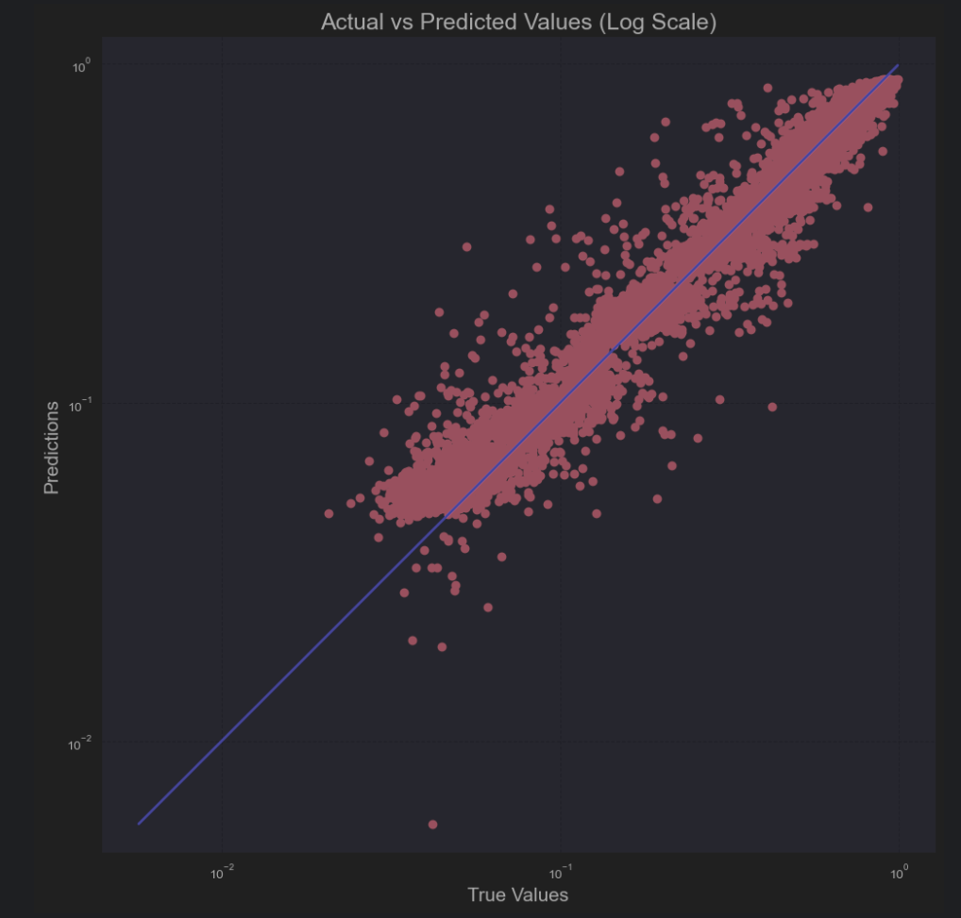

Figure 64: LightGBM actual vs predicted value (log scale)

In the log scale actual versus predicted plot for the LightGBM model, most of the dots are situated near the reference line, indicating a proximity between the predicted and actual values. This clustering of points around the reference line signifies a generally good fit between the model's predictions and the true traffic values. However, amidst this overall pattern, there is one noticeable outlier point that stands out due to its significant deviation from the reference line. This outlier suggests a notable discrepancy or error in that particular prediction compared to the rest of the data points.

### 5.2.2 Random Forest

param_grid = {

'n_estimators': [100, 200, 300],

'max_depth': [None, 5, 10],

'min_samples_split': [2, 5, 10],

'min_samples_leaf': [1, 2, 4]

}

# Define the Random Forest Regressor model

rf_model = RandomForestRegressor()

# Create Grid Search with cross-validation for R2 scoring

grid_search = GridSearchCV(estimator=rf_model, param_grid=param_grid, cv=5, scoring='r2', verbose=1, n_jobs=-1)

The provided code sets up a grid search for hyperparameter tuning of a Random Forest Regressor model using cross-validation. The param_grid dictionary specifies different values to explore for key hyperparameters of the Random Forest model, including n_estimators (number of trees), max_depth (maximum depth of each tree), min_samples_split (minimum number of samples required to split an internal node), and min_samples_leaf (minimum number of samples required to be at a leaf node). The grid search will evaluate various combinations of these hyperparameters using 5-fold cross-validation and use the R2 score as the evaluation metric (scoring='r2'). The verbose=1 parameter enables verbose output during the grid search process, and n_jobs=-1 utilises all available CPU cores for parallel processing, speeding up the grid search.

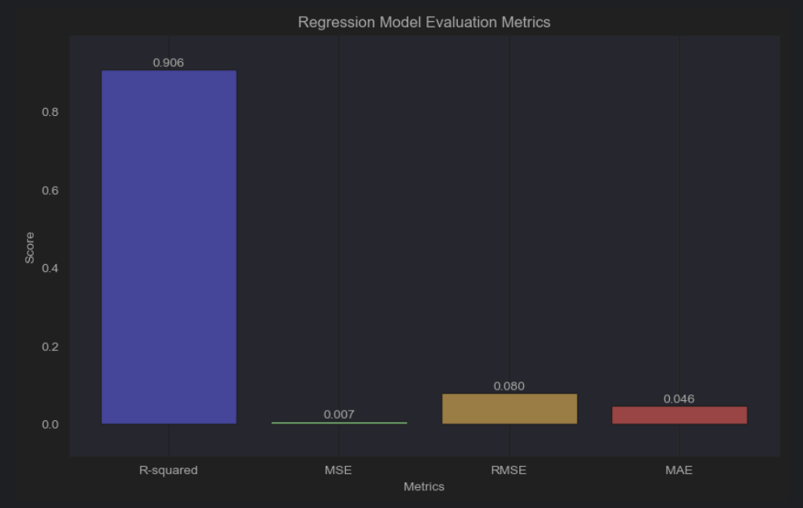

Figure 65: Random Forest evaluation metrics (Grid Search)

Before the grid search, the Random Forest Regressor model achieved an R-squared (R2) score of 0.9015, indicating it explained approximately 90.15% of the variance in the data. The mean squared error (MSE) was 0.0072, reflecting the average squared difference between predicted and actual values. The root mean squared error (RMSE) at 0.0824 represented the square root of the MSE, indicating the average magnitude of error in the model's predictions. The mean absolute error (MAE) of 0.0482 highlighted the average magnitude of errors in the model's predictions without considering their direction.

After the grid search, notable improvements were observed in the model's performance. The R2 score increased to 0.9060, signifying a better fit to the data and an enhanced ability to explain variance. The MSE decreased to 0.0069, indicating closer proximity between predicted and actual values, resulting in lower prediction errors on average. The RMSE also decreased to 0.0797, indicating reduced error magnitudes in the model's predictions. The MAE improved to 0.0463, further reflecting the reduction in prediction errors without considering their direction. Overall, the grid search process led to a more refined and improved Random Forest model, as evidenced by these performance metrics.

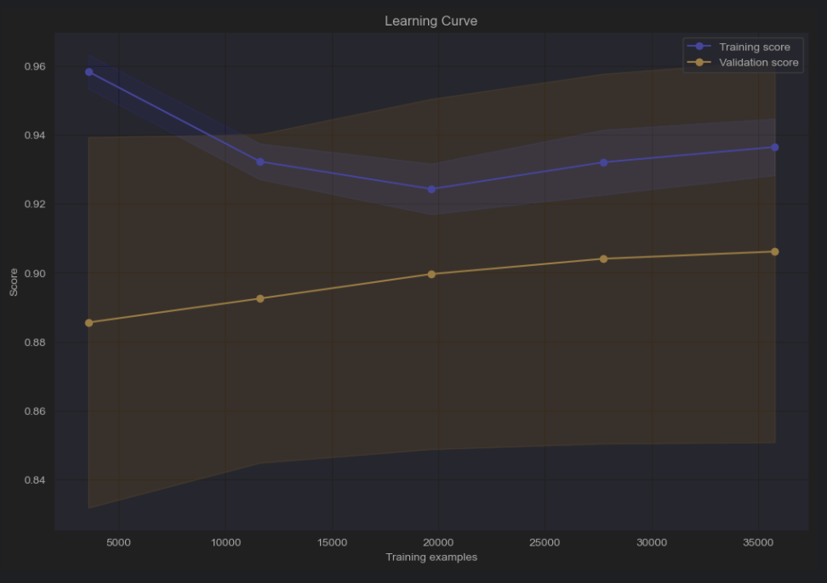

Figure 66: Random Forest Learning Curve

The mean training scores exhibit a gradual decrease with the expansion of the training size. This decline suggests that the model's performance on the training data slightly diminishes as more data points are included. However, it's noteworthy that even with larger training sizes, the training scores remain relatively high, indicating a robust fit of the model to the training dataset.

Conversely, the mean validation scores showcase an upward trajectory as the training size expands. This uptick indicates an enhancement in the model's performance on unseen data, represented by the validation set, with the inclusion of additional training examples. The rising validation scores signify that the model generalises better as more diverse data points are incorporated into the training process.

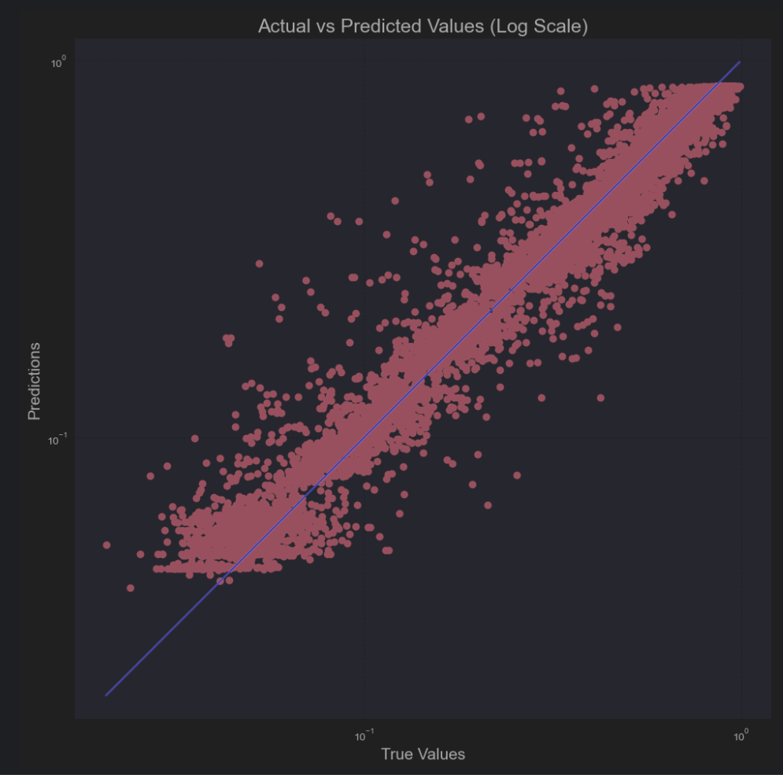

Figure 67: Random Forest actual vs predicted value (log scale)

The log scale actual versus predicted plot for our model displays a notable trend: the majority of dots cluster closely around the reference line, indicating a strong alignment between predicted and actual values and thus a high level of accuracy. However, this general trend is contrasted by approximately 10% of dots that are slightly further from the line, suggesting instances of larger prediction errors.

This contradiction in the plot reveals a nuanced picture of the model's performance. On one hand, the bulk of the data points show a good fit, indicating that the model captures underlying patterns effectively. On the other hand, the presence of outliers implies areas where the model's predictions deviate more significantly from the actual values.

### 5.2.3 Gradient Boosting

parameters = {

'n_estimators': [100, 200, 300],

'max_depth': [3, 5, 7],

'loss': ['squared_error', 'huber'],

'learning_rate': [0.01, 0.05, 0.1],

'min_samples_split': [2, 3, 5],

'min_samples_leaf': [1, 2, 3],

'max_features': ['sqrt', 'log2']

}

# Create the GradientBoostingRegressor model

gb_model = GradientBoostingRegressor()

# Perform GridSearchCV for hyperparameter tuning

grid_search = GridSearchCV(estimator=gb_model, param_grid=parameters, cv=5, verbose=2, n_jobs=-1)

The code snippet demonstrates the setup for hyperparameter tuning using GridSearchCV with a GradientBoostingRegressor model. The parameters specified for tuning include `n_estimators`, which controls the number of boosting stages, `max_depth` to manage tree depth, and `loss` to define the loss function. Additionally, `learning_rate` regulates step size, `min_samples_split` sets the minimum samples required for node splitting, `min_samples_leaf` determines minimum samples at leaf nodes, and `max_features` limits the number of features considered for splitting.

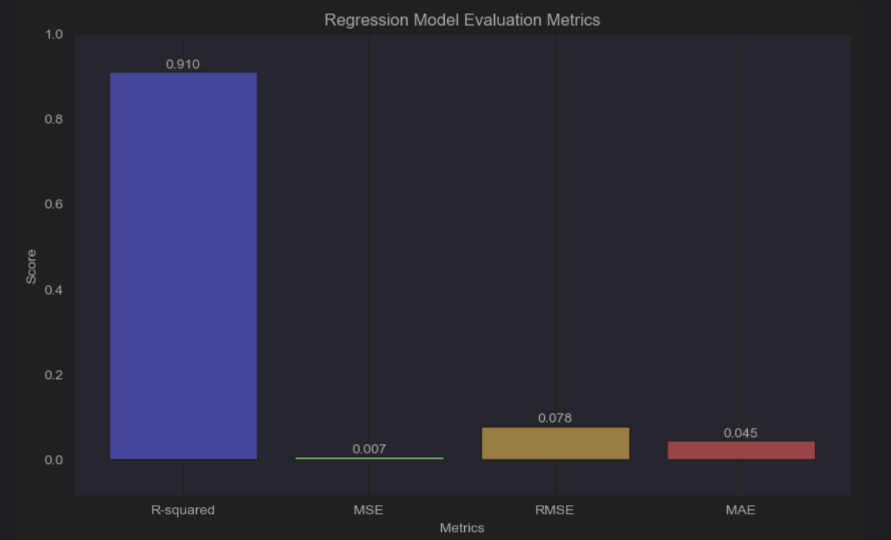

Figure 68: Gradient Boosting evaluation metrics (Grid Search)

Before the grid search, the Gradient Boosting Regressor model achieved an R-squared (R2) score of 0.8792, indicating that it explained approximately 87.92% of the variance in the data. The mean squared error (MSE) was 0.0088, reflecting the average squared difference between predicted and actual values. The root mean squared error (RMSE) of 0.0924 represented the standard deviation of the residuals. The mean absolute error (MAE) of 0.0611 quantified the average magnitude of errors in the model's predictions.

After the grid search, significant improvements were observed in the model's performance metrics. The R2 score increased to 0.9096, signifying a better fit of the model to the data and a higher level of explained variance. The MSE decreased to 0.0066, indicating reduced error in predicting values. The RMSE also decreased to 0.0779, showing improved accuracy in predicting the target variable. Furthermore, the MAE decreased to 0.0445, indicating a decrease in the average magnitude of errors in the model's predictions. Overall, the grid search process effectively optimised the model's hyperparameters, leading to enhanced predictive performance.

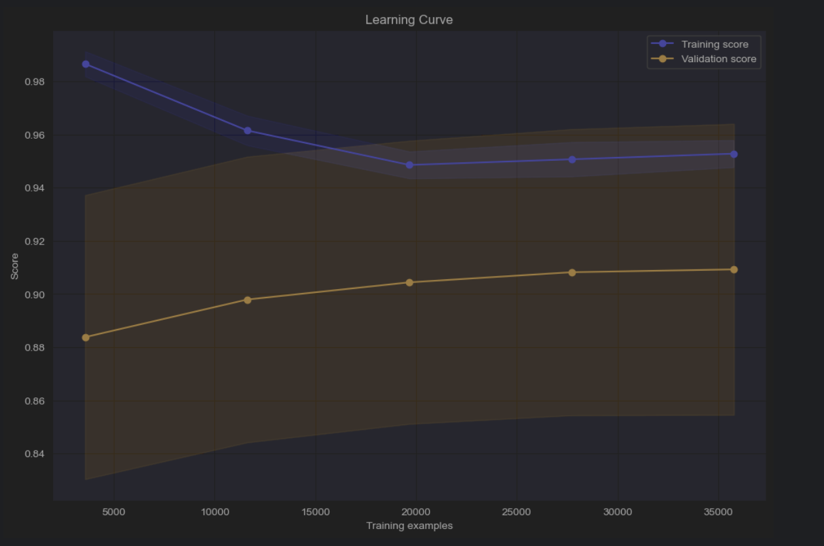

Figure 69: Gradient Boosting Learning Curve

The learning curve based on the R2 score for the model reveals several key insights. As the training size increases, the mean training scores gradually decrease, indicating a slight drop in model performance on the training data. However, it's important to note that even with larger training sizes, the training scores remain relatively high, indicating a good fit of the model to the training dataset.

On the validation side, there is a consistent increase in mean validation scores as the training size expands. This rise suggests that the model generalises better with more diverse data points included in the training process. The higher validation scores imply improved performance on unseen data, showcasing the model's ability to capture underlying patterns and trends effectively.

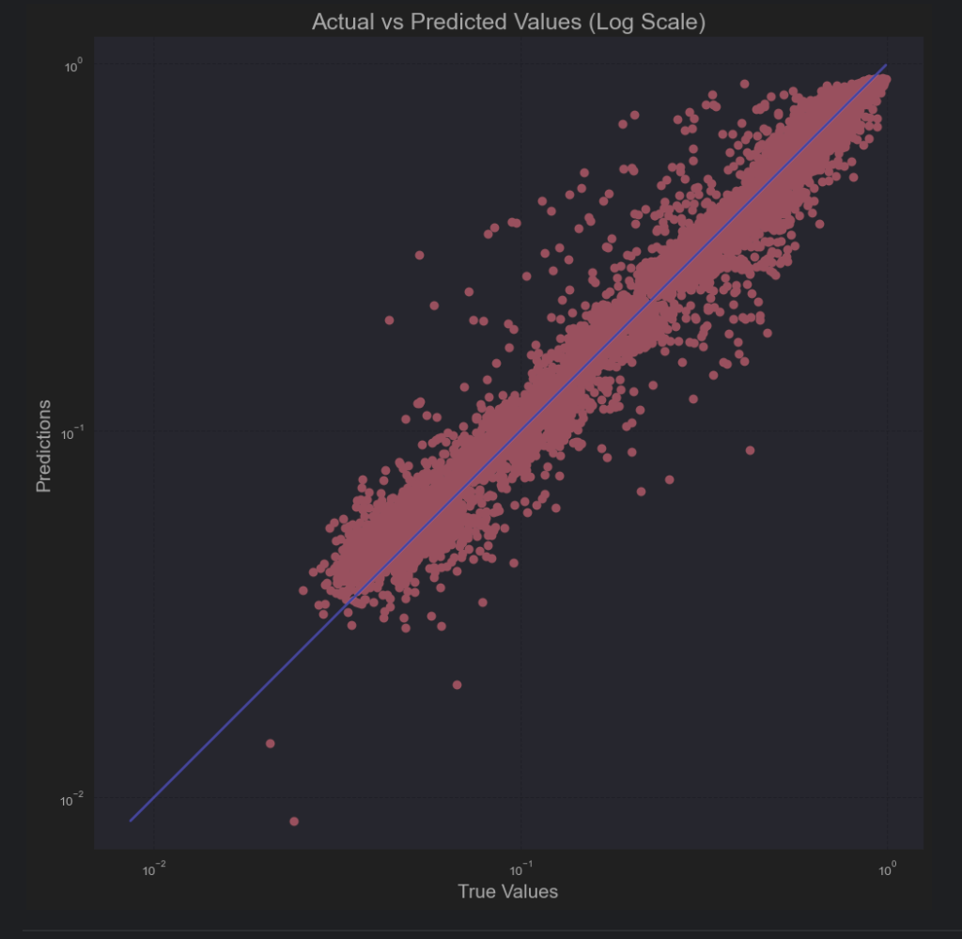

Figure 70: Gradient Boosting actual vs predicted values (log scale)

The log scale actual versus predicted plot for the Gradient Boosting (GB) model displays a generally strong alignment between predicted and actual values. The majority of data points, representing the predictions made by the model, cluster closely around the reference line. This clustering indicates that the model's predictions are close to the actual values, suggesting a good overall fit.

However, there is a subset of data points, approximately 10% of the total, that deviate noticeably from the reference line. These outliers represent instances where the model's predictions significantly differ from the actual values. In analysis, the plot indicates that while the GB model performs well in general, there are specific instances where its predictions are less accurate.

### 5.2.4 Multilayer Perceptron(MLP)

# Define the parameter grid for hyperparameter tuning

param_grid = {

'hidden_layer_sizes': [(50,), (100,), (50, 50), (100, 100)],

'activation': ['relu', 'tanh'],

'solver': ['adam'],

'alpha': [0.0001, 0.001, 0.01],

'learning_rate': ['constant', 'adaptive'],

'early_stopping': ['true']

}

# Define the MLPRegressor model

mlp_model = MLPRegressor()

# Create Grid Search with cross-validation for R2 scoring

grid_search = GridSearchCV(estimator=mlp_model, param_grid=param_grid, cv=5, scoring='r2', verbose=1, n_jobs=-1)

Firstly, `hidden_layer_sizes` specifies the layout of the hidden layers, offering options for single-layer configurations with 50 or 100 neurons and dual-layer setups with 50-50 or 100-100 neurons. The choice of `activation` function, including 'relu' and 'tanh', influences how the neurons in these layers respond to input data, affecting the network's ability to capture complex patterns.

The `solver` parameter refers to the optimization algorithm employed during training, with 'adam' being a popular choice known for its efficiency in adjusting learning rates dynamically. Additionally, `alpha` controls regularisation strength through L2 regularisation, aiding in preventing overfitting by penalising large coefficients.

The `learning_rate` parameter's options of 'constant' and 'adaptive' govern how the model adjusts its learning rate during training, with 'adaptive' decreasing it based on validation loss improvements. Lastly, `early_stopping` is set to 'true' to enable early stopping during training if validation scores plateau, assisting in preventing overfitting and improving generalisation.

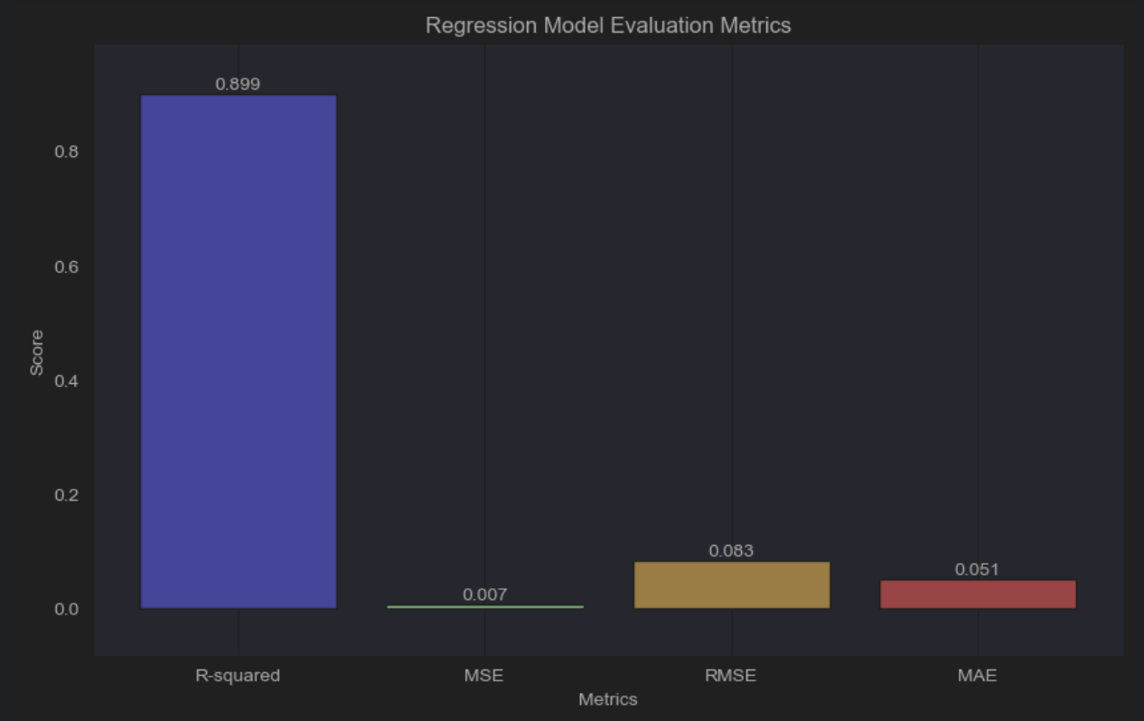

Figure 71: MLP evaluation metrics (Grid Search)

Before hyperparameter tuning with Grid Search Cross-Validation (GridSearchCV), the Multi-layer Perceptron (MLP) Regressor model demonstrated moderate performance, with an R-squared (R2) score of 0.8643. This score indicated that the model could explain approximately 86.43% of the variance in the dataset, reflecting a decent initial predictive capability. However, the Mean Squared Error (MSE) of 0.0099, Root Mean Squared Error (RMSE) of 0.0980, and Mean Absolute Error (MAE) of 0.0685 highlighted areas where the model could improve, especially in reducing prediction errors and enhancing overall accuracy.

After undergoing hyperparameter tuning through GridSearchCV, notable improvements were observed in the MLP Regressor's performance metrics. The R2 score increased to 0.8992, showcasing a substantial enhancement in the model's ability to capture the variance in the data. This improvement indicates that the tuned model can now explain approximately 89.92% of the dataset's variance, signifying a more robust fit. The decreases in MSE to 0.0073, RMSE to 0.0828, and MAE to 0.0506 further validate the effectiveness of parameter optimization. These reductions in error metrics reflect the refined predictive accuracy and reduced prediction errors achieved through hyperparameter tuning, highlighting the significance of parameter optimization in enhancing model performance.

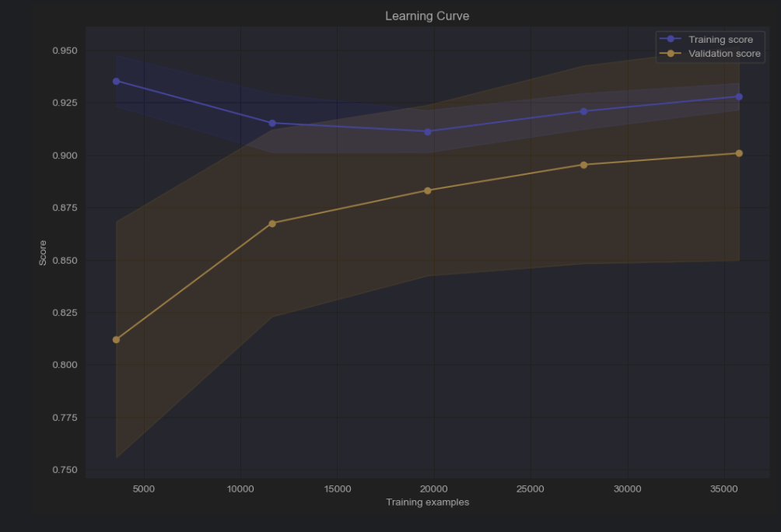

Figure 72: MLP Learning Curve

The learning curve based on the R2 score reveals an interesting trend. Initially, as the training size increases, there's a gradual decrease in the mean training scores, indicating a potential decline in the model's performance on the training data. However, this trend shifts after reaching a certain training size, specifically after 19,669 data points, where the mean training scores start to increase. This change suggests that beyond a certain point, providing more training data improves the model's performance on the training set.

Concurrently, the mean validation scores exhibit an upward trend throughout, indicating continuous improvement in the model's ability to generalise to unseen data as the training size expands. This behaviour aligns with the concept that larger and more diverse training datasets can lead to better generalisation of the model.

The contrasting trends in mean training and validation scores highlight the trade-off between overfitting and underfitting. Initially, with smaller training sizes, the model might overfit to the training data, leading to a decrease in validation performance. However, as the training size increases, the model generalises better to unseen data, resulting in improved validation scores.

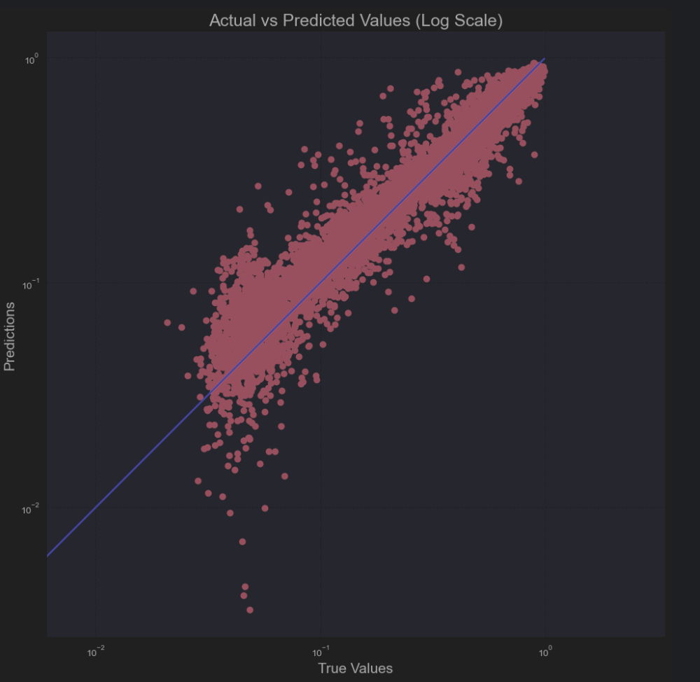

Figure 73: MLP actual vs predicted (log scale)

The log scale actual versus predicted value plot for the MLP model presents several observations. Firstly, the majority of dots are clustered near the reference line, indicating a close alignment between the predicted and actual values. This clustering suggests that the model's predictions are generally accurate, capturing the underlying patterns in the data effectively.

However, approximately 15% of the dots are slightly further away from the line, indicating a moderate level of discrepancy between predicted and actual values for these data points. This could imply areas where the model's predictions are less precise or where the data exhibits complexities that the model struggles to capture accurately.

Additionally, around 5% of the dots are noticeably far from the line, indicating significant discrepancies or errors in prediction for these specific data points. These outliers may represent instances where the model's performance is significantly challenged, possibly due to outliers or anomalies in the data or areas where the model lacks robustness.

Overall, the plot suggests that while the MLP model performs well for the majority of data points, there are still areas where its predictions deviate from the actual values.

### 5.2.5 Models Comparison

In sections 5.2.1 to 5.2.4, detailed analyses were conducted for each model, evaluating their performance using various evaluation metrics, learning curves, and log scale actual vs. predicted plots. Now, the focus shifts to comparing the performance of these four models.

#### 5.2.5.1 Evaluation Metrics

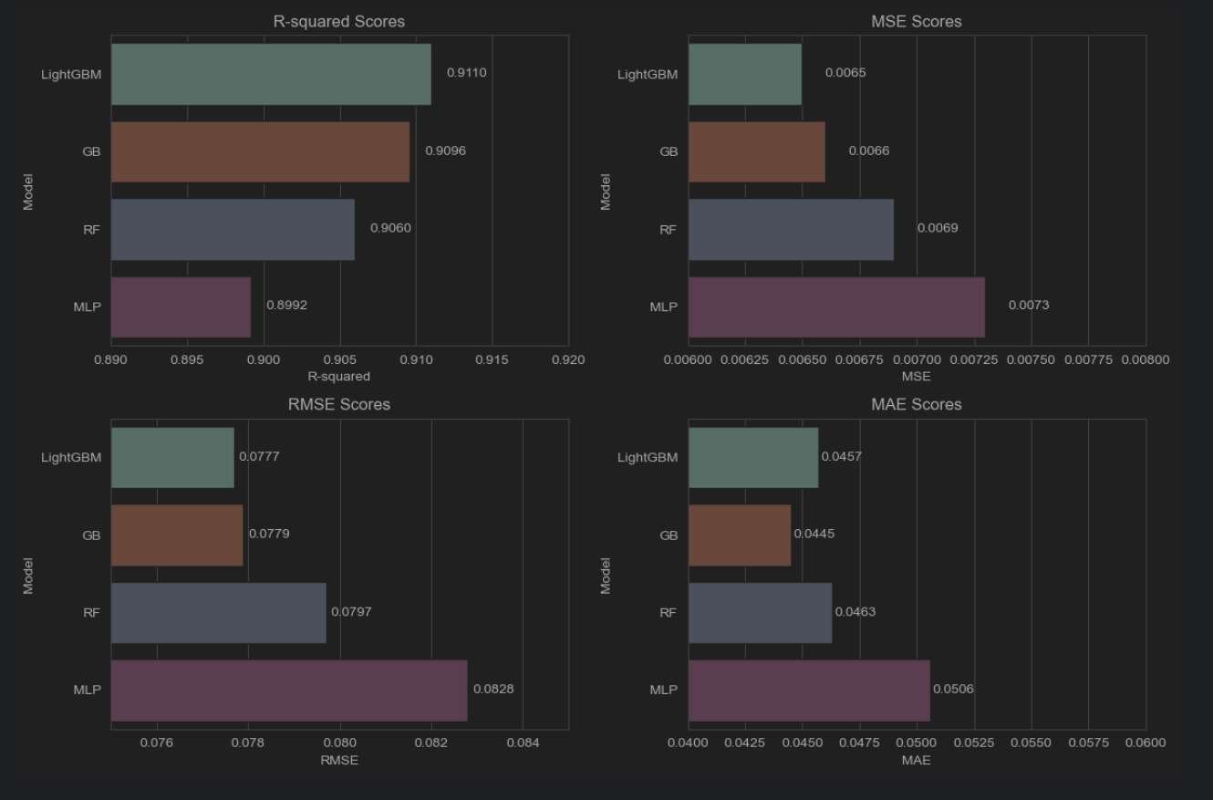

Figure 74: 4 Models evaluation metrics performance plots

After analysing the evaluation metrics for the four models—Gradient Boosting (GB), LightGBM, Random Forest (RF), and Multi-layer Perceptron (MLP)—we can determine the best performer. Among these models, LightGBM stands out with the highest R-squared (R2) score of 0.9110, indicating its superior fit to the data. This is followed closely by GB with an R2 score of 0.9096. In terms of Mean Squared Error (MSE) and Root Mean Squared Error (RMSE), LightGBM again leads with the lowest values, indicating more accurate predictions and smaller errors. Although GB and RF also perform well, LightGBM maintains a slight edge. Additionally, LightGBM exhibits the lowest Mean Absolute Error (MAE), highlighting its ability to make predictions with smaller average errors compared to the other models. Overall, based on these metrics, LightGBM emerges as the best-performing model among GB, RF, and MLP, demonstrating superior accuracy and error handling in predicting the target variable.

#### 5.2.5.2 Learning Curve (R2 Score)

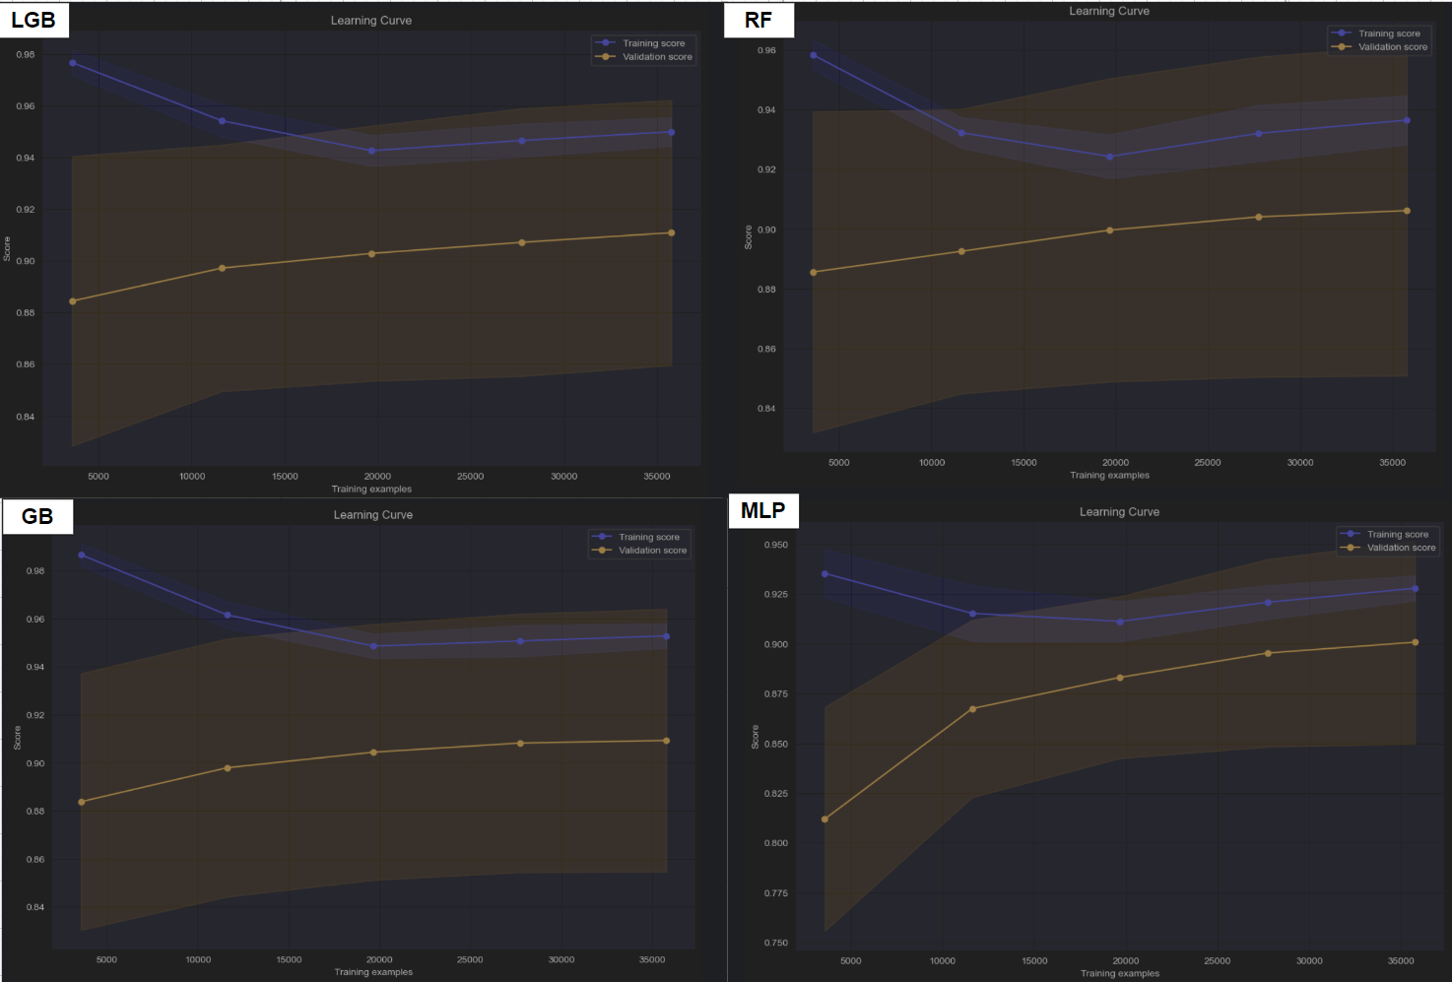

Figure 75: 4 Models Learning Curve in R2 Score

The learning curves for the four models, Gradient Boosting (GB), LightGBM, Random Forest (RF), and Multi-layer Perceptron (MLP), reveal interesting trends in their performance as training size increases, particularly in terms of the R-squared (R2) score with a cross-validation fold of 5 (cv=5). Initially, all models exhibit a decrease in training scores as more data points are included in the training set. This decline can be attributed to the models facing challenges in fitting the increasing amount of training data accurately.

However, beyond a certain training size (approximately the third point), there's a notable reversal in the training scores for all models. They start to increase, indicating improved model fitting as more data is utilised. This upward trend suggests that the models are capturing the underlying patterns and complexities in the data more effectively with larger training sets.

In terms of validation scores, a gradual increase is observed across all models, indicating improved generalisation performance on unseen data. This steady rise signifies that the models are becoming better at making predictions on new data points, showcasing their ability to generalise well beyond the training data.

A notable observation is with the MLP model's validation score. Unlike the other models, the MLP model shows a significant improvement from the first to the second point in the validation score (from 0.81199049 to 0.86747011), indicating a substantial leap in its generalisation ability early in the training process. However, after this initial jump, the improvement in validation score slows down, aligning with the gradual increase seen in the validation scores of the other models.

Overall, these learning curve trends suggest that as the models are exposed to more training data, they tend to improve in both their ability to fit the training data and generalise to new data points, with each model showcasing its unique strengths and performance characteristics.

#### 5.2.5.3 Log Scale Actual Versus Predicted Value

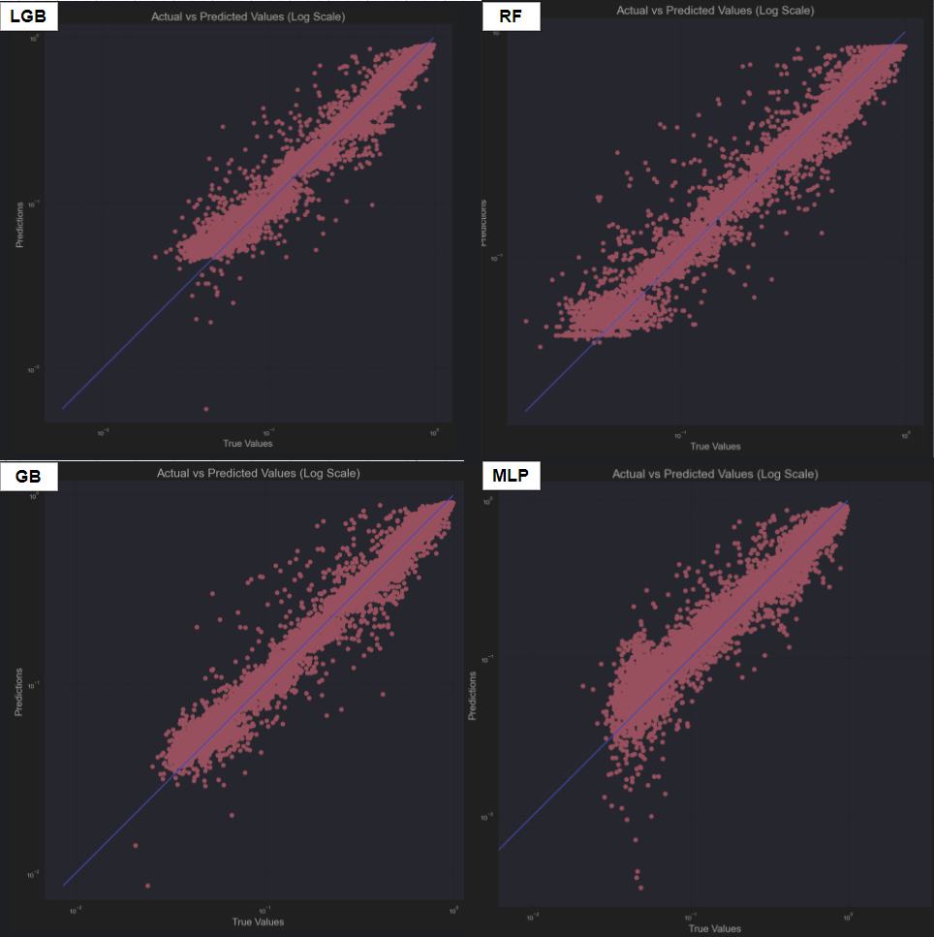

Figure 76: 4 Models Actual versus Predicted (log scale) Plot

The log scale actual versus predicted plots for the four models—Gradient Boosting (GB), LightGBM, Random Forest (RF), and Multi-layer Perceptron (MLP)—reveal interesting insights into their predictive performance. Overall, most of the dots for all models are clustered near the reference line, indicating a relatively close match between predicted and actual values. However, there are subtle differences in the distribution of dots among the models.

The LightGBM model exhibits the tightest clustering of dots around the reference line, suggesting a higher level of accuracy and precision in its predictions compared to the other models. Following LightGBM, the GB model shows a slightly wider spread of dots but still maintains a relatively close alignment with the reference line, indicating good predictive performance. The Random Forest model comes next, with a bit more variability in the dot distribution but still demonstrating a reasonable level of accuracy in predictions.

In contrast, the Multi-layer Perceptron (MLP) model presents a different picture in the plot. While it also has dots clustered near the reference line, there are noticeable outliers that deviate significantly from the expected range. These outliers represent predictions that are considerably off from the actual values, suggesting areas where the MLP model may struggle or encounter challenges in making accurate predictions.

The order of performance, based on the overall dots distribution and proximity to the reference line, appears to be LightGBM > GB > RF > MLP. This ranking reflects the models' relative abilities to predict values closely aligned with the actual data, with LightGBM demonstrating the highest level of precision and the MLP showing some areas of improvement needed, particularly in handling outlier predictions.

Overall, the log scale actual versus predicted plots provide a visual representation of each model's predictive accuracy, with closer clustering around the reference line indicating more accurate predictions and outliers highlighting potential areas for model refinement or improvement.

### 5.2.6 Model Selection

After an extensive analysis of the evaluation metrics, learning curves, and log scale actual versus predicted plots for Gradient Boosting (GB), LightGBM, Random Forest (RF), and Multi-layer Perceptron (MLP), the LightGBM model emerges as the most suitable choice for deployment in the webpage prediction purpose.

The evaluation metrics reveal that LightGBM achieves the highest R-squared (R2) score of 0.9110, indicating its exceptional ability to explain variance in the data and produce accurate predictions. Additionally, it exhibits the lowest Mean Squared Error (MSE), Root Mean Squared Error (RMSE), and Mean Absolute Error (MAE) among the models, showcasing its superior predictive accuracy and smaller errors.

Analysing the learning curves further solidifies LightGBM's performance. As the training size increases, LightGBM consistently demonstrates a significant improvement in both training and validation scores. This trend indicates its robustness in capturing underlying patterns and generalising well to new data points.

The log scale actual versus predicted plot reinforces LightGBM's superiority. The plot shows tight clustering of dots around the reference line, signifying precise predictions with minimal deviation from actual values. In contrast, the other models exhibit more variability and outliers, highlighting potential challenges in prediction accuracy.

Considering its overall performance across metrics and plots, LightGBM stands out as the model that offers the highest accuracy, error handling capability, and generalisation. Therefore, LightGBM is the preferred choice for deployment in the webpage prediction scenario, ensuring reliable and precise predictions for users.

## 5.3 Model Deployment

In the final phase of this project, the focus shifts to model deployment, utilising the top-performing model identified earlier, LightGBM. This advanced model has demonstrated exceptional performance across various evaluation metrics, making it the ideal choice for traffic prediction tasks. By harnessing LightGBM's capabilities, the aim is to enhance the accuracy and reliability of traffic predictions, ensuring robust and efficient traffic management strategies.

### 5.3.1 Process of the Web Page

The webpage deployment uses Flask, a Python API framework, to manage interactions between the front-end and back-end. Flask handles requests, serves HTML files, and updates content dynamically based on traffic predictions.

#### 5.3.1.1 Input Form

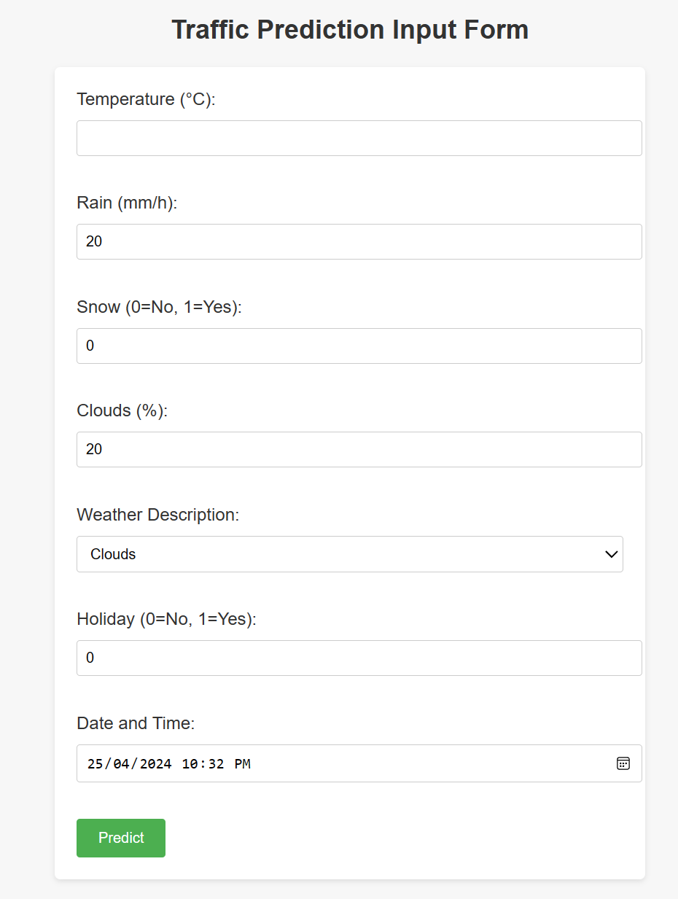

Figure 77: Traffic Prediction Input Form

The index.html page of the project is meticulously designed to ensure user-friendliness, employing a layout that is intuitive and straightforward. This design aims to make it easy for users to interact with the page and provide input data. The input fields are carefully set within specified limits, ensuring that users enter data within the required parameters. This approach not only enhances the user experience by simplifying data entry but also helps maintain data integrity by enforcing input constraints.



Upon submission, the form data is sent using the POST method to the `predict` function, which handles the input processing. This process involves validating the user's input to ensure it falls within the specified bounds and meets any required criteria. Once the input is verified, the `predict` function executes the necessary computations or algorithms to generate predictions or perform other tasks based on the input data.

Simultaneously, the browser's console logs the submission event, providing a real-time confirmation of the successful reception of the user's input. This logging mechanism serves as a validation step, ensuring that the input data is correctly captured and ready for further processing.

#### 5.3.1.2 Data Preprocessing

# Label encode categorical columns in the dataset

le = LabelEncoder()

for column in df_relevant.columns:

if df_relevant[column].dtype == 'object':

df_relevant[column] = le.fit_transform(df_relevant[column])

# Scale numerical columns using MinMaxScaler

scaled_data = scaler.fit_transform(df_relevant)

Upon receiving input data, the project employs MinMaxScaler to normalise numerical data and LabelEncoder to encode categorical variables. This preprocessing ensures data consistency and suitability for machine learning algorithms, enhancing model performance and accuracy.

#### 5.3.1.3 Model Prediction

model = joblib.load('best_lgb_model.joblib')

preprocess = preprocess_data(params)

# Make predictions using the preprocessed data

predictions = model.predict(preprocess)

After preprocessing with MinMaxScaler and LabelEncoder, the project uses the LightGBM model for predicting traffic volume. LightGBM's efficiency and accuracy make it ideal for handling the processed data and generating reliable traffic volume predictions.

#### 5.3.1.4 Prediction Result Rendering

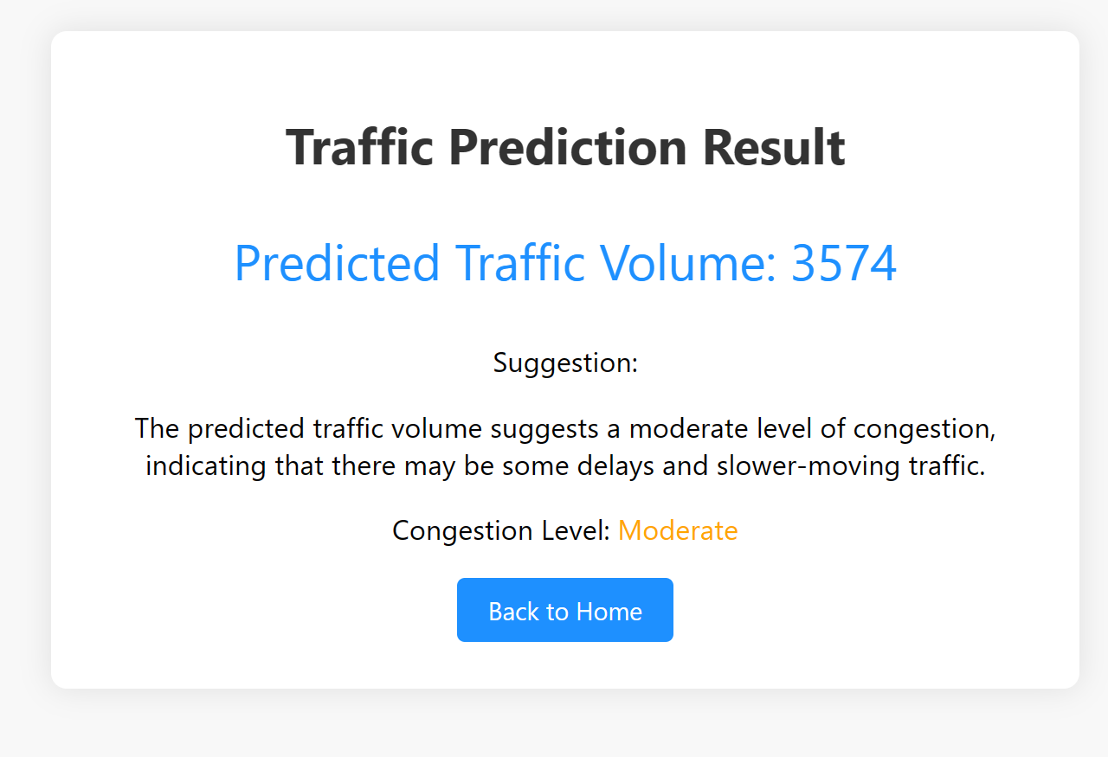

Figure 78: Traffic Prediction Result Rendering Page

The result.html webpage is meticulously crafted to ensure that users can quickly grasp the traffic volume prediction results at first glance. Its design strikes a balance between simplicity and informativeness, presenting the essential information in a visually appealing manner.

The layout of the webpage is structured to prioritise the display of critical data, such as the predicted traffic volume and corresponding congestion level. This information is prominently featured, allowing users to immediately understand the implications of the prediction.

To enhance user comprehension, the webpage employs colour-coded indicators for different congestion levels. For instance, low congestion levels are highlighted in green to signify smooth traffic conditions, while moderate congestion levels are presented in orange to indicate potential traffic build up. High congestion levels, representing significant traffic congestion, are visually distinguished in red, alerting users to potential delays and congestion-related issues.

By incorporating colour-coded visual cues, the webpage not only streamlines information delivery but also enhances user engagement and understanding of the traffic prediction results.

### 5.3.2 Testing

The project involves conducting three tests with identical parameters but varying times of the day: morning, afternoon, and night. The objective is to analyse and compare the prediction results obtained during each time period.

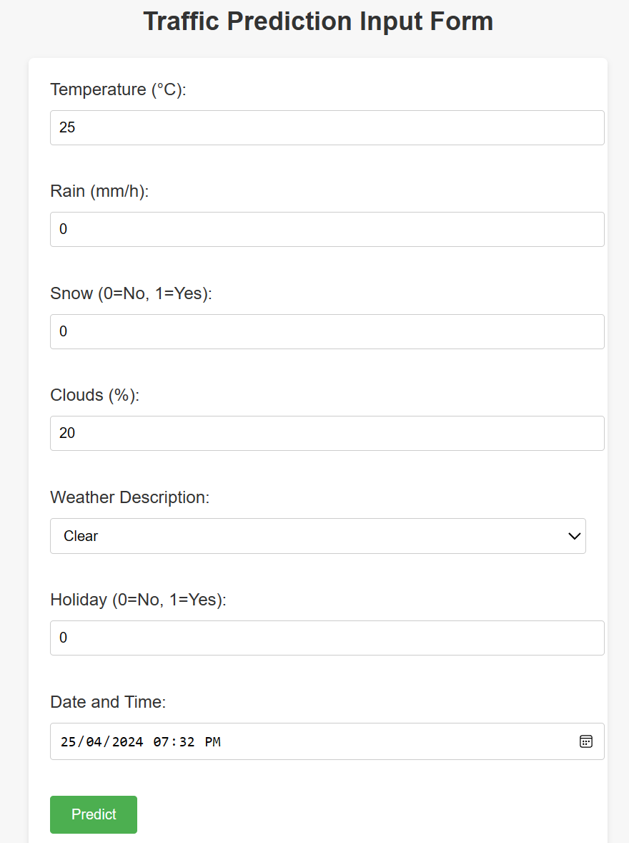

Figure 79: Testing data show

#### 

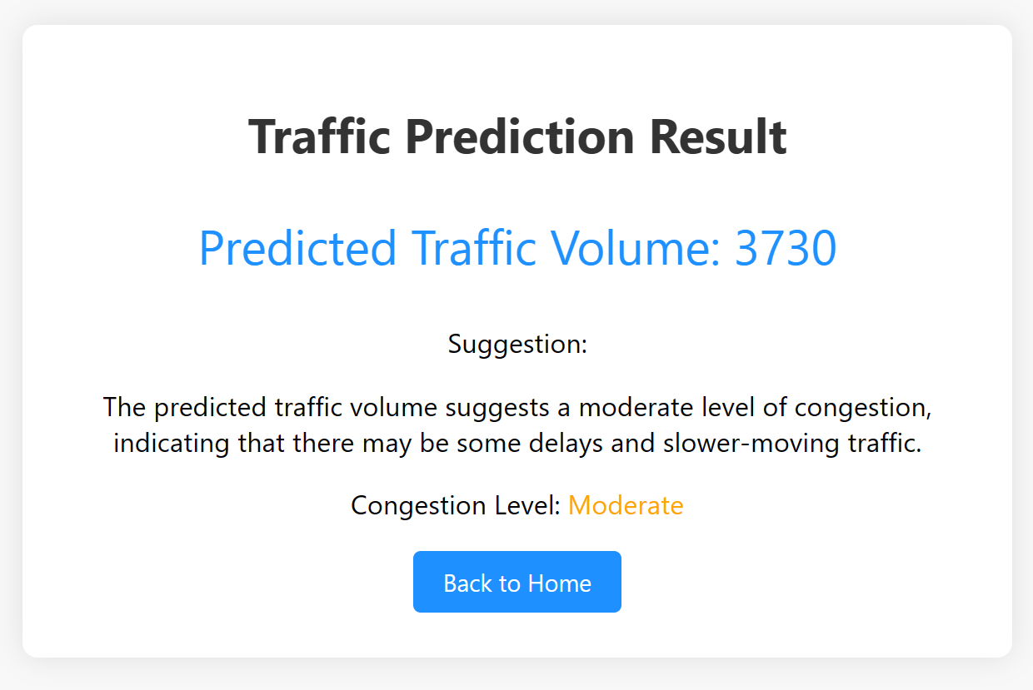

Figure 80: The traffic volume in the morning is 3720.

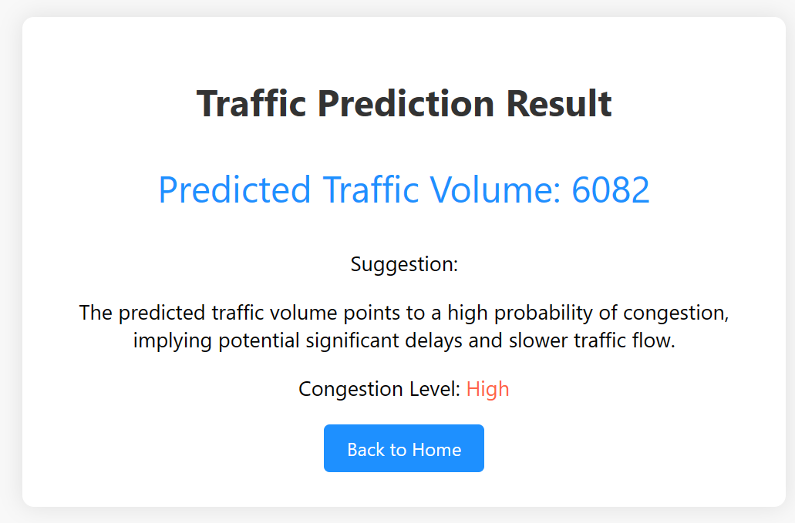

Figure 81: The traffic volume in the afternoon is 6082.



Figure 82: The traffic volume in the night is 3286.

## 5.4 Summary

Chapter 5 of the project encompassed rigorous evaluations of the top four models, utilising various metrics such as MAE, MSE, RMSE, MAR, learning curves with 5-fold cross-validation for R2 scores, and comparisons of log scale actual vs. predicted values. Among these models, LightGBM emerged as the most effective, leading to its deployment into a webpage through a systematic process. Three comprehensive testing scenarios were conducted thereafter, confirming the webpage's successful functionality and accurate prediction of traffic volume.

# Chapter6: Conclusion

## 6.1 Critical Evaluation

This section critically evaluates the project's accomplishments aimed at addressing traffic congestion issues through machine learning-based traffic prediction, with a focus on the LightGBM, Gradient Boosting (GB), Random Forest, and Multilayer Perceptron (MLP) models. The project's primary objectives included evaluating these machine learning algorithms, constructing robust prediction models, providing valuable insights, and addressing challenges inherent in traffic prediction for congestion alleviation.

The project effectively assessed the applicability of LightGBM, GB, Random Forest, and MLP models in predicting traffic volumes, emphasising predictive accuracy. This initiative significantly contributed to the field of traffic prediction and showed promise for mitigating traffic congestion challenges in real-world scenarios.

Leveraging historical traffic data, the research demonstrated the practical implementation of these machine learning techniques to develop predictive models. The utilisation of LightGBM, GB, and Random Forest models showcased substantial improvements in accurately predicting traffic volumes, essential for proactive traffic management and congestion control strategies.

Additionally, the project delved into methodological discussions and offered actionable recommendations for model enhancements, emphasising practical deployment readiness. These insights provide valuable guidance for improving the reliability and effectiveness of machine learning-based traffic prediction models, contributing to better traffic management and congestion reduction efforts.

In conclusion, the project's achievements, leveraging models like LightGBM, GB, Random Forest, and MLP, demonstrate adaptability and robustness in addressing real-time traffic forecasting challenges and making a substantial impact in traffic management and urban mobility.

## 6.2 Limitation

While this project has provided valuable insights into machine learning-based traffic prediction and congestion mitigation, several limitations warrant consideration. Firstly, the computational demands and hardware requirements pose significant challenges. The datasets used to train models like LightGBM, Gradient Boosting (GB), Random Forest, and Multilayer Perceptron (MLP) contain substantial traffic-related data, requiring significant computational power. This can strain resources and lead to extended model training times, impacting the timely development of sophisticated congestion prediction models.

Additionally, hardware constraints, especially concerning memory and processing speed, may hinder certain devices' ability to handle the vast amount of traffic data needed for accurate predictions. These limitations highlight the importance of balancing computational efficiency and model complexity when selecting and implementing machine learning algorithms, ensuring optimal model performance within resource constraints.

Furthermore, the temporal scope of the project, focusing on historical traffic data, introduces limitations regarding evolving traffic patterns and congestion factors. Relying solely on past data may overlook emerging trends and seasonal variations crucial for accurate congestion predictions. Moreover, the project's specificity to traffic conditions in Malaysia may limit generalizability to other regions with different traffic dynamics and patterns.

Lastly, external factors like road conditions, events, or infrastructure changes significantly influence traffic congestion. Failure to incorporate or update these factors in the dataset can lead to inaccuracies in real-time traffic predictions. Continuous data enrichment, model refinement, and adaptation to evolving traffic dynamics are essential to address these limitations and improve the reliability of traffic congestion prediction models during practical deployment.

## 6.3 Recommendation

Given the primary limitations encountered in this machine learning-based traffic prediction project, several recommendations are proposed to enhance the effectiveness and relevance of further research in this field. Firstly, addressing computational constraints is crucial for studying more complex models and handling large datasets effectively. Training sophisticated machine learning models requires significant computing resources, which researchers should aim to achieve. Collaborating with organisations or utilising cloud computing services can alleviate the burden on local hardware and expedite model training operations.

Future research efforts should consider a broader time range and multi-year data to accurately capture changing traffic patterns and seasonal impacts, addressing temporal limitations. Additionally, expanding the scope of research to include various geographical regions and traffic environments will enhance our understanding of factors influencing traffic congestion. By avoiding common pitfalls in limited studies, this approach contributes to broader applications of predictive models.

Considering the importance of external factors such as road conditions, events, or infrastructure changes, future datasets should include comprehensive data to reflect real-time conditions accurately. Continuous data enrichment and model refinement are essential for adapting to changing traffic dynamics and improving the reliability and effectiveness of traffic congestion prediction models in practical deployment scenarios.

In conclusion, key recommendations for further research in machine learning-based traffic prediction include minimising computational complexity, prioritising algorithm efficiency, broadening the temporal and spatial scope, incorporating comprehensive external factors data, and continuous data enrichment and model refinement. By addressing these recommendations, the field will improve, leading to the development of more predictive models with significant impacts on addressing traffic congestion issues effectively.

# Reference

1. Abdel-Shafy, H. I., & Mansour, M. S. M. (2018). Solid waste issue: Sources, composition, disposal, Recycling, and valorization. Egyptian Journal of Petroleum, 27(4), 1275–1290. <https://doi.org/10.1016/j.ejpe.2018.07.003>
2. Almselati, A. S. I., & Rahmat, R. A., & Jaafar, O. (2011). An Overview of Urban Transport in Malaysia. Journal of Social Sciences, 6(1), 24-33. From http://www.medwelljournals.com/fulltext/?doi=ssci ence.2011.24.33
3. Akhtar M., Moridpour S.

A review of traffic congestion prediction using artificial intelligence

J. Adv. Transp., 2021 (2021)

1. ‌‌Avinash Navlani. (2019, December 27). *Support Vector Machines with Scikit-learn Tutorial*. Datacamp.com; DataCamp. <https://www.datacamp.com/tutorial/svm-classification-scikit-learn-python>
2. Abdallah, M., Adghim, M., Maraqa, M., & Aldahab, E. (2019). Simulation and optimization of dynamic waste collection routes. Waste Management & Research, 37(8), 793–802. <https://doi.org/10.1177/0734242x19833152>
3. Anello, E. (2023, September 3). Introduction to numpy and Pandas. KDnuggets. <https://www.kdnuggets.com/introduction-to-numpy-and-pandas>
4. Bányai, T., Tamás, P., Illés, B., Stankevičiūtė, Ž., & Bányai, Á. (2019). Optimization of municipal waste collection routing: Impact of industry 4.0 technologies on environmental awareness and Sustainability. International Journal of Environmental Research and Public Health, 16(4), 634. <https://doi.org/10.3390/ijerph16040634>
5. Barros J., Araujo M., Rossetti R.J.

Short-term real-time traffic prediction methods: A survey

2015 International Conference on Models and Technologies for Intelligent Transportation Systems, MT-ITS, IEEE (2015), pp. 132-139

1. Bekhruz Tuychiev. (2019, November 8). *Using XGBoost in Python Tutorial*. Datacamp.com; DataCamp. <https://www.datacamp.com/tutorial/xgboost-in-python>
2. Boukerche A., Wang J.

Machine learning-based traffic prediction models for intelligent transportation systems

Comput. Netw., 181 (2020), Article 107530

1. Baldo, D., Mecocci, A., Parrino, S., Peruzzi, G., & Pozzebon, A. (2021). A multi-layer Lorawan infrastructure for Smart Waste Management. Sensors, 21(8), 2600. <https://doi.org/10.3390/s21082600>
2. Barth L., Sarperi L., Dettling M., Meierhofer J., Bulatovic A., Schweiger L. (2021). Development of a smart connected product-service-system (pss) for the waste management ecosystem. https://doi.org/10.21256/zhaw-25014
3. Bhatia, S., & Chawla, M. (2023). IOT based Smart Waste Management System in aspect of COVID-19. Journal of Open Innovation: Technology, Market, and Complexity, 9(2), 100048. <https://doi.org/10.1016/j.joitmc.2023.100048>
4. Cheng, K. M., Tan, J. Y., Wong, S. Y., Koo, A. C., & Amir Sharji, E. (2022). A review of Future Household Waste Management for sustainable environment in Malaysian cities. Sustainability, 14(11), 6517. <https://doi.org/10.3390/su14116517>
5. ‌Cybiant. (2021, February 8). *Artificial Neural Networks | Cybiant*. Cybiant. <https://www.cybiant.com/knowledge/artificial-neural-networks/>
6. Damini. (2023, September 18). Sustainability and green practices in contract manufacturing. Deskera Blog. <https://www.deskera.com/blog/sustainability-green-practices-contract-manufacturing/>
7. Do L.N., Taherifar N., Vu H.L.

Survey of neural network-based models for short-term traffic state prediction

Wiley Interdiscipl. Rev.: Data Min. Knowl. Discov., 9 (1) (2019), Article e1285

1. Dereci, U., & Karabekmez, M. E. (2022). The applications of multiple route optimization heuristics and meta-heuristic algorithms to solid waste transportation: A case study in Turkey. Decision Analytics Journal, 4, 100113. <https://doi.org/10.1016/j.dajour.2022.100113>
2. Energy5. (2023). Utilizing smart sensors for energy efficiency in waste management. <https://energy5.com/utilizing-smart-sensors-for-energy-efficiency-in-waste-management#anchor-0>
3. Ermagun A., Levinson D.

Spatiotemporal traffic forecasting: Review and proposed directions

Transp. Rev., 38 (6) (2018), pp. 786-814

1. Ejaz, N., Akhtar, N., Nisar, H., & Naeem, U. A. (2010). Environmental impacts of improper solid waste management in developing countries: A case study of Rawalpindi city. The Sustainable World. <https://doi.org/10.2495/sw100351>
2. Franco González, J., Gallardo Izquierdo, A., Commans, F., & Carlos, M. (2021). Fuel-efficient driving in the context of urban waste-collection: A Spanish case study. Journal of Cleaner Production, 289, 125831. <https://doi.org/10.1016/j.jclepro.2021.125831>
3. Ferronato, N., & Torretta, V. (2019). Waste mismanagement in developing countries: A Review of Global Issues. International Journal of Environmental Research and Public Health, 16(6), 1060. [https://doi.org/10.3390/ijerph1606106](https://doi.org/10.3390/ijerph16061060)
4. Gowda M.K., Niranjan P.T. Optimal Routing of Municipal Solid Waste collection vehicle in Selected wards of Mysore City using GIS, International Research Journal of Engineering and Technology (IRJET), Volume: 09 Issue: 08, Aug 2022, Pp. 2029-2032, eISSN: 2395-0056, p-ISSN: 2395-0072
5. GfG. (2020, July 15). *LightGBM (Light Gradient Boosting Machine)*. GeeksforGeeks; GeeksforGeeks. <https://www.geeksforgeeks.org/lightgbm-light-gradient-boosting-machine/>
6. Hannan, M. A., Akhtar, M., Begum, R. A., Basri, H., Hussain, A., & Scavino, E. (2018). Capacitated vehicle-routing problem model for scheduled solid waste collection and route optimization using PSO algorithm. Waste Management, 71, 31–41. <https://doi.org/10.1016/j.wasman.2017.10.019>
7. Hantoko, D., Li, X., Pariatamby, A., Yoshikawa, K., Horttanainen, M., & Yan, M. (2021). Challenges and practices on waste management and disposal during COVID-19 pandemic. Journal of Environmental Management, 286, 112140. <https://doi.org/10.1016/j.jenvman.2021.112140>
8. Hashemi-Amiri, O., Mohammadi, M., Rahmanifar, G., Hajiaghaei-Keshteli, M., Fusco, G., & Colombaroni, C. (2023). An allocation-routing optimization model for Integrated Solid Waste Management. Expert Systems with Applications, 227, 120364. <https://doi.org/10.1016/j.eswa.2023.120364>
9. Hotz, N. (2023, January 19). What is CRISP DM?. Data Science Process Alliance. <https://www.datascience-pm.com/crisp-dm-2/>
10. Hotz, N. (2023a, January 19). CRISP DM methodology. Smart Vision Europe. <https://www.sv-europe.com/crisp-dm-methodology/>
11. Ivey, A. (2023, July 24). History of python programming language. Cointelegraph. <https://cointelegraph.com/news/history-of-python-programming-language>
12. Infra Growth 99. (2019, December 24). What are the advantages of road transport | Freight Delivery Services. Utah Freight Delivery L Utah Trucking L Freight Shipping Utah L Corlett Express. <https://corlettexpress.com/what-are-the-advantages-of-road-transport/>
13. Jatinkumar Shah, P., Anagnostopoulos, T., Zaslavsky, A., & Behdad, S. (2018). A stochastic optimization framework for planning of waste collection and value recovery operations in smart and Sustainable Cities. Waste Management, 78, 104–114. <https://doi.org/10.1016/j.wasman.201>
14. Jay Patel, & Dr. Reshma Patel. (2023, April 22). Route Optimization of Vehicle Collecting Municipal Solid Waste: A Review. Route optimization of vehicle collecting municipal solid waste: A Review. ISSN (Online): 2320-9364, ISSN (Print): 2320-9356
15. Jiang, D., & Zhou, X. (2021). Understanding waste sorting behavior in campus: The roles of knowledge, perceived behavior control, and social norms. Resources, Conservation and Recycling, 164, 105108. <https://doi.org/10.1016/j.resconrec.2020.105108>
16. Kamble S, Patil K, Pawar U. GIS in Municipal Solid Waste Management, International Journal of Scientific & Engineering Research Volume 10, Issue 5, May-2019 ISSN 2229-5518
17. Karimipour, H., Tam, Vivian W. Y., Le, K. N., & Burnie, H. (2021). Routing on-road heavy vehicles for alleviating greenhouse gas emissions. Cleaner Engineering and Technology, 5, 100325. <https://doi.org/10.1016/j.clet.2021.100325>
18. Kaur, R., Kaur, J., & Jain, D. (2020). Internet of Things (IoT) in solid waste management: A comprehensive survey. Journal of King Saud University - Computer and Information Sciences. <https://doi.org/10.1016/j.jksuci.2020.11.034>
19. Kumar A., Saha P.

A review of deep learning models for traffic flow prediction in autonomous vehicles

2020 2nd International Conference on Advances in Computing, Communication Control and Networking, ICACCCN, IEEE (2020)

1. Kaur, R., & Jain, D. (2020). A review of the applications of Internet of Things (IoT) in solid waste management. In 2020 11th International Conference on Computing, Communication and Networking Technologies (ICCCNT) (pp. 1–5). <https://doi.org/10.1109/ICCCNT51641.2020.9225407>
2. Kaya, S., & Durmuşoğlu, A. (2021). An efficient multi-objective model for a sustainable solid waste management system with a case study. Journal of Cleaner Production, 311, 127473. <https://doi.org/10.1016/j.jclepro.2021.127473>
3. Khan, I. H., Das, R., & Aung, Z. (2021). Urban solid waste management: A review of waste-to-energy potentials and health risk assessment. Journal of Cleaner Production, 289, 125979. <https://doi.org/10.1016/j.jclepro.2021.125979>
4. Khani, A., Kargar, M., Ghorbani, R., & Kavoosi, M. (2018). A sustainable two-echelon solid waste collection and location-routing problem. Journal of Cleaner Production, 202, 678–696. <https://doi.org/10.1016/j.jclepro.2018.08.041>
5. Kuok, S. C., Zailani, S., & Iranmanesh, M. (2022). Predicting intention to use smart waste bins: A structural equation modeling approach. Resources, Conservation and Recycling, 175, 105856. <https://doi.org/10.1016/j.resconrec.2021.105856>
6. Lee, L. H., & Zailani, S. (2021). Adoption of Internet of Things (IoT) in waste management: A cross-country analysis. Resources, Conservation and Recycling, 170, 105635. <https://doi.org/10.1016/j.resconrec.2021.105635>
7. Li, J., & Liu, Y. (2020). A critical review of smart waste management in the era of Internet of Things. Journal of Cleaner Production, 277, 124058. <https://doi.org/10.1016/j.jclepro.2020.124058>
8. Li Y., Shahabi C.

A brief overview of machine learning methods for short-term traffic forecasting and future directions

Sigspatial Special, 10 (1) (2018), pp. 3-9

1. Li, X., Zhang, X., Pariatamby, A., Yoshikawa, K., Chiemchaisri, C., Qi, S., Xie, T., Wang, J., & Yan, M. (2021). Municipal solid waste (MSW) management in China: A policy and technology perspective. Journal of Environmental Management, 297, 113321. <https://doi.org/10.1016/j.jenvman.2021.113321>
2. Lana I., Del Ser J., Velez M., Vlahogianni E.I.

Road traffic forecasting: Recent advances and new challenges

IEEE Intell. Transp. Syst. Mag., 10 (2) (2018), pp. 93-109

1. Liu, N., Yasin, M. A., Alsagoff, S. A., Ng, C. F., & Li, M. (2023). Political modernization and digital democracy: The internet participation of Malaysia domestic citizens to “2021–2022 Malaysian floods” event in public policy process of flood response. International Journal of Academic Research in Business and Social Sciences, 13(4). <https://doi.org/10.6007/ijarbss/v13-i4/16707>
2. Lozano, Á., Caridad, J., De Paz, J., Villarrubia González, G., & Bajo, J. (2018). Smart waste collection system with low consumption lorawan nodes and route optimization. Sensors, 18(5), 1465. <https://doi.org/10.3390/s18051465>
3. Luna, J. C. (2022, December 28). Python vs R for data science: Which should you learn?. DataCamp. <https://www.datacamp.com/blog/python-vs-r-for-data-science>
4. Mahara, G., Shin, H., Chae, H., Lim, W., & Shin, S. (2018). A novel waste collection system using Wireless Sensor Network and Radio Frequency Identification (WSN-RFID). Journal of Cleaner Production, 184, 538–547. <https://doi.org/10.1016/j.jclepro.2018.02.240>
5. Mohammed Naeem Abdulkareem, Layth Riyadh Alsaidi, Muhamad, & Mina Salah Mahdi. (2020, August 16). *Traffic Congestion: Shift from Private Car to Public Transportation*. ResearchGate; Ital Publication. <https://www.researchgate.net/publication/343685217_Traffic_Congestion_Shift_from_Private_Car_to_Public_Transportation>
6. Mele, F., Colombaroni, C., Comazzi, S., & Rossini, M. (2023). Identifying the determinants of policy implementation: An application of the fuzzy-set qualitative comparative analysis to the waste sector in Lombardy. Resources, Conservation and Recycling, 188, 105255. <https://doi.org/10.1016/j.resconrec.2022.105255>
7. Mele, F., Colombaroni, C., Rada, E. C., & Rossini, M. (2021). Public participation in waste management: Evidence from Italian municipalities. Resources, Conservation and Recycling, 164, 105137. <https://doi.org/10.1016/j.resconrec.2020.105137>
8. Mohammadi, M., Teixeira, R., Hashemi-Amiri, O., & Vitoriano, B. (2021). A location-routing model for solid waste management: A case study in the City of São Paulo. Resources, Conservation and Recycling, 174, 105831. <https://doi.org/10.1016/j.resconrec.2021.105831>
9. Mok, K. Y., Shen, G. Q., & Yang, J. (2015). An evaluation of the barriers to entry of green buildings in developed cities. Habitat International, 45, 26–36. <https://doi.org/10.1016/j.habitatint.2014.07.013>
10. Moraros, J., Lemstra, M., & El Bilbeisi, H. (2022). The use of quality management systems in healthcare and their effect on Patient Outcomes. BMC Health Services Research, 22(1), 172. <https://doi.org/10.1186/s12913-022-07606-0>
11. Motta, D. G., Falasconi, L., & Cesarotti, V. (2021). Sustainable waste management: Analysis of the performance of solid waste collection with the use of Electric Vehicles. Journal of Cleaner Production, 303, 126985. <https://doi.org/10.1016/j.jclepro.2021.126985>
12. Moussa, M. S., Khalaf, O. I., & Abdulqader, F. S. (2019). Evaluation of the efficiency of a municipal solid waste collection system in Iraq using geographic information system and vehicle routing optimization. Journal of Cleaner Production, 215, 427–437. <https://doi.org/10.1016/j.jclepro.2018.12.185>
13. Munir, M. T., Bist, J. S., & Nguyen, N. H. (2023). A review on Smart Waste Management: A need for environmental sustainability. Process Safety and Environmental Protection, 156, 360–378. <https://doi.org/10.1016/j.psep.2022.09.009>
14. Nguyen H., Kieu L.M., Wen T., Cai C.

Deep learning methods in transportation domain: A review

IET Intell. Transp. Syst., 12 (9) (2018), pp. 998-1004

1. Namsa, S., Hazarika, M., & Bhuyan, M. (2021). Assessment of municipal solid waste generation and composition in Guwahati City, Assam, India. Sustainable Cities and Society, 68, 102772. <https://doi.org/10.1016/j.scs.2021.102772>
2. Nagy A.M., Simon V.

Survey on traffic prediction in smart cities

Pervasive Mob. Comput., 50 (2018), pp. 148-163

1. Nasir, M., Naim, M. M., & Aktas, E. (2018). Real-time dynamic vehicle routing for perishable food transportation in urban areas. Transportation Research Part E: Logistics and Transportation Review, 115, 36–57. <https://doi.org/10.1016/j.tre.2018.04.006>
2. ngarita-Zapata J.S., Masegosa A.D., Triguero I.

A taxonomy of traffic forecasting regression problems from a supervised learning perspective

IEEE Access, 7 (2019), pp. 68185-68205

1. Ni, L., & Wei, Y. (2018). Municipal solid waste management in Wuhan, China: Practices and challenges. Waste Management, 74, 26–37. <https://doi.org/10.1016/j.wasman.2017.12.025>
2. Nica, E., Drosescu, M., & Popescu, V. (2019). GIS-based approach for optimizing Municipal Solid Waste (MSW) collection routes. Case study: Sector 4, Bucharest, Romania. Waste Management, 87, 124–134. <https://doi.org/10.1016/j.wasman.2019.01.010>
3. Ocampo-Martínez, C., & Brito-Loeza, C. (2022). Solid waste management in urban areas: A review. Journal of Cleaner Production, 318, 128528. <https://doi.org/10.1016/j.jclepro.2021.128528>
4. Ogbonna, P. O., & Mendoza, J. G. (2023). Sustainable waste management system using GIS-based modeling: A case study of municipal solid waste disposal sites in Nigeria. Environmental Science and Pollution Research. <https://doi.org/10.1007/s11356-023-09718-6>
5. Ojo, M., Oluwatobi, A., Ndiyo, N., & Ojo, A. (2019). Analysis of factors affecting the adoption of e-waste recycling services in Lagos State, Nigeria. Heliyon, 5(11), e02817. <https://doi.org/10.1016/j.heliyon.2019.e02817>
6. Ondel, O., Demir, E., & Kaya, I. (2018). A wireless sensor network-based system for monitoring and optimizing waste collection routes. Journal of Ambient Intelligence and Humanized Computing, 9(5), 1553–1562. <https://doi.org/10.1007/s12652-017-0501-2>
7. Pappis, C. P., & Karellas, S. (2017). Solid waste management and waste to energy production in Greece-An overview. Energy Reports, 3, 65–71. <https://doi.org/10.1016/j.egyr.2016.10.002>
8. Paramasivam, P., & Rajkumar, R. (2017). Internet of Things: An overview. In Advanced Computing and Communication Technologies (pp. 43–51). <https://doi.org/10.1007/978-981-10-2942-6_5>
9. Patil, S. K., & Rupanagudi, S. R. (2018). Optimal fleet size and waste collection frequency in smart cities. Resources, Conservation and Recycling, 134, 261–270. <https://doi.org/10.1016/j.resconrec.2017.12.029>
10. Peng, X., Zhao, Y., Yu, W., Liu, X., & Guo, Y. ((2023). A comprehensive review on the role of Artificial Intelligence in Solid Waste Management. Journal of Cleaner Production, 312, 127842. <https://doi.org/10.1016/j.jclepro.2021.127842>
11. Qadri, M. S., Sheeraz, M., & Rasool, T. (2017). Characterization of solid waste in Gujranwala City and modelling of its collection using Geospatial Information System (GIS). Journal of King Saud University - Engineering Sciences. <https://doi.org/10.1016/j.jksues.2017.07.009>
12. Qolomany, B., Nasirpouri, F., & Maghrebi, M. (2017). The role of reverse logistics in sustainable solid waste management: A case study of Mashhad city in Iran. Journal of Cleaner Production, 142, 2434–2443. <https://doi.org/10.1016/j.jclepro.2016.11.169>
13. Radhika, V., & Ravi, V. (2019). Applications of Internet of Things (IoT) in solid waste management: A literature review. Materials Today: Proceedings, 18, 2138–2143. <https://doi.org/10.1016/j.matpr.2019.07.394>
14. Ratti, C., & Townsend, A. (2011). The social nexus for ubiquitous sensing. International Journal of Ambient Computing and Intelligence (IJACI), 3(2), 42–51. <https://doi.org/10.4018/jaci.2011040104>
15. R, S. E. (2021, June 17). *Understand Random Forest Algorithms With Examples (Updated 2024)*. Analytics Vidhya. <https://www.analyticsvidhya.com/blog/2021/06/understanding-random-forest/>
16. Razzaq, A., Salah, K., Hafeez, K., & Abolfazli, S. (2018). Integrating Blockchain into the internet of things: Challenges and opportunities. IEEE Internet of Things Magazine, 1(1), 13–19. <https://doi.org/10.1109/IOTM.2018.1120072>
17. Raza, S. A., Wallin, M., Voigt, T., & Yaqoob, I. (2017). Cognitive IoT-based healthcare systems: A survey. IEEE Internet of Things Journal, 4(1), 41–56. <https://doi.org/10.1109/JIOT.2016.2634660>
18. Reddy, S. M., & Rao, K. S. (2021). Analysis of factors influencing municipal solid waste management in Vijayawada city. Materials Today: Proceedings, 42, 205–210. <https://doi.org/10.1016/j.matpr.2021.02.236>
19. Rehan, R., & Faisal, M. (2019). A review on current status and future perspectives of solid waste management in Pakistan. Journal of Cleaner Production, 208, 906–923. <https://doi.org/10.1016/j.jclepro.2018.10.243>
20. Rizos, V., Behrens, A., & Papathanassopoulos, S. (2017). Applying the Social Cognitive Career Theory to individuals working in waste management. Resources, Conservation and Recycling, 117, 235–242. <https://doi.org/10.1016/j.resconrec.2016.09.008>
21. Sabry, S. E., & Sharaf Eldin, A. (2017). An integrated approach for optimization of waste collection and transportation route: A case study of Alexandria city, Egypt. Alexandria Engineering Journal, 56(2), 125–133. <https://doi.org/10.1016/j.aej.2016.10.003>
22. Shafii, H., & Musa, S. M. S. (2008). Pengangkutan di Bandar: Isu dan Penyelesaian. Journal of Techno-Social, 31-46. From http://penerbit.uthm.edu.my/ojs/index.php/JTS/artic le/viewFile/324/201
23. SD Reporter. (2024, January 12). *World’s worst traffic: London leads, KL joins the list*. Sinar Daily; Sinar Daily. <https://www.sinardaily.my/article/214751/focus/worlds-worst-traffic-london-leads-kl-joins-the-list>
24. Sahu, S. (2018). Solid waste management practices, perceptions and attitudes in a developing country: Bhubaneswar, Odisha. Sustainable Cities and Society, 37, 267–276. <https://doi.org/10.1016/j.scs.2017.11.024>
25. Sahu, S., & Mohanty, P. (2018). Solid waste generation, composition, and management: The case of Bhubaneswar City, Odisha, India. Journal of Environmental Management, 205, 367–376. <https://doi.org/10.1016/j.jenvman.2017.09.065>
26. Sahu, S., & Mohanty, P. (2019). Sustainable urban solid waste management through integrated approach: A case study. Journal of Environmental Management, 231, 272–279. <https://doi.org/10.1016/j.jenvman.2018.10.026>
27. Sahyoun, S. K., Kalashyan, E., El-Fadel, M., & Marhaba, T. F. (2018). Modeling household e-waste generation: Case study of a Mediterranean country. Journal of Cleaner Production, 176, 251–262. <https://doi.org/10.1016/j.jclepro.2017.12.108>
28. Sajjadi, B., Vahdani, B., & Tavakkoli-Moghaddam, R. (2018). A bi-objective sustainable supply chain network design: A new heuristic solution method. Journal of Cleaner Production, 197, 1438–1455. <https://doi.org/10.1016/j.jclepro.2018.06.192>
29. Saleem, M., Hasbullah, H., & Abdullahi, M. (2018). Internet of Things (IoT) in solid waste bin monitoring system. Procedia Computer Science, 143, 62–69. <https://doi.org/10.1016/j.procs.2018.10.282>
30. Samant, S. S., Awasthi, A. K., Dhamija, H., & Chauhan, A. (2022). Municipal solid waste management and its sustainable practices in India: A review. Journal of Cleaner Production, 342, 130236. <https://doi.org/10.1016/j.jclepro.2021.130236>
31. Shaddad, S. M. A., Faisal, K., Zawbaa, H. M., & Mahmoud, S. Y. (2019). Optimising waste collection in smart cities using machine learning and IoT. Future Generation Computer Systems, 100, 1105–1112. <https://doi.org/10.1016/j.future.2019.04.036>
32. Shalaby, M. M., El-Salam, E. M. A., & Negm, A. M. (2022). Municipal solid waste characteristics and management strategies in Greater Cairo, Egypt. Sustainable Cities and Society, 75, 103122. <https://doi.org/10.1016/j.scs.2022.103122>
33. Shirmohammadi, M., Shakouri G., & Frayon S., H2R: A tool for routing of hydrogen-refueling vehicles, International Journal of Hydrogen Energy, Volume 47, Issue 49, 2022, Pp. 24021-24030, ISSN 0360-3199, <https://doi.org/10.1016/j.ijhydene.2022.07.187>
34. Silva, E. F., Barcellos, J. O. J., de Souza, E. L., & Duarte, R. S. (2019). Development of a systematic and automatic methodology to optimize municipal solid waste collection routes: A case study of an emerging country. Journal of Cleaner Production, 222, 204–213. <https://doi.org/10.1016/j.jclepro.2019.03.188>
35. Singh, A., & Mardani, A. (2019). IoT-based smart waste management: A review. Journal of Cleaner Production, 228, 1151–1164. <https://doi.org/10.1016/j.jclepro.2019.04.170>
36. Singh, A., Mardani, A., & Goh, M. (2020). Integrated big data framework for sustainable waste management in smart cities: A case study of Singapore. Journal of Cleaner Production, 268, 121725. <https://doi.org/10.1016/j.jclepro.2020.121725>
37. Sinha, P., Siddiqui, A., & Patel, M. (2021). Challenges and issues of electronic waste management practices in India. Journal of Cleaner Production, 283, 125365. <https://doi.org/10.1016/j.jclepro.2020.125365>
38. Srivastava, P., Al-Somali, S. A., & Farhan, B. (2022). A novel swarm intelligence based method for waste collection in urban areas. Journal of Cleaner Production, 318, 128536. <https://doi.org/10.1016/j.jclepro.2021.128536>
39. Stojanovic, S., & Milinkovic, D. (2020). Review of reverse logistics for end-of-life vehicles. Journal of Cleaner Production, 270, 122450. <https://doi.org/10.1016/j.jclepro.2020.122450>
40. Sun, S., & Cao, Y. (2020). Mobile health research in China: A review of progress, challenges, and prospects. Telemedicine and e-Health, 26(5), 573–582. <https://doi.org/10.1089/tmj.2019.0095>
41. Taccari, G., Zavagli, M., & Costa, A. L. (2023). Artificial Intelligence and deep learning models for waste composition analysis: A Review. Waste Management, 136, 103–115. <https://doi.org/10.1016/j.wasman.2021.09.023>
42. Tammina, R., Kassem, A., Sablania, K. A., & Megahed, N. A. (2022). A review of the role of Internet of Things (IoT) in smart waste management. Journal of Cleaner Production, 335, 130106. <https://doi.org/10.1016/j.jclepro.2021.130106>
43. Tedjopurnomo D.A., Bao Z., Zheng B., Choudhury F., Qin A.

A survey on modern deep neural network for traffic prediction: Trends, methods and challenges

IEEE Trans. Knowl. Data Eng. (2020)

1. Tang, L., & Shah, N. (2015). A review of current challenges of Radio Frequency Identification (RFID) in supply chain management. International Journal of Production Economics, 159, 104–114. <https://doi.org/10.1016/j.ijpe.2014.10.013>
2. Teye, J. K., & Nik Norulaini, N. A. (2022). Municipal solid waste management in Malaysia: Current practices, challenges, and future outlook. Journal of Environmental Management, 306, 114399. <https://doi.org/10.1016/j.jenvman.2021.114399>
3. Thawale, P. R., Thawale, P. L., & Doye, D. D. (2019). Optimization of municipal solid waste collection and transportation routes: A case study. Materials Today: Proceedings, 17, 1647–1652. <https://doi.org/10.1016/j.matpr.2019.01.403>
4. Thawale, P. R., & Doye, D. D. (2019). A comprehensive review on optimization of municipal solid waste collection and transportation route. Materials Today: Proceedings, 18, 2144–2149. <https://doi.org/10.1016/j.matpr.2019.07.395>
5. Thirumal, V., Chinnathambi, V., Prakash, S. K., Adeniyi, J., Al-Turjman, F., Choi, G. S., & Muthuvelu, N. (2022). Green computing framework for a sustainable smart city environment. Journal of Cleaner Production, 330, 129739. <https://doi.org/10.1016/j.jclepro.2022.129739>
6. Tlili, I., & Jemni, M. (2015). Towards a framework for a smart classroom: A real-time formative evaluation. Smart Learning Environments, 2(1), 1–16. <https://doi.org/10.1186/s40561-014-0001-7>
7. Tlili, I., Huang, R., Chang, M., Nascimbeni, F., & Burgos, D. (2019). Challenges for adopting blockchain in education: A Review of six cases. Journal of Educational Technology & Society, 22(2), 20–30.
8. Toma, E. S., Marinescu, V., & Rusu, A. (2018). Application of geostatistical tools to assess the impact of urbanisation on land surface temperature. Case study: Bistrita City, Romania. The Egyptian Journal of Remote Sensing and Space Science, 21(2), 145–157. <https://doi.org/10.1016/j.ejrs.2017.06.002>
9. Tommaso, D., Cicconetti, C., & Avveduto, G. (2022). Smart waste management using cloud computing: A performance study. Journal of Cleaner Production, 331, 129587. <https://doi.org/10.1016/j.jclepro.2021.129587>
10. Tuan, N. M., Gia, T. N., Anh, N. K., Phong, N. D., & Hai, N. T. M. (2019). Optimal approach for solid waste collection and transportation routing optimization in Hanoi, Vietnam. Journal of Environmental Management, 232, 560–567. <https://doi.org/10.1016/j.jenvman.2018.11.006>
11. Ulrich, H., & Sarigöllü, E. (2012). Business model for information security in the extended enterprise. Computers & Security, 31(4), 470–484. <https://doi.org/10.1016/j.cose.2012.02.004>
12. Ullah, A., Khan, M. A., Ahmed, S., & Khan, I. (2019). Sustainable municipal solid waste management practices in developing countries: A Review. Sustainable Cities and Society, 46, 101423. <https://doi.org/10.1016/j.scs.2019.101423>
13. Unnikrishnan, N. P., & Mathew, R. M. (2019). Review of waste-to-energy technologies for municipal solid waste management in India. Journal of Cleaner Production, 236, 117624. <https://doi.org/10.1016/j.jclepro.2019.117624>
14. Uwizeye, A., & El-adaway, I. (2019). Performance evaluation of RFID technology in construction materials tracking. Journal of Cleaner Production, 207, 225–241. <https://doi.org/10.1016/j.jclepro.2018.09.219>
15. Vanegas, J. A., & Muñoz, J. C. (2019). A decision support system for sustainable solid waste management. Journal of Cleaner Production, 231, 507–519. <https://doi.org/10.1016/j.jclepro.2019.05.327>
16. Vito Paolo Pastore, Paolo Massobrio, Aleksandar Godjoski, & Martinoia, S. (2018). Identification of excitatory-inhibitory links and network topology in large-scale neuronal assemblies from multi-electrode recordings. *PLoS Computational Biology*, *14*(8), e1006381–e1006381. <https://doi.org/10.1371/journal.pcbi.1006381>
17. Vazquez-Rowe, I., Dowd, A. M., & Frischknecht, R. (2019). A review of e-waste management strategies, progress, and challenges in the circular economy context. Journal of Cleaner Production, 233, 916–925. <https://doi.org/10.1016/j.jclepro.2019.06.304>
18. Vlahogianni E.I., Golias J.C., Karlaftis M.G.

Short-term traffic forecasting: Overview of objectives and methods

Transp. Rev., 24 (5) (2004), pp. 533-55

1. Venkatraman, P., & Samui, P. (2020). Evaluating the effectiveness of electronic waste collection centers: A case study from Coimbatore, India. Journal of Cleaner Production, 266, 121942. <https://doi.org/10.1016/j.jclepro.2020.121942>
2. Vezzetti, E., Rosato, A., Guelpa, E., & Fissore, D. (2022). Environmental sustainability of waste sorting plant location: A multi-objective optimization approach. Journal of Cleaner Production, 331, 129424. <https://doi.org/10.1016/j.jclepro.2021.129424>
3. Vishnu, R., Gudimetla, P., Eun-Sung, S., & Cho, J. (2021). A review on waste-to-energy systems in the context of circular economy. Journal of Cleaner Production, 319, 128763. <https://doi.org/10.1016/j.jclepro.2021.128763>
4. Vojinovic, Z., & Davídková, M. (2018). Smart waste collection in smart cities: A review. Journal of Cleaner Production, 195, 487–500. <https://doi.org/10.1016/j.jclepro.2018.05.191>
5. Wang, X., Fang, G., & Lu, H. (2021). Analysis of influencing factors and multi-objective optimization model for urban household solid waste separation behavior: A case study of Nanjing, China. Journal of Cleaner Production, 281, 124349. <https://doi.org/10.1016/j.jclepro.2020.124349>
6. Wang Y., Zhang D., Liu Y., Dai B., Lee L.H.

Enhancing transportation systems via deep learning: A survey

Transp. Res. C, 99 (2019), pp. 144-163

1. Wang, Y., & He, Y. (2021). Optimal scheduling of a waste-to-energy supply chain based on BIM and GIS technologies. Journal of Cleaner Production, 291, 125935. <https://doi.org/10.1016/j.jclepro.2021.125935>
2. Wei, X., Zhang, Q., & Poh, K. L. (2019). A review of smart waste monitoring management: Strategies and technology. Waste Management, 94, 42–54. <https://doi.org/10.1016/j.wasman.2019.06.036>
3. Wu, J., & Wu, J. (2019). Investigating the effect of smart waste management on sustainable urban development. Journal of Cleaner Production, 215, 404–411. <https://doi.org/10.1016/j.jclepro.2018.12.136>
4. Wu, S., Yin, K., & Hong, L. (2022). A review on Internet of Things for smart solid waste management. Journal of Cleaner Production, 320, 128712. <https://doi.org/10.1016/j.jclepro.2021.128712>
5. Wu, Y., Qiao, X., Wang, Y., Zhang, H., & Fan, Y. (2018). Modelling and optimization of an urban waste collection and transportation problem with transfer stations: A case study in Xiamen, China. Journal of Cleaner Production, 194, 123–137. <https://doi.org/10.1016/j.jclepro.2018.05.223>
6. Xiong, Y., & Govindan, K. (2018). A system dynamics model to facilitate improvements in municipal solid waste management performance. Resources, Conservation and Recycling, 134, 36–44. <https://doi.org/10.1016/j.resconrec.2017.11.021>
7. Xiong, Y., & Tam, V. W. Y. (2018). Stakeholder coordination for waste-to-energy strategic alliances: A system dynamics approach. Journal of Cleaner Production, 183, 471–481. <https://doi.org/10.1016/j.jclepro.2018.02.174>
8. Yadav, P., & Samadder, S. R. (2018). Environmental impact assessment of municipal solid waste management options using life cycle assessment: A case study. Journal of Cleaner Production, 182, 722–732. <https://doi.org/10.1016/j.jclepro.2018.02.200>
9. Yan, W., Tian, X., & Zhang, T. (2020). Internet of Things in solid waste management: Current status and perspectives. Journal of Cleaner Production, 254, 120104. <https://doi.org/10.1016/j.jclepro.2020.120104>
10. Ye J., Zhao J., Ye K., Xu C.

How to build a graph-based deep learning architecture in traffic domain: A survey

IEEE Trans. Intell. Transp. Syst. (2020)

1. Yan, X., & Zhang, Z. (2020). Urban food waste recycling: Status, challenges, and future perspectives. Journal of Cleaner Production, 267, 122012. <https://doi.org/10.1016/j.jclepro.2020.122012>
2. Yang, M., Wu, J., & Li, Y. (2019). Sustainability of rural solid waste management: A case study of the Chinese eco-village. Journal of Cleaner Production, 229, 10–17. <https://doi.org/10.1016/j.jclepro.2019.05.248>
3. Yang, Z., Jiao, K., & Liu, L. (2021). Municipal solid waste composition analysis based on image recognition and deep learning. Journal of Cleaner Production, 288, 125683. <https://doi.org/10.1016/j.jclepro.2020.125683>
4. Yuan, Z., Bi, J., & Moriguchi, Y. (2006). The circular economy: A new development strategy in China. Journal of Industrial Ecology, 10(1‐2), 4–8. <https://doi.org/10.1162/108819806775545221>
5. Zanetti, M. C., Cerutti, A. K., Geldermann, J., & Marchet, G. (2015). Review of sustainability indices and indicators: Towards a new City Sustainability Index (CSI). Environmental Impact Assessment Review, 55, 28–51. <https://doi.org/10.1016/j.eiar.2015.08.003>
6. Zeng, X., & Ma, H. (2019). Assessment of municipal solid waste source-separated collection: A case study in Xiamen City, China. Journal of Cleaner Production, 211, 829–837. <https://doi.org/10.1016/j.jclepro.2018.11.215>
7. Zhang, D., Zhang, D., & Chang, Y. (2022). A comprehensive review of solid waste sorting technologies: Progress, prospects, and challenges. Journal of Cleaner Production, 334, 130071. <https://doi.org/10.1016/j.jclepro.2021.130071>
8. Zhang, Y., Pan, L., & Jin, X. (2020). Internet of Things-enabled smart waste management: A survey. Journal of Cleaner Production, 258, 120853. <https://doi.org/10.1016/j.jclepro.2020.120853>
9. Zhao, Y., & Zhang, B. (2021). Urban solid waste reduction strategy under the constraints of public participation and government supervision. Journal of Cleaner Production, 319, 128790. <https://doi.org/10.1016/j.jclepro.2021.128790>
10. Zheng, Z., Zhang, Y., & Shi, P. (2022). Blockchain technology in waste management: A review and research framework. Journal of Cleaner Production, 334, 130237. <https://doi.org/10.1016/j.jclepro.2021.130237>
11. Zhu, M., Geng, Y., Dong, H., Zhang, Y., Fu, J., & Xie, Y. (2020). Urban solid waste management in the era of big data: A literature review and research agenda. Journal of Cleaner Production, 255, 120240. <https://doi.org/10.1016/j.jclepro.2020.120240>
12. Zuo, Q., Li, J., Zhang, Z., & Li, Y. (2018). A comprehensive review of energy and resource recovery from municipal solid waste by utilising landfill gas and incineration ash in China. Journal of Cleaner Production, 195, 495–508. <https://doi.org/10.1016/j.jclepro.2018.06.100>

‌

# 

# Appendix

## Appendix A: PPF – Title Registration Proposal



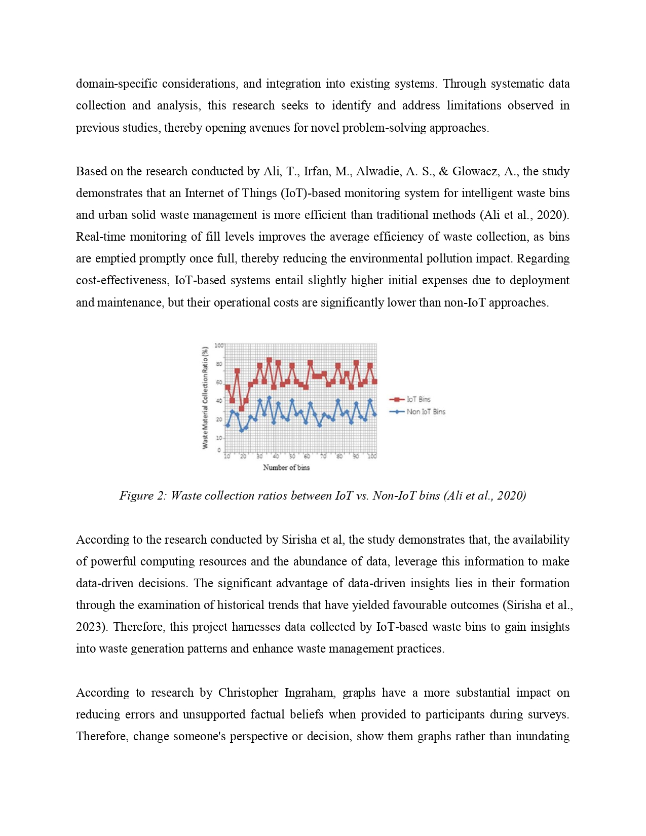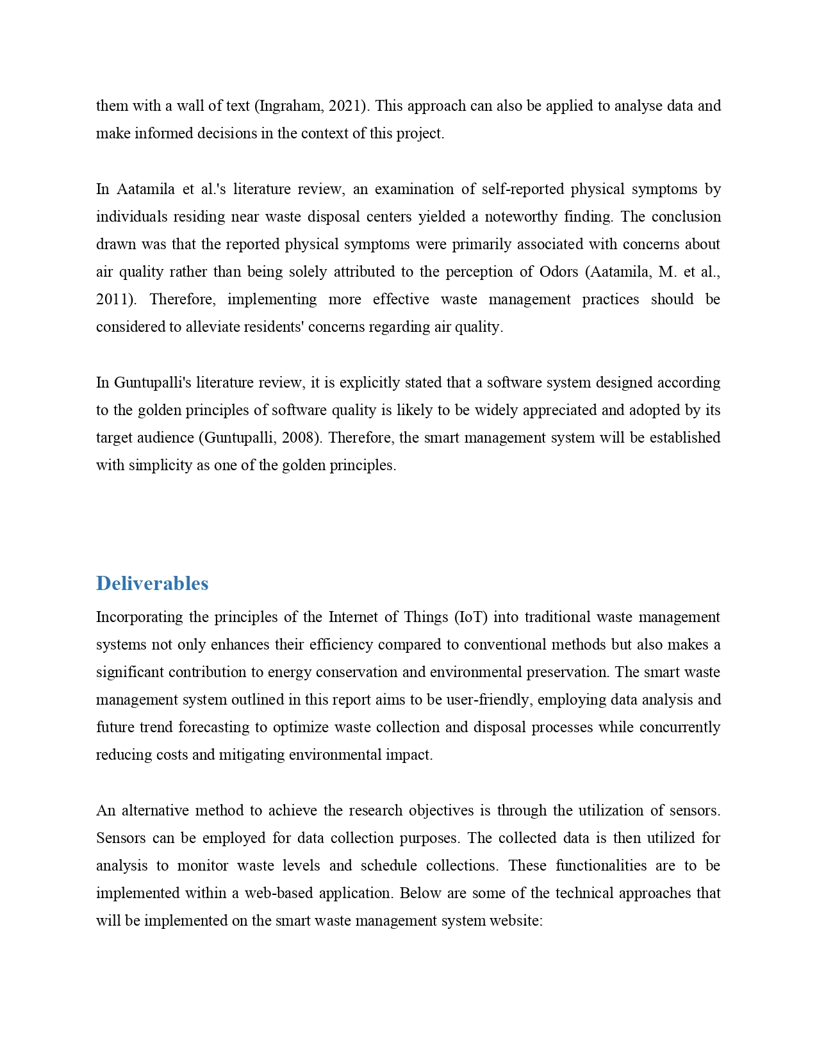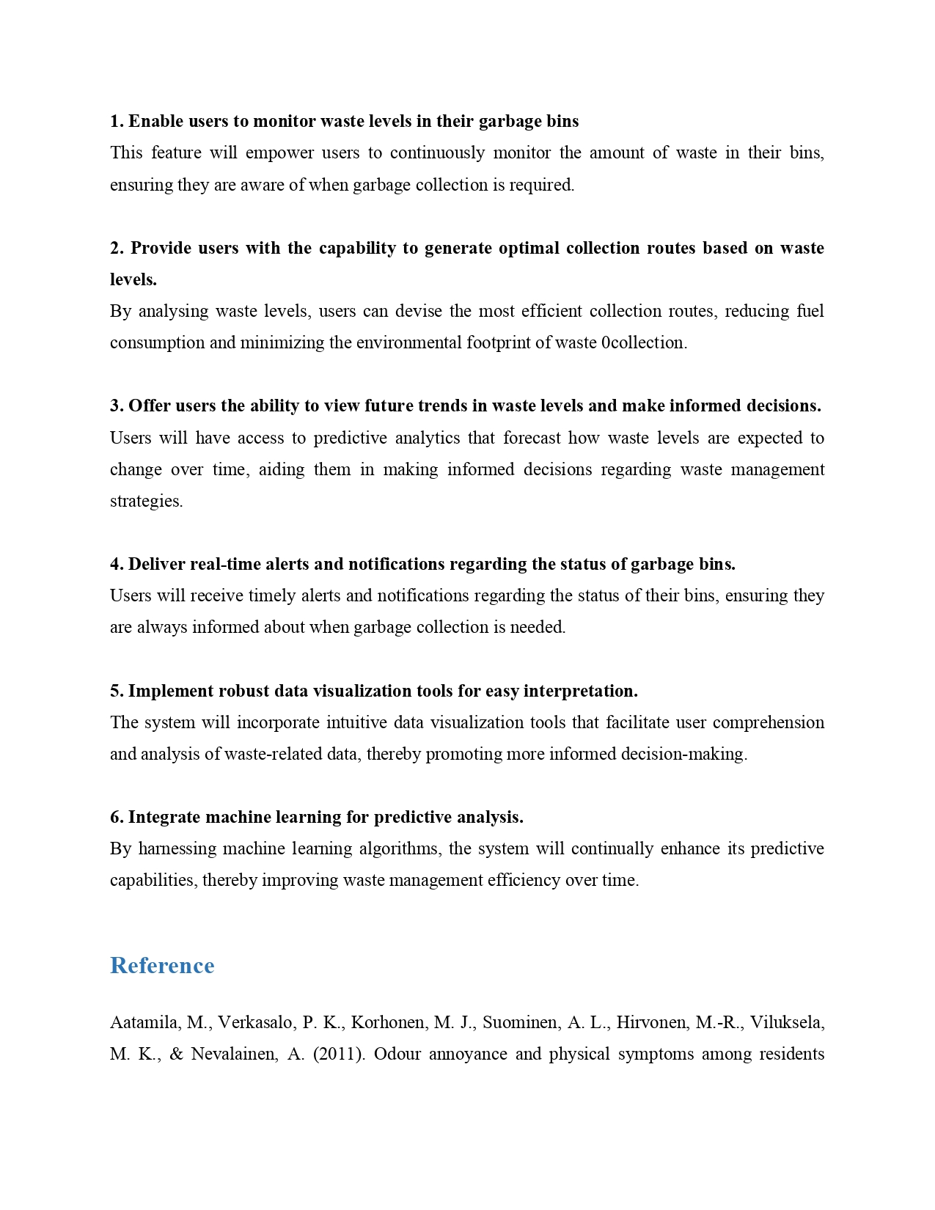

## Appendix B: Ethics Forms ( Fast Track / Full Track)





## Appendix C: Log Sheets ( 6 log sheets)





## Appendix D: Poster

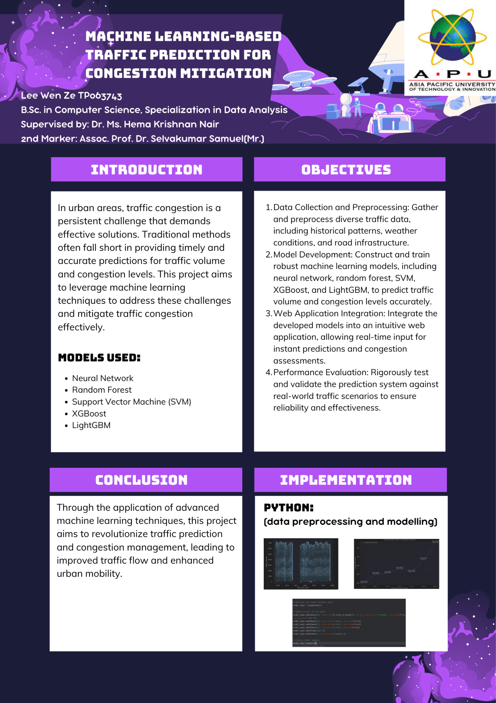

## Appendix E: Gantt Chart

Part 1:

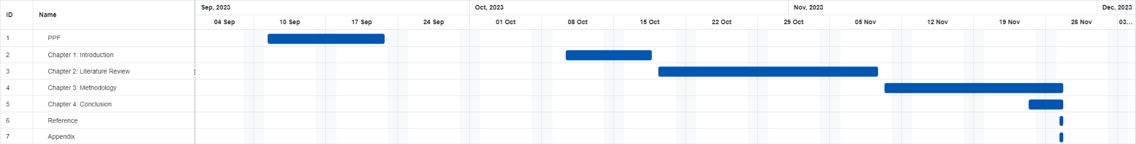

Part 2:

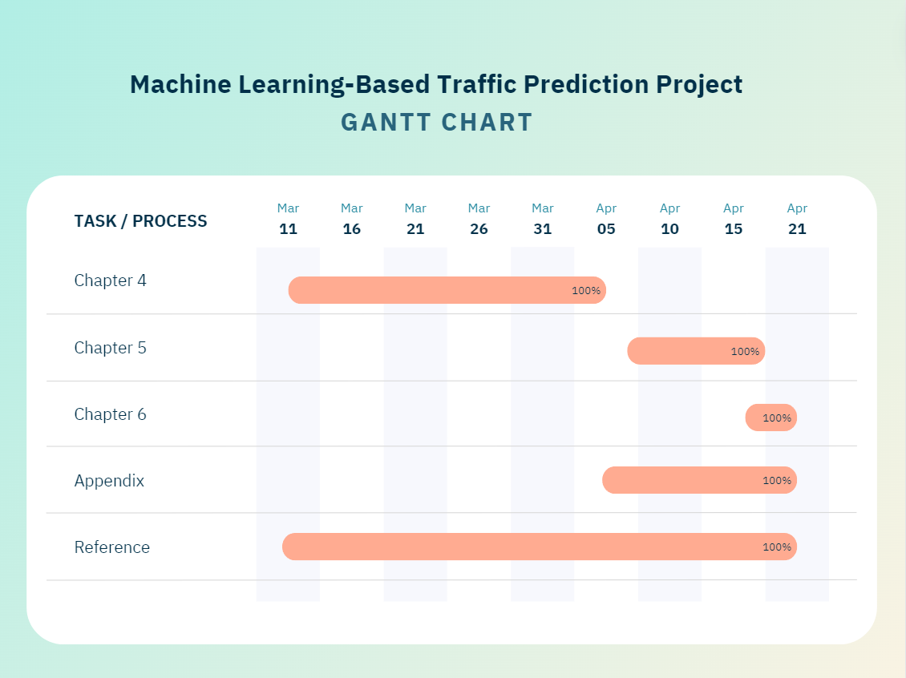

## Appendix F: Sources Code

